

**JMJ MARIST BROTHERSMIT 261 - Project**

Notre Dame of Marbel University 1st Semester SY 2025-2026

City of Koronadal Mrs. Brenda M. Balala, MIT

**MIT 261– Parallel and Distributed Systems**

**Project Title**

**Parallel and Distributed Student Performance Analytics Platform with MongoDB**

**Group members: Assigned Tasked**

1. **ALDEN QUIÑONES REGISTRAR**
2. **JUSTINE JOHN JAY DE ALA FACULTY**
3. **APRIL ANN BUDIONGAN STUDENT**

Contents

**Registrar’s Office Dashboard Reports 4**

1. Student Academic Standing Report 4

2. Subject Pass/Fail Distribution 5

3. Enrollment Trend Analysis 8

4. Incomplete Grades Report 9

5. Retention and Dropout Rates 10

6. Top Performers per Program 11

7. Curriculum Progress and Advising 12

**Faculty Dashboard Reports 17**

1. Class Grade Distribution 17

2. Student Progress Tracker 18

3. Subject Difficulty Heatmap 21

4. Intervention Candidates List 22

5. Grade Submission Status 23

6. Custom Query Builder 23

7. Students Grade Analytics (Per Teacher) 28

**Students Dashboard Reports 37**

1. Academic Transcript Viewer 37

2. Performance Trend Over Time 41

3. Subject Difficulty Ratings 42

4. Comparison with Class Average 43

5. Passed vs Failed Summary 43

6.Curriculum and Subject Viewer 45

**Source code for each dashboard and reports 50**

**Registrar’s Office Dashboard Reports 50**

1. Student Academic Standing Report 50

2. Subject Pass/Fail Distribution 52

3. Enrollment Trend Analysis 54

4. Incomplete Grades Report 56

5. Retention and Dropout Rates 58

6. Top Performers per Program 60

7. Curriculum Progress and Advising 62

**Faculty Dashboard Reports 67**

1. Class Grade Distribution 67

2. Student Progress Tracker 70

3. Subject Difficulty Heatmap 75

4. Intervention Candidates List 81

5. Grade Submission Status 84

6. Custom Query Builder 86

7. Students Grade Analytics (Per Teacher) 90

**Students Dashboard Reports 95**

1. Academic Transcript Viewer 95

2. Performance Trend Over Time 101

3. Subject Difficulty Ratings 103

4. Comparison with Class Average 106

5. Passed vs Failed Summary 108

Recommendations for Dashboard Enhancements 112

A. Registrar Dashboard 113

B. Faculty Dashboard 113

C. Student Dashboard 114

**MongoDB Database Model for Dashboard Enhancements 115**

A. Registrar Dashboard – Data Flow 115

B. Faculty Dashboard – Data Flow 116

C. Student Dashboard – Data Flow 116

# **Registrar’s Office Dashboard Reports**

## **1. Student Academic Standing Report**

|  |  |  |  |  |  |  |
| --- | --- | --- | --- | --- | --- | --- |
|  |  |  |  |  |  |  |
|  |  |  |  |  |  |  |
|  |  |  |  |  |  |  |

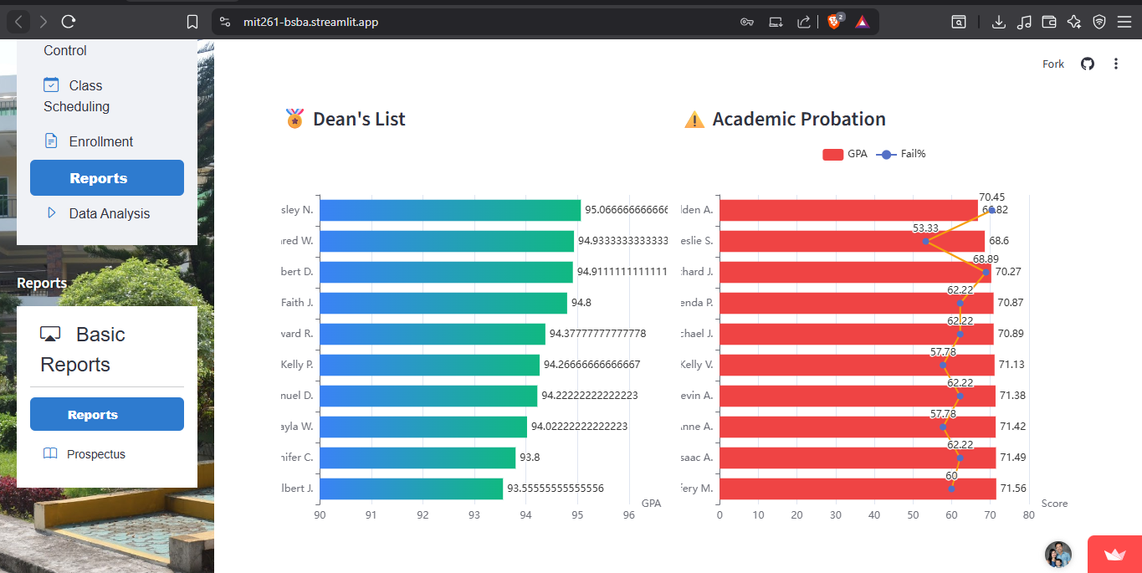**Insight**: Enables quick identification of high achievers, students needing support, and overall academic distribution.

## **2. Subject Pass/Fail Distribution**

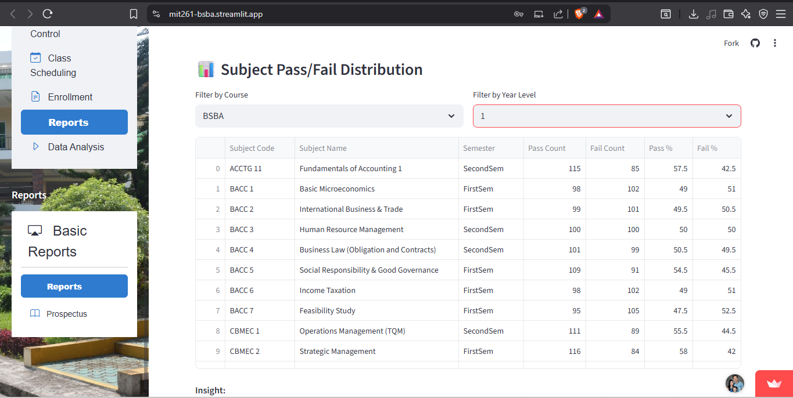

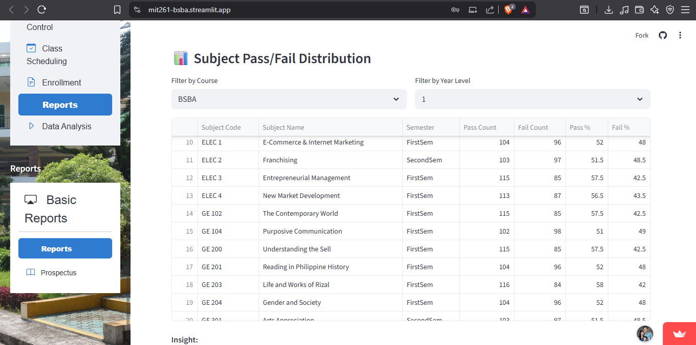

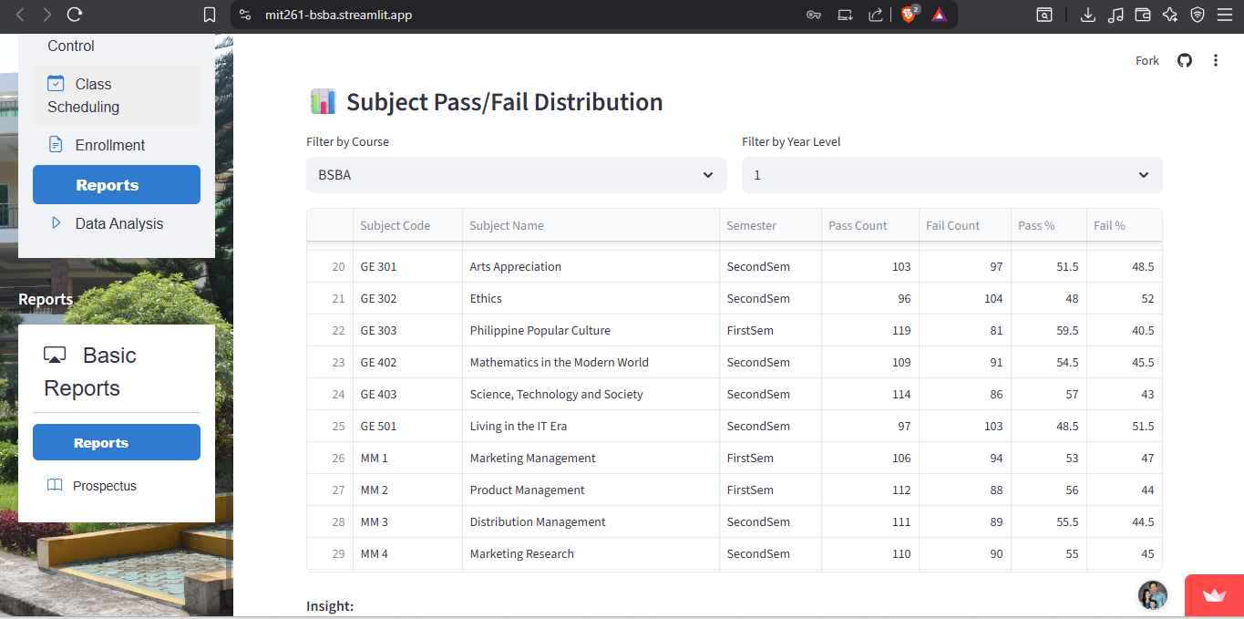

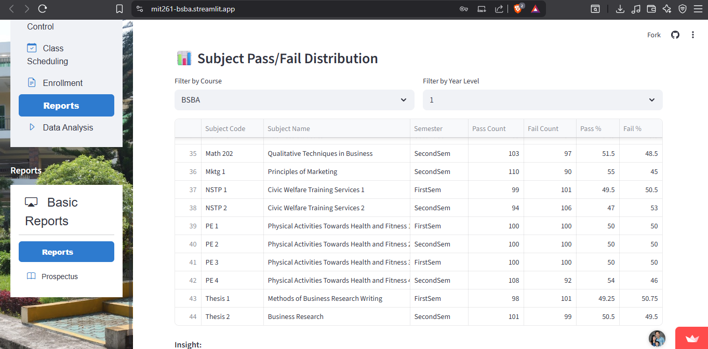

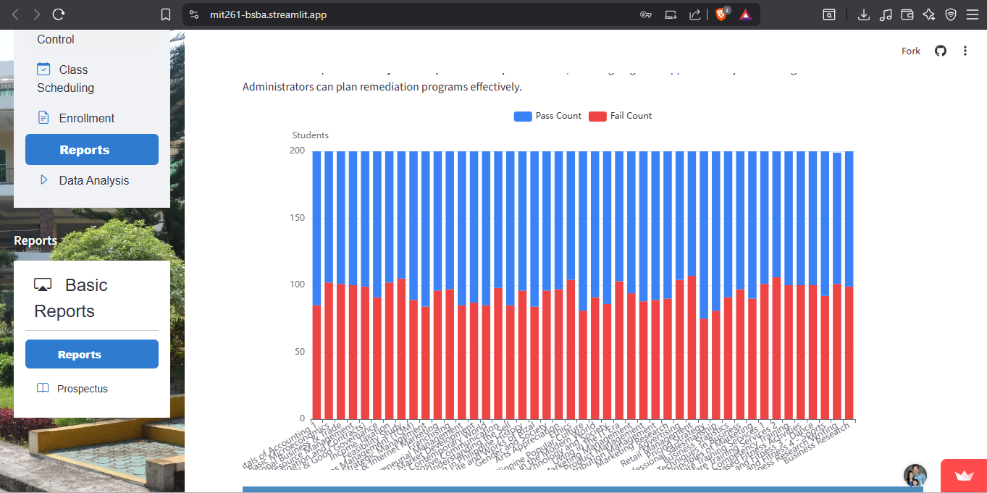

**Insight**: Clear visibility into subject-level performance by term—supports targeted interventions.

## 

## **3. Enrollment Trend Analysis**

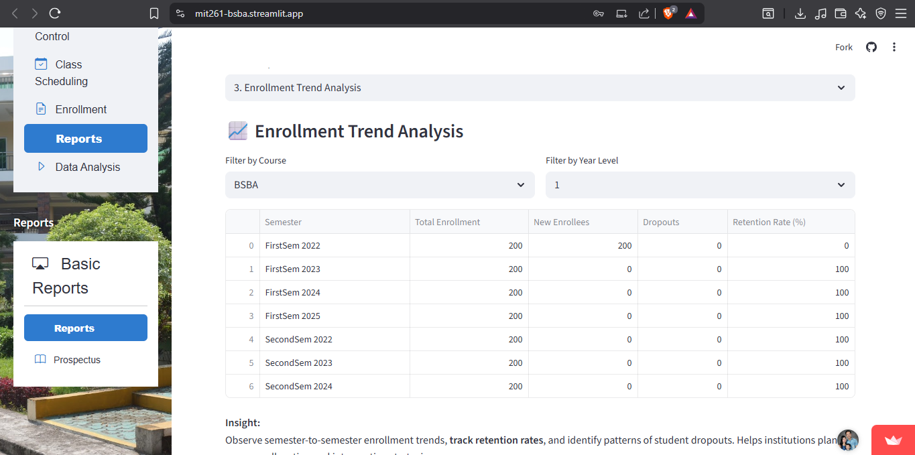

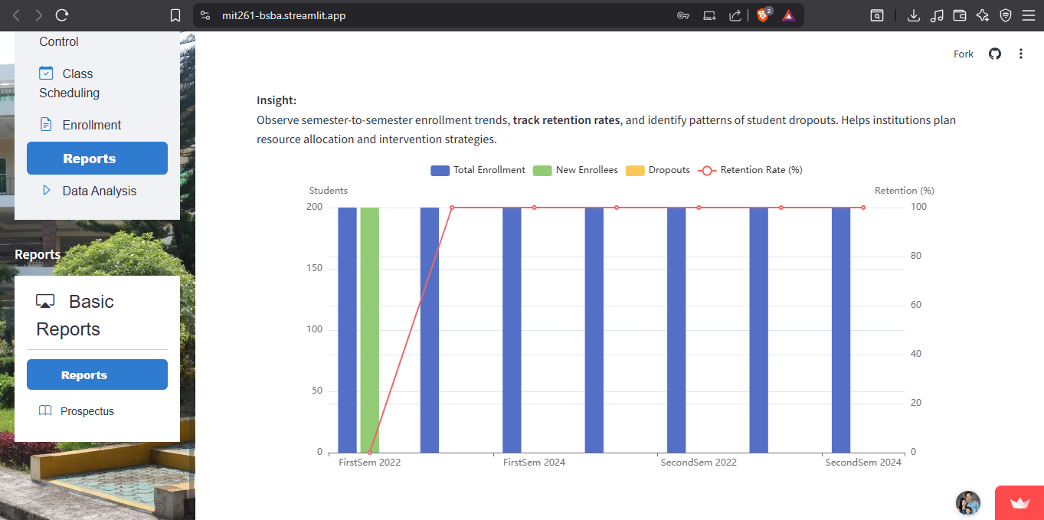

**Insight**: Plotting these values as line or area charts reveals enrollment dynamics—semester over semester or year over year.

## **4. Incomplete Grades Report**

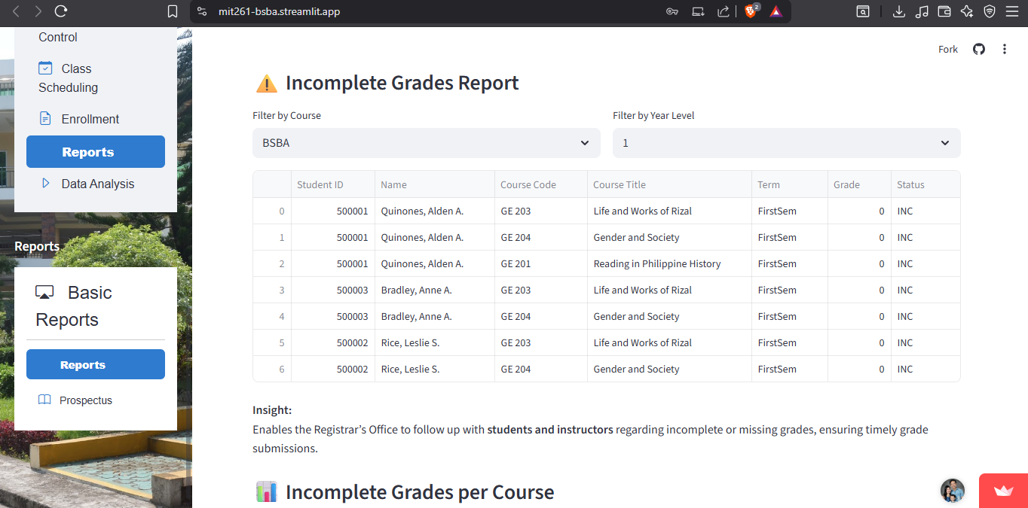

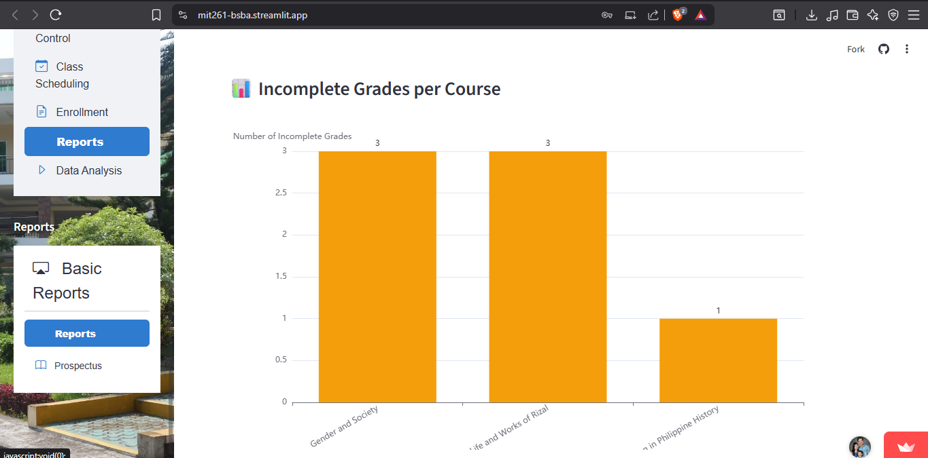

**Insight**: Helps Registrar’s Office identify and follow up with students and instructors regarding incomplete or missing grade submissions.

## **5. Retention and Dropout Rates**

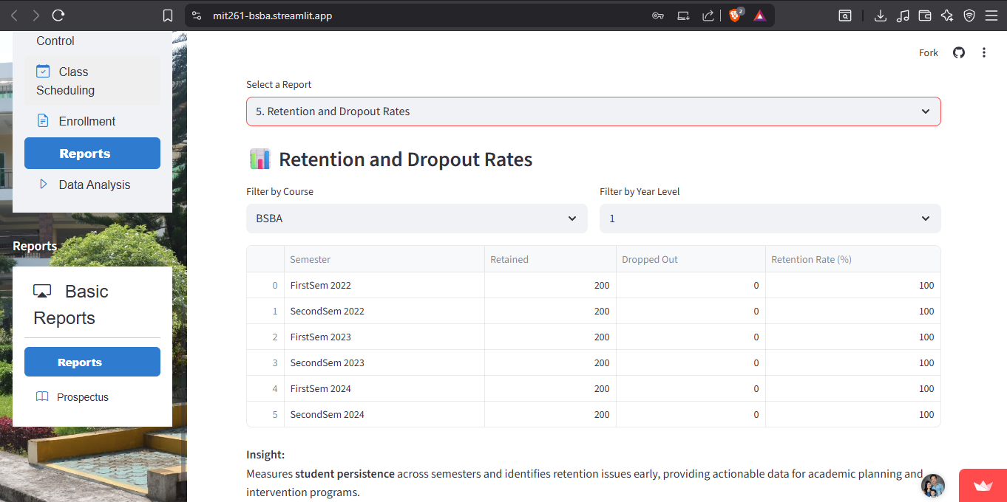

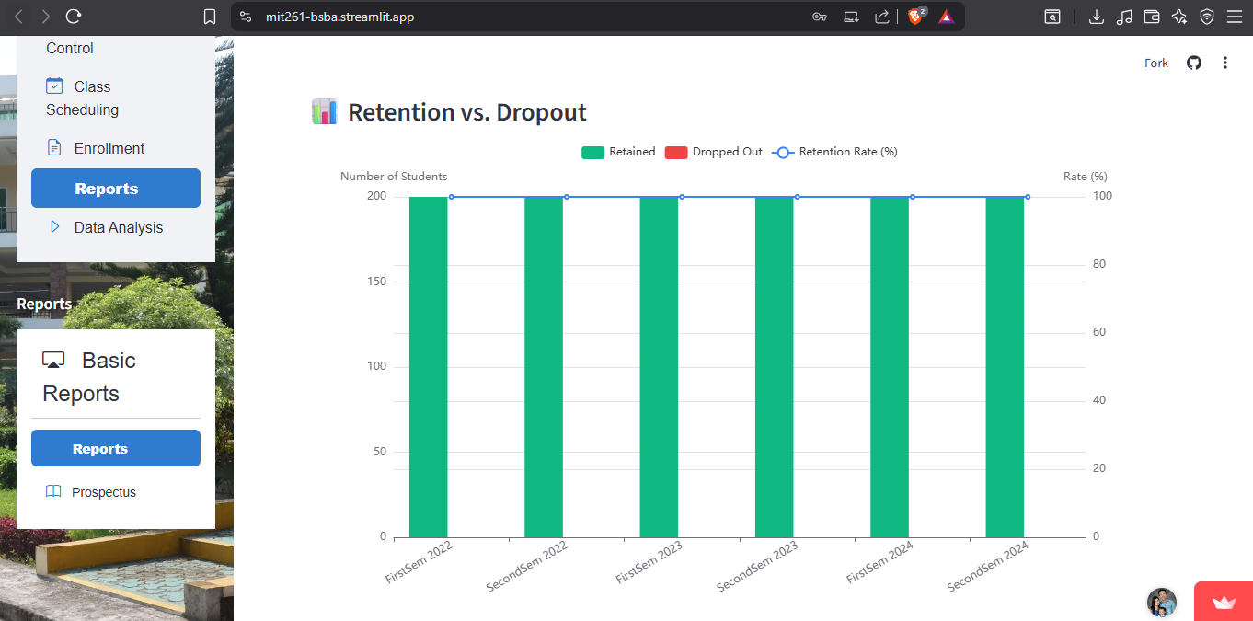

**Insight**: Measures student persistence and identifies retention issues early—critical for institutional planning.

## **6. Top Performers per Program**

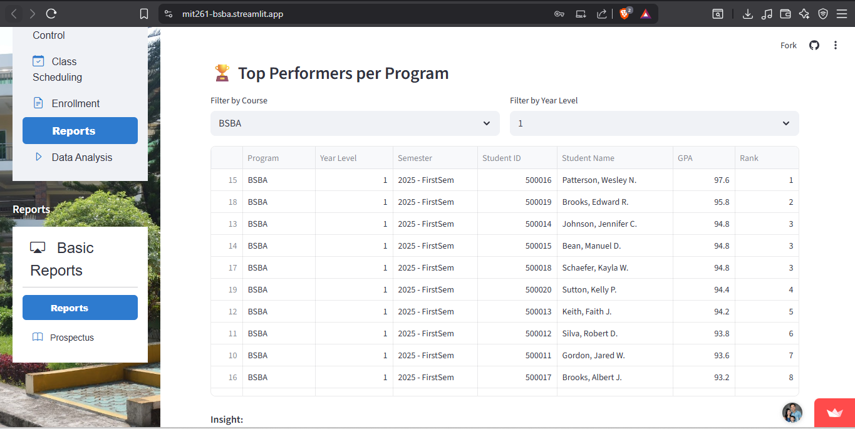

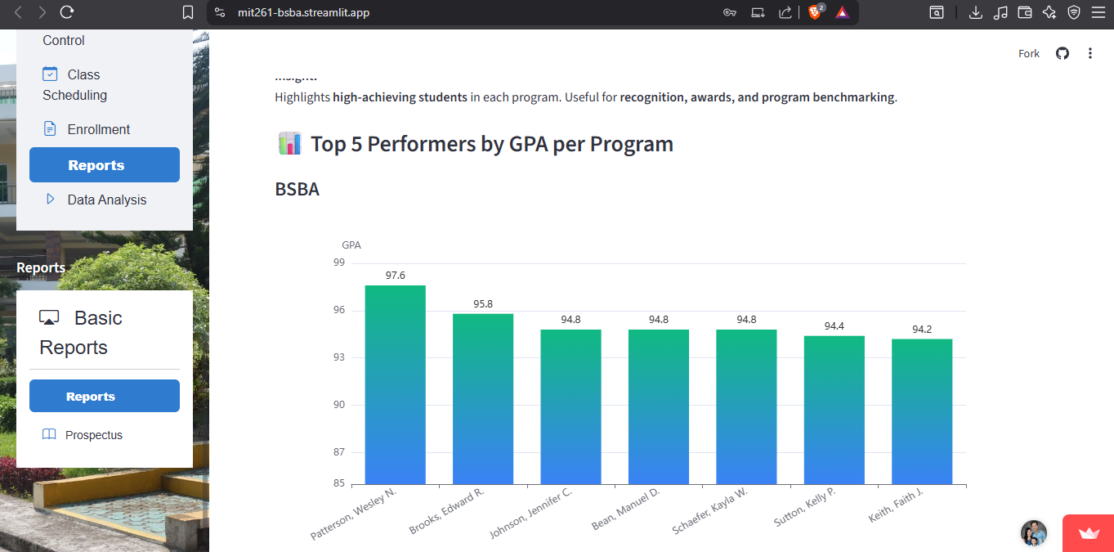

**Insight**: Highlights top academic performers by discipline—great for awards, recognitions, and program-level analysis.

## **7. Curriculum Progress and Advising**

**Filter by course and student name: BSBA- Jennifer C. Johnson**

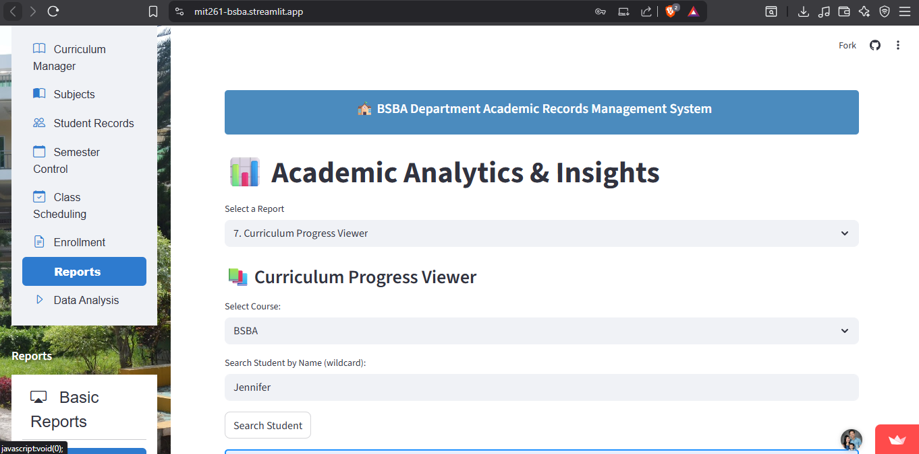

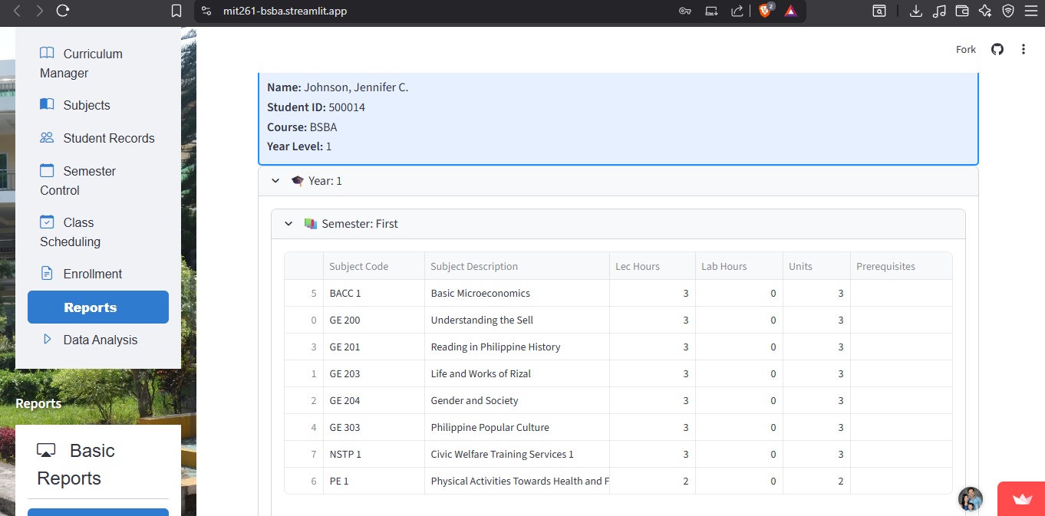

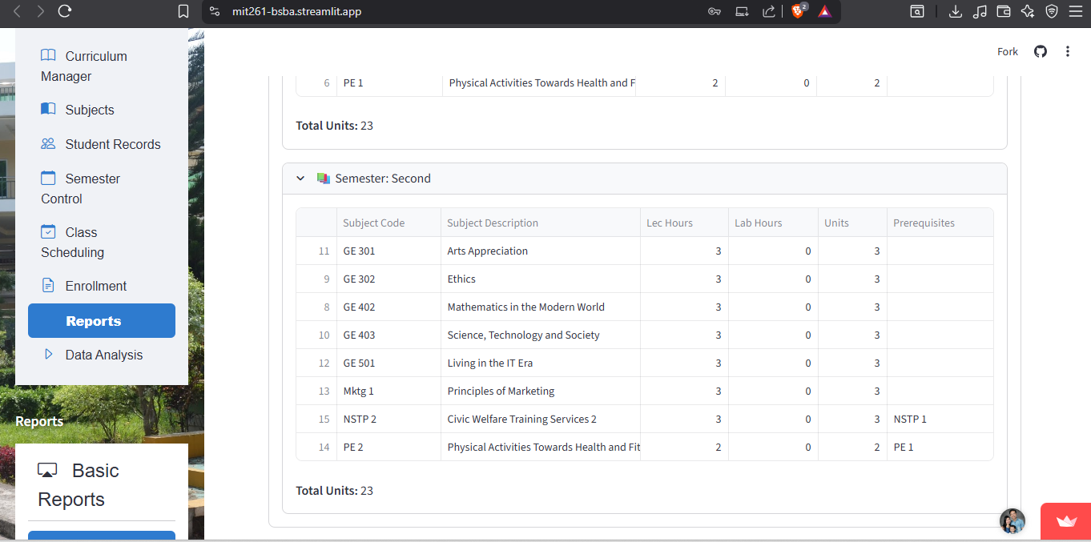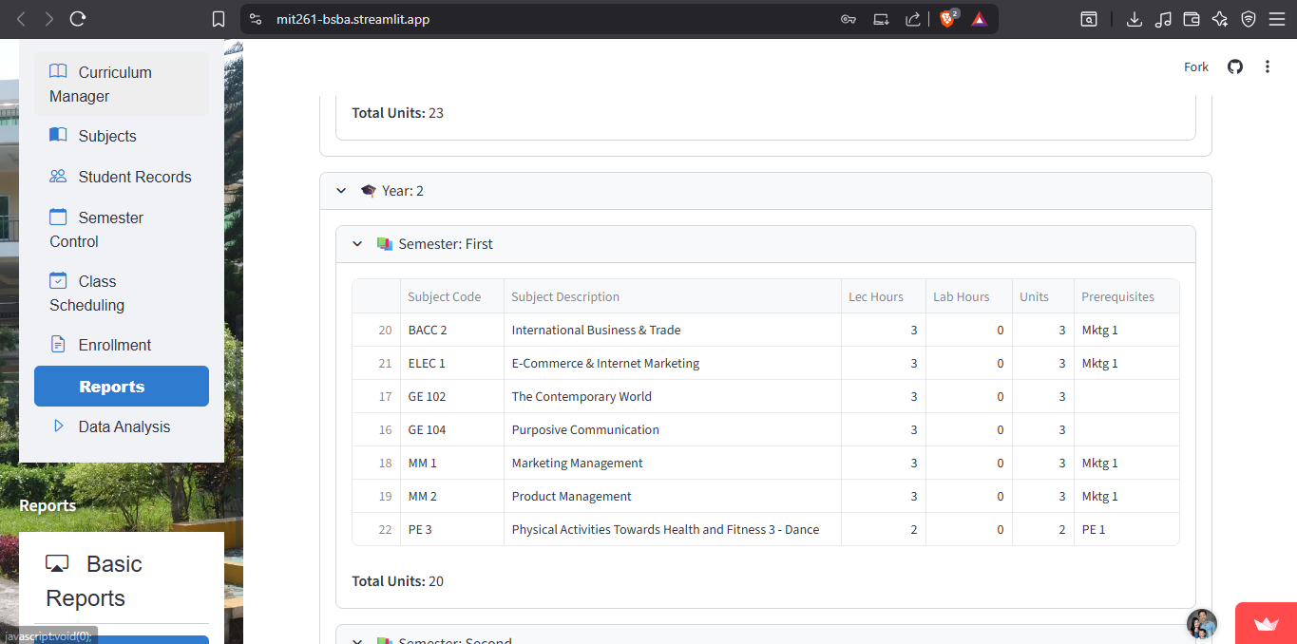

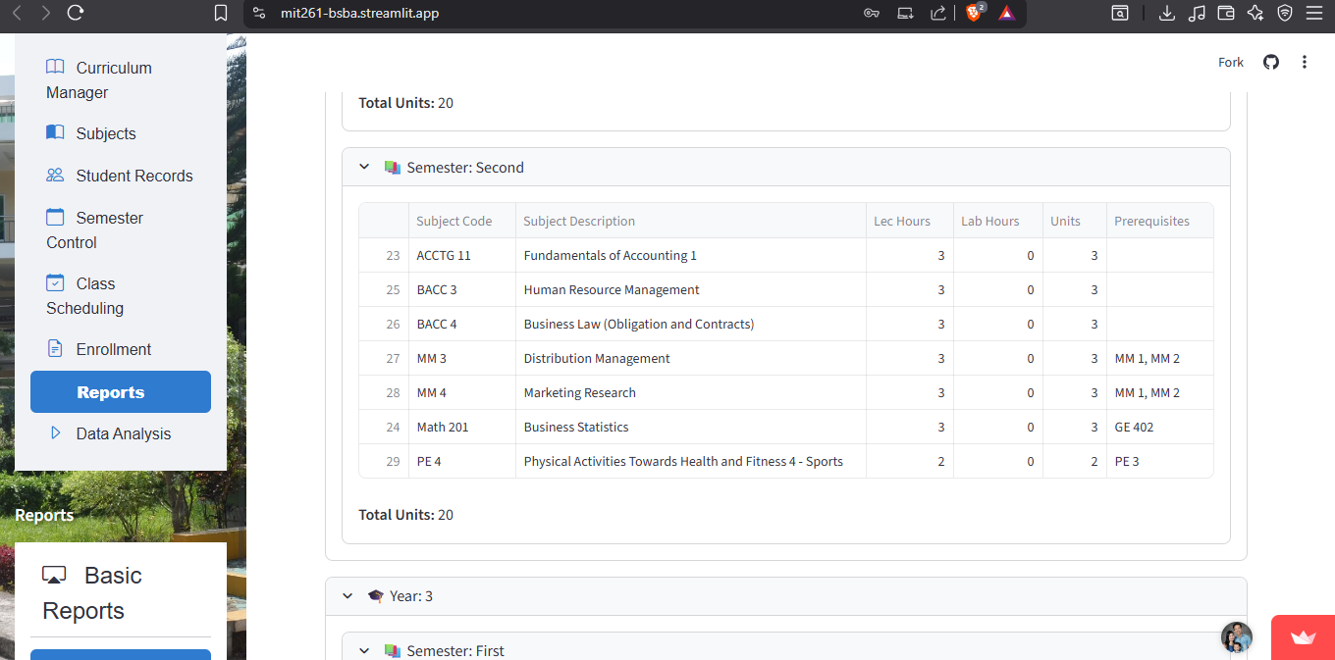

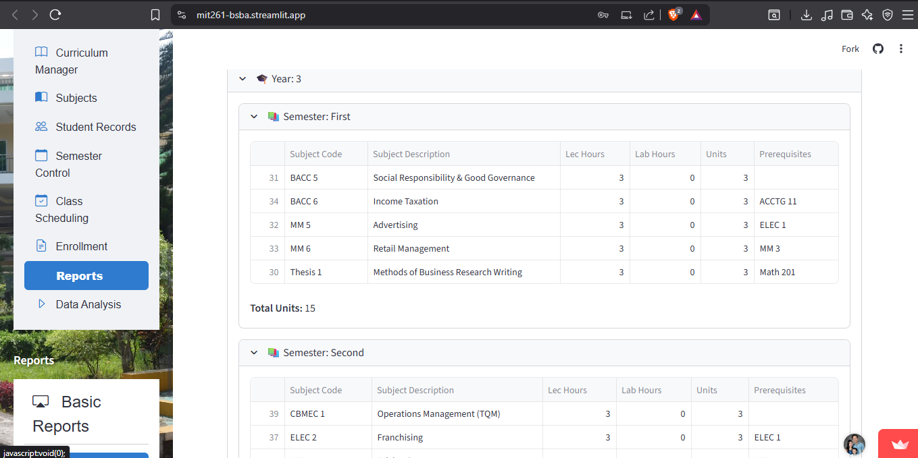

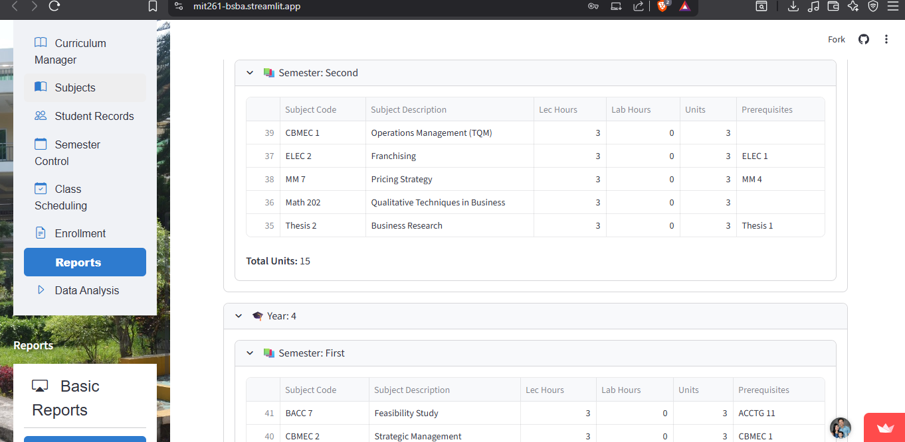

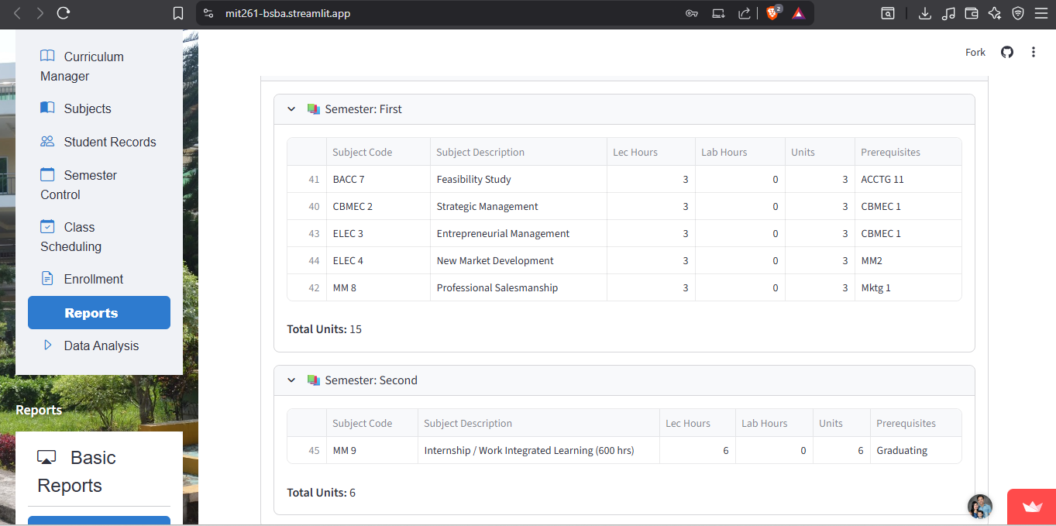

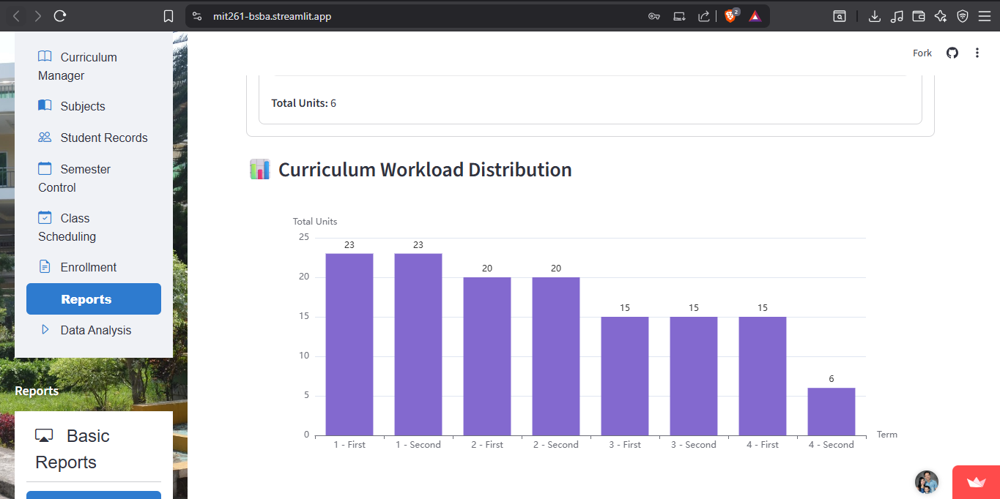

# 

# **Faculty Dashboard Reports**

## **Class Grade Distribution**

* **Displays a histogram of student grade distribution per subject.**

**Faculty Name: Antonio Luna**

**Semester and School Year: FirstSem 2022**

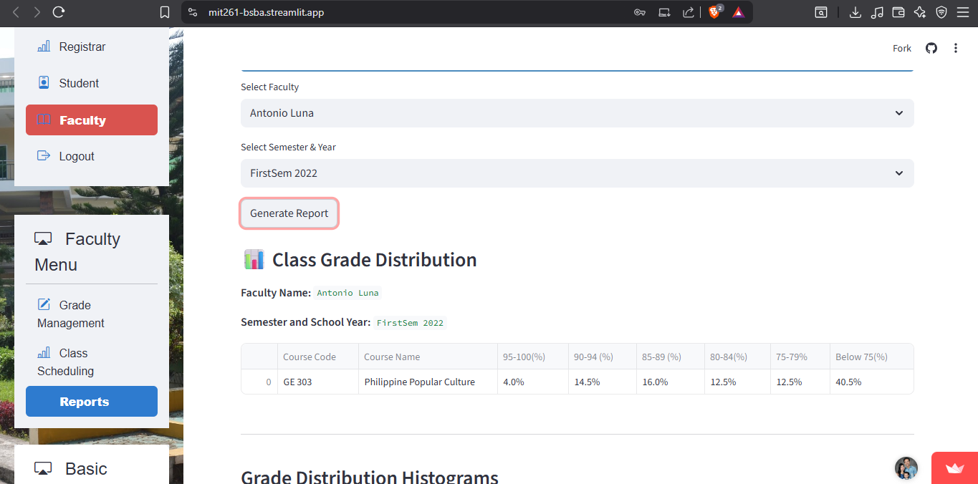

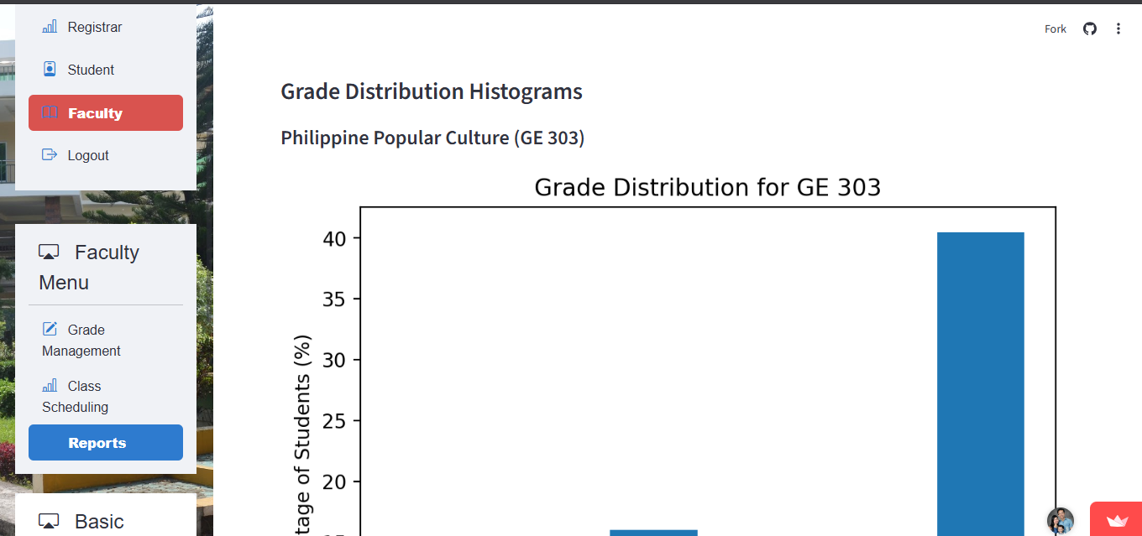

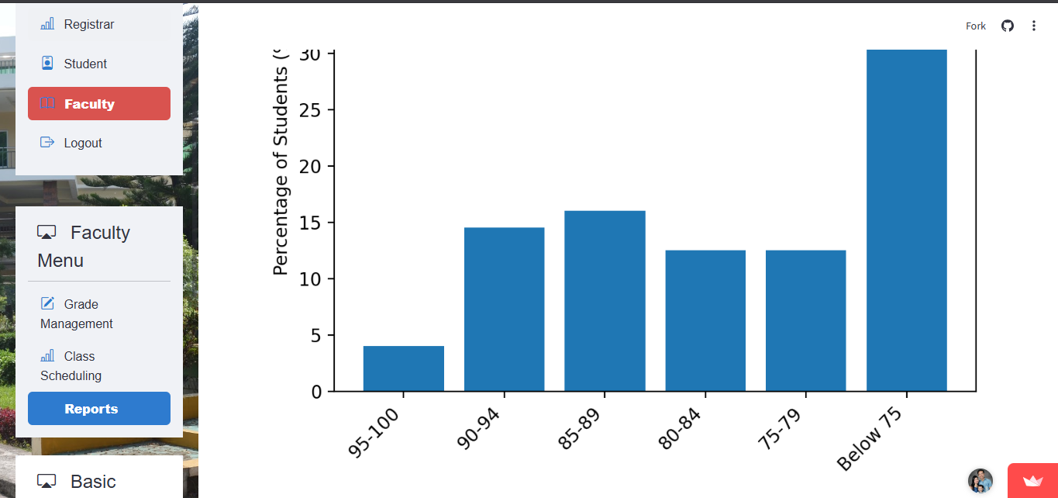

**Insight:** Quick view of overall performance—identifies courses with skewed grade distributions or those with high failure rates.

## **Student Progress Tracker**

**Shows longitudinal performance for individual students.**

**Filtered by Subject or course or YearLevel**

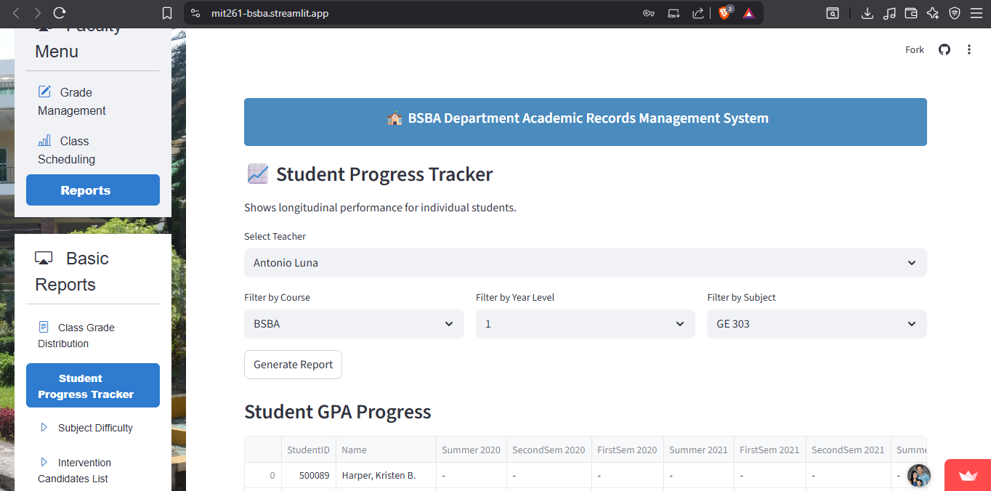

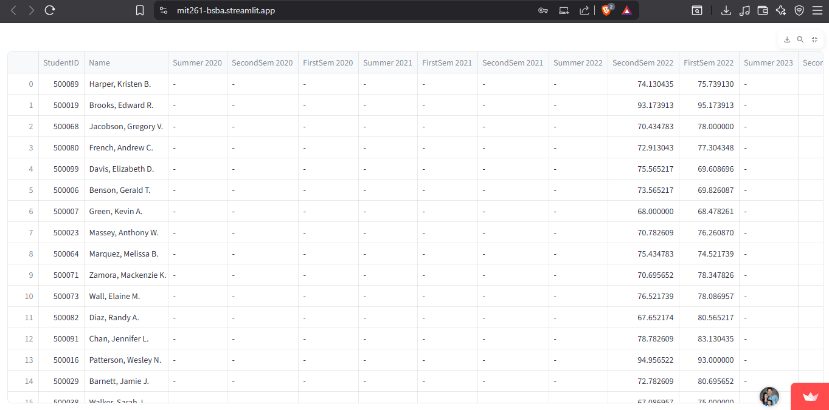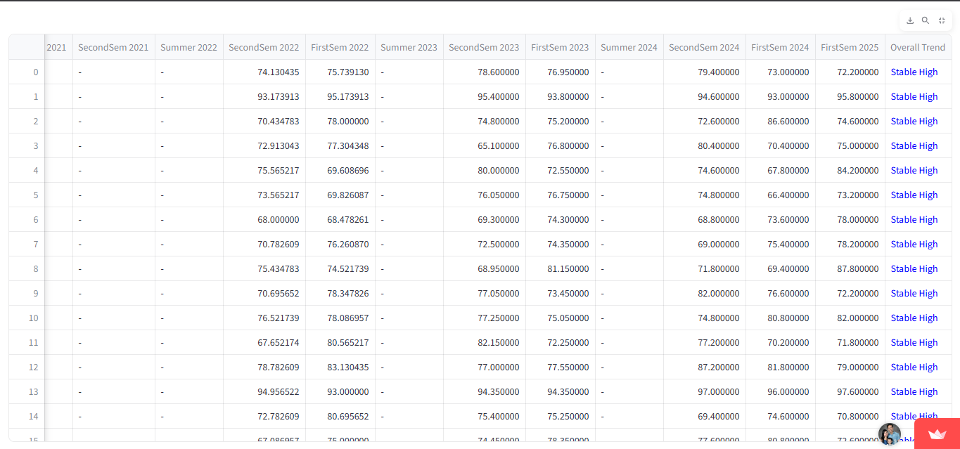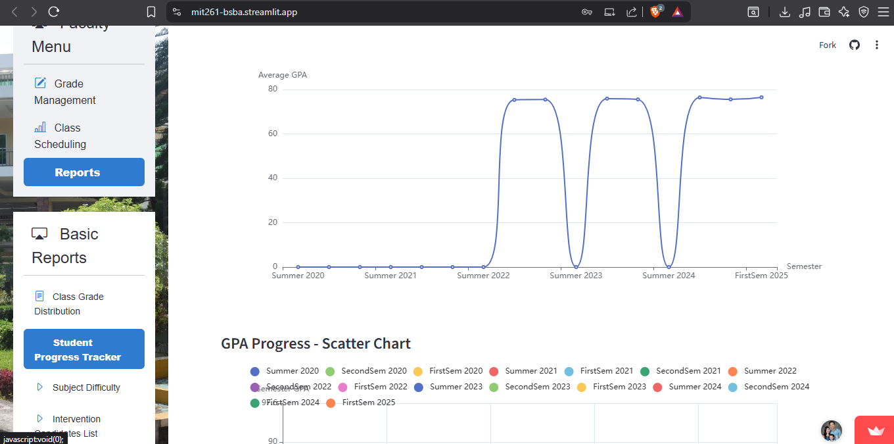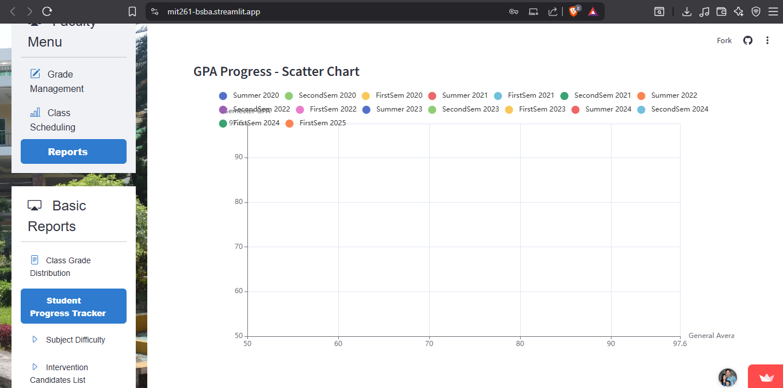

## **Subject Difficulty Heatmap**

* **Visualizes subjects with high failure or dropouts**
* **Subjects handled by the faculty**

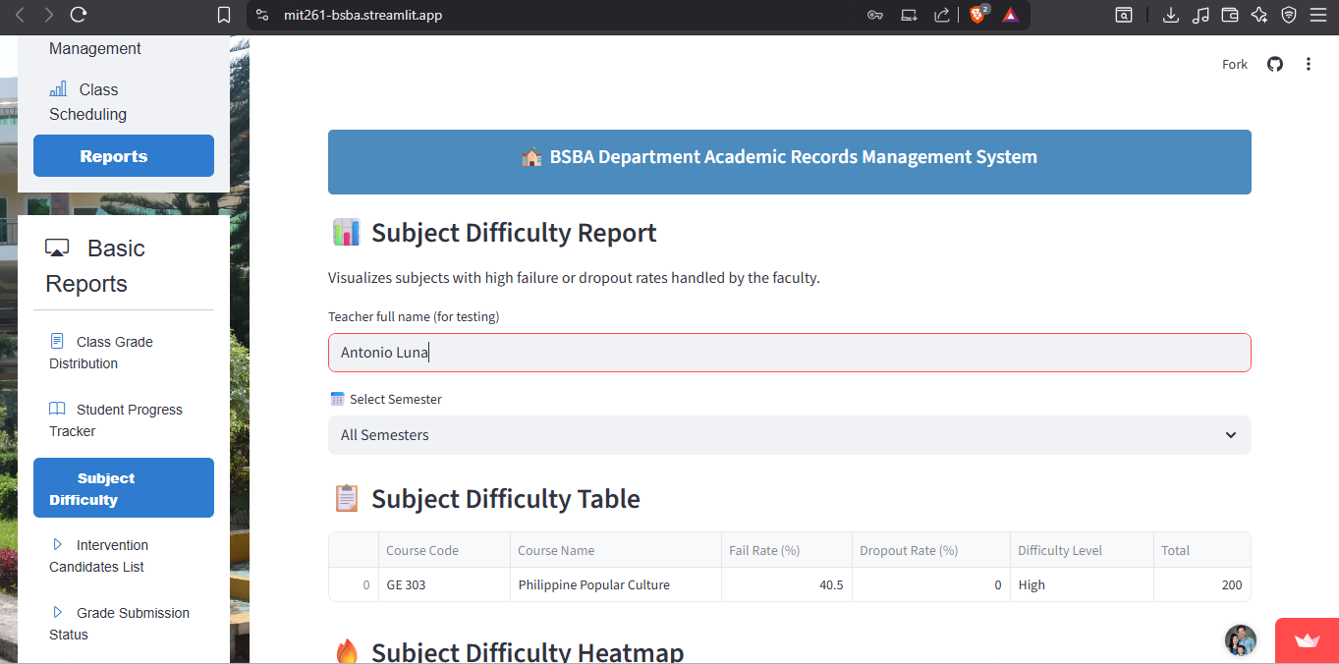

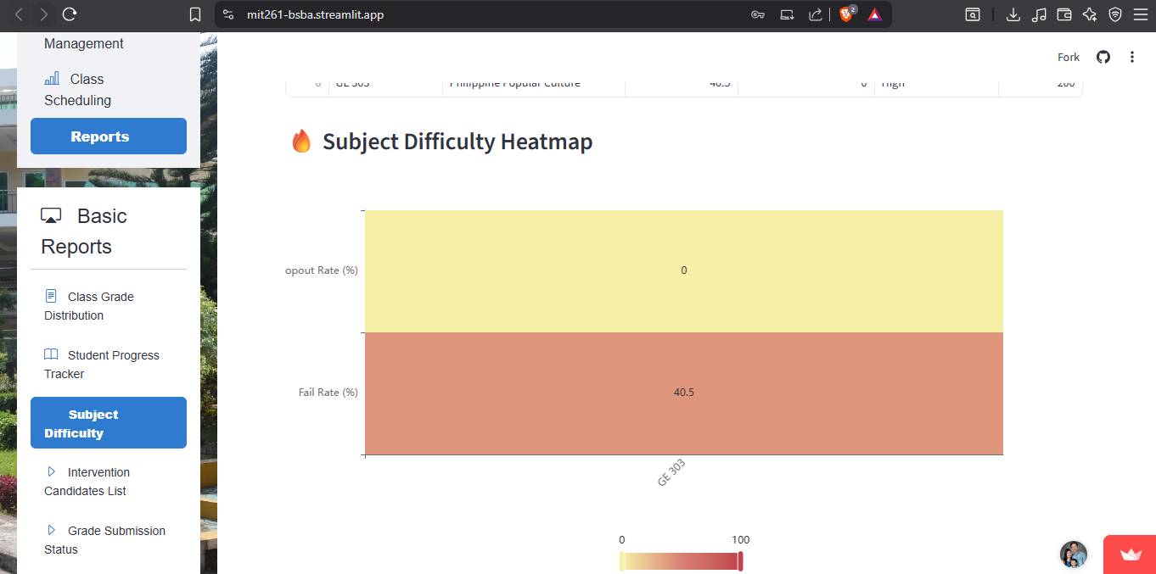

## **Intervention Candidates List**

* **Lists students at academic risk based on current semester data (e.g. low grades, missing grades)**

**Faculty Name: Antonio Luna**

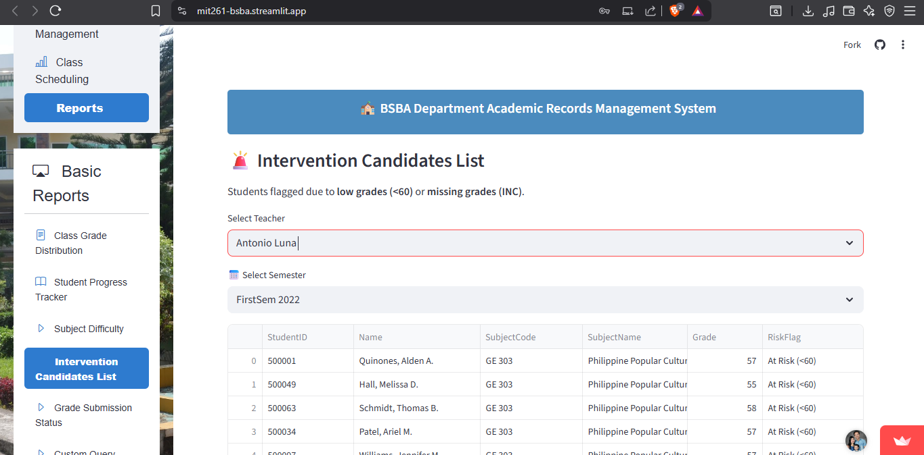

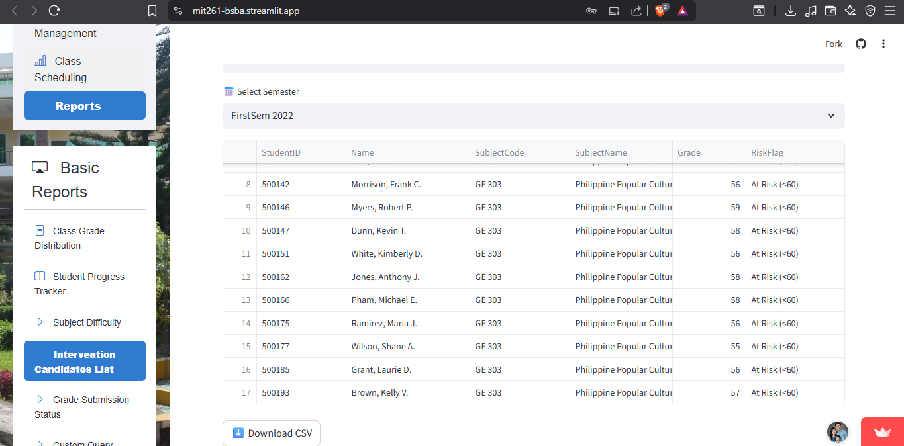

## **Grade Submission Status**

* **Tracks the status of grade submissions by faculty for each class. (e.g. complete grades, with blank grades)**

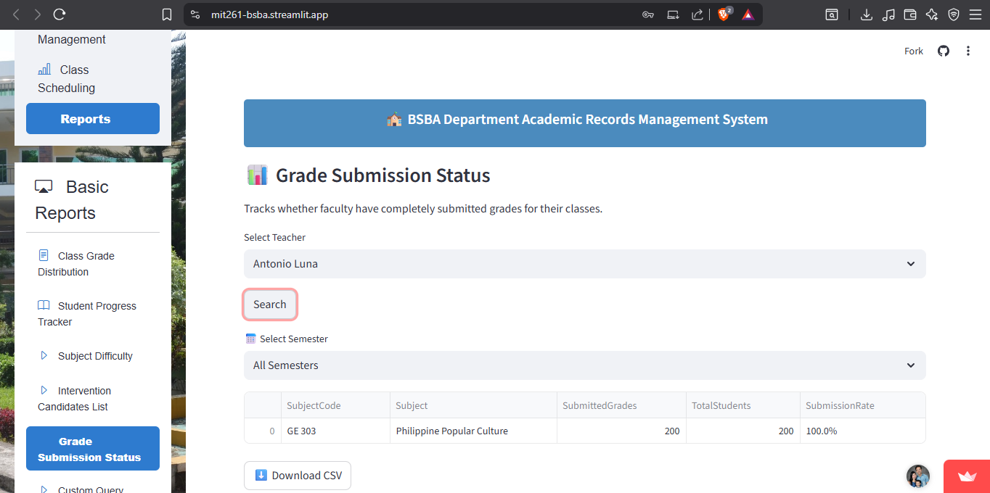

## **Custom Query Builder**

* **Allows users to build filtered queries (e.g., “Show all students with <75 in CS101”).**

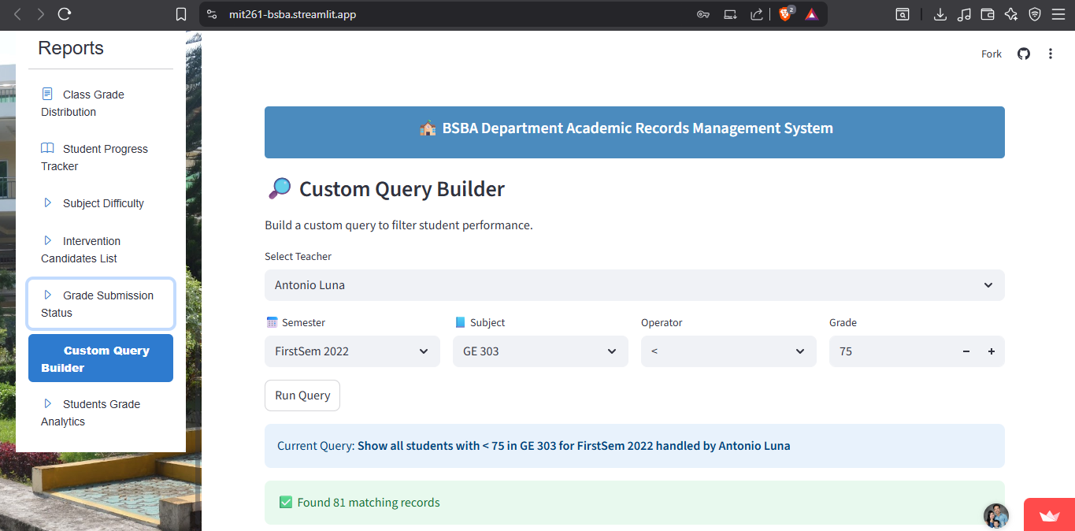

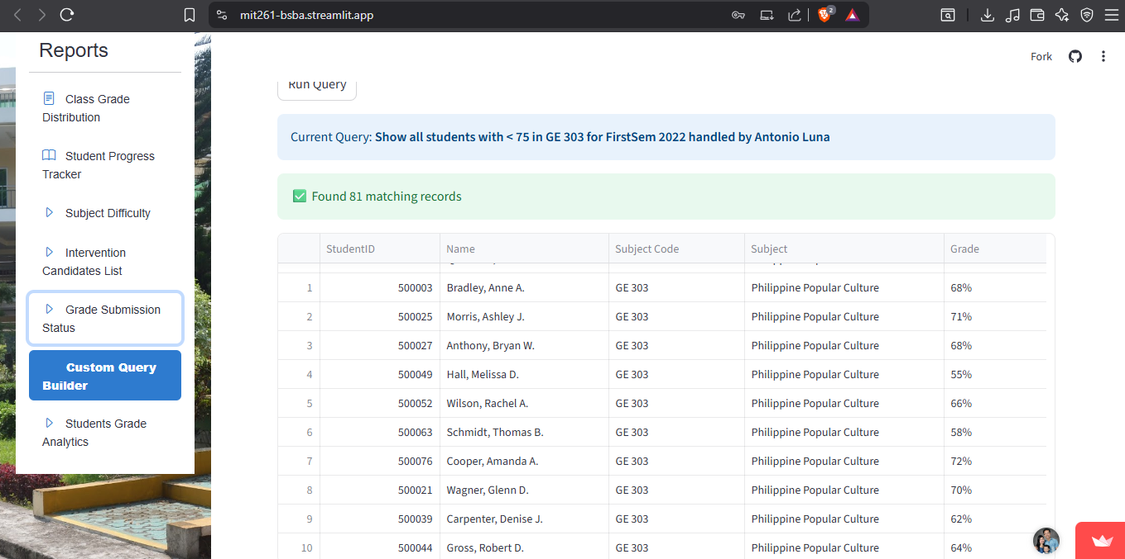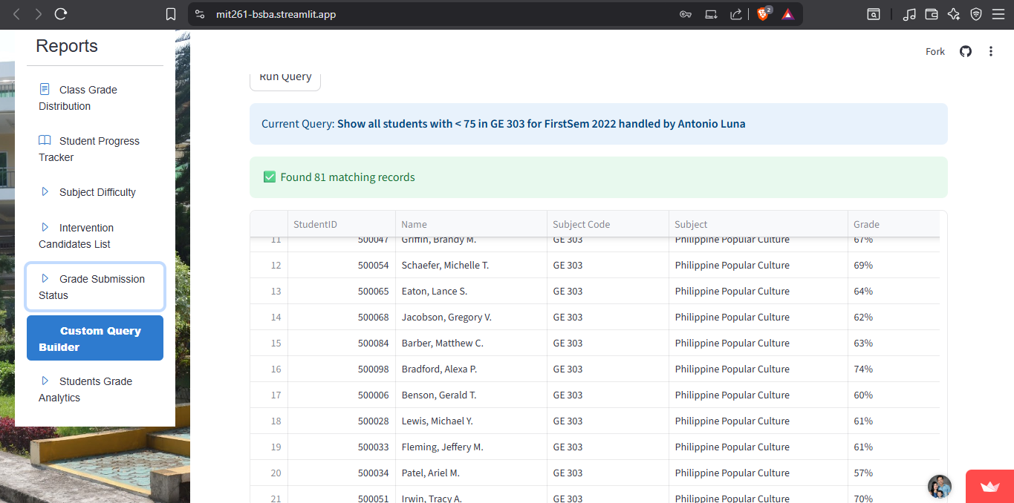

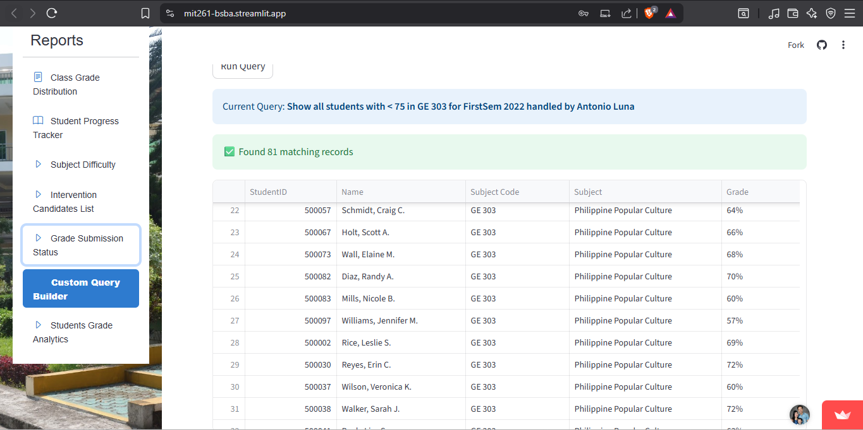

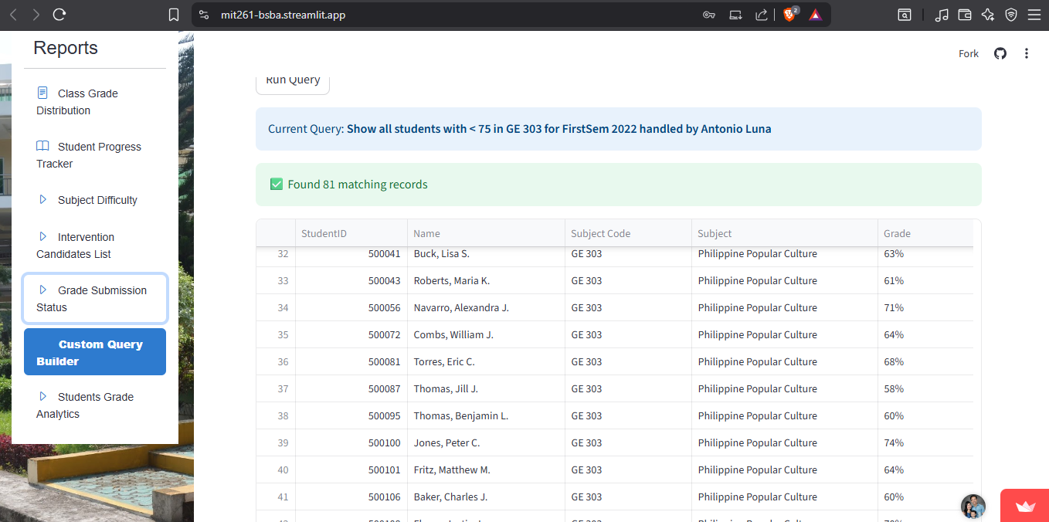

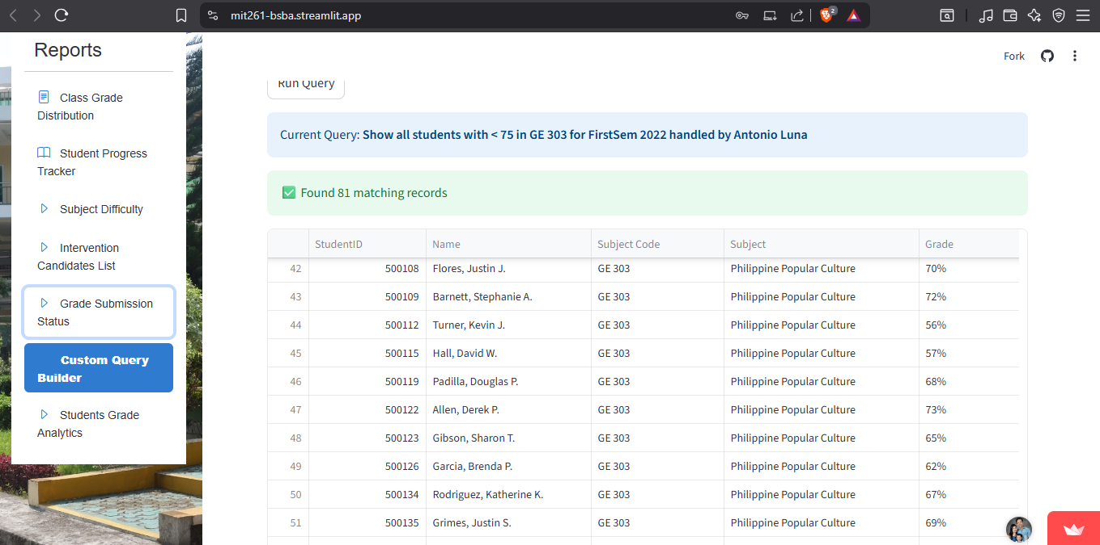

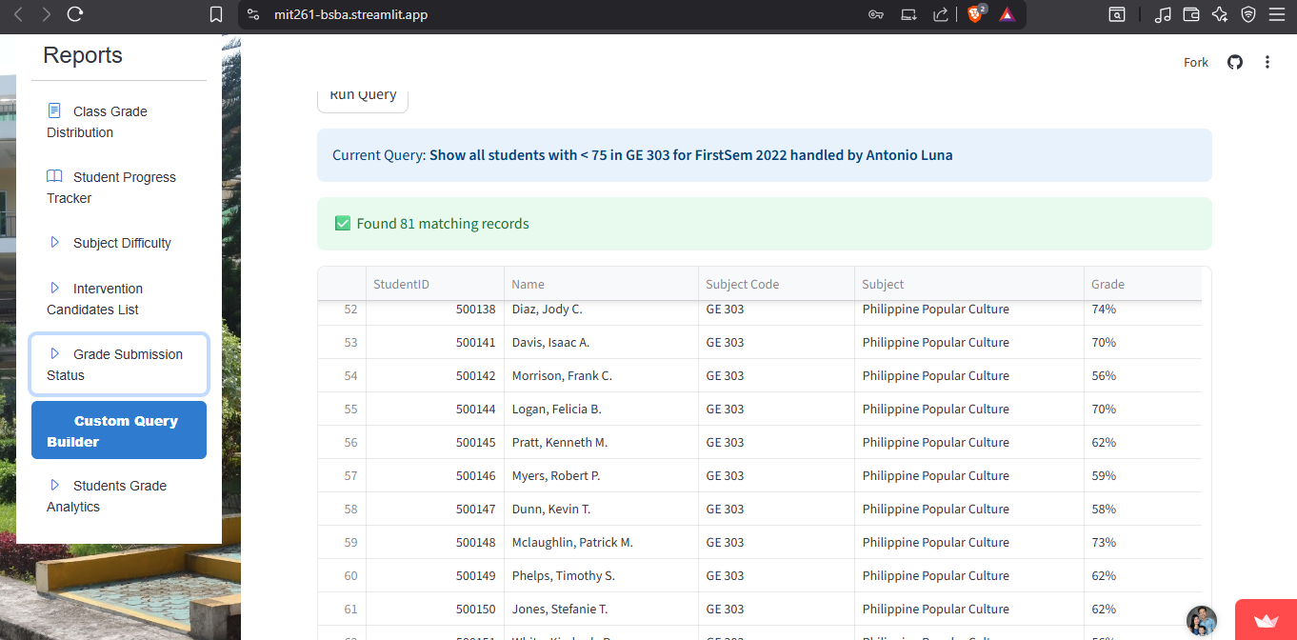

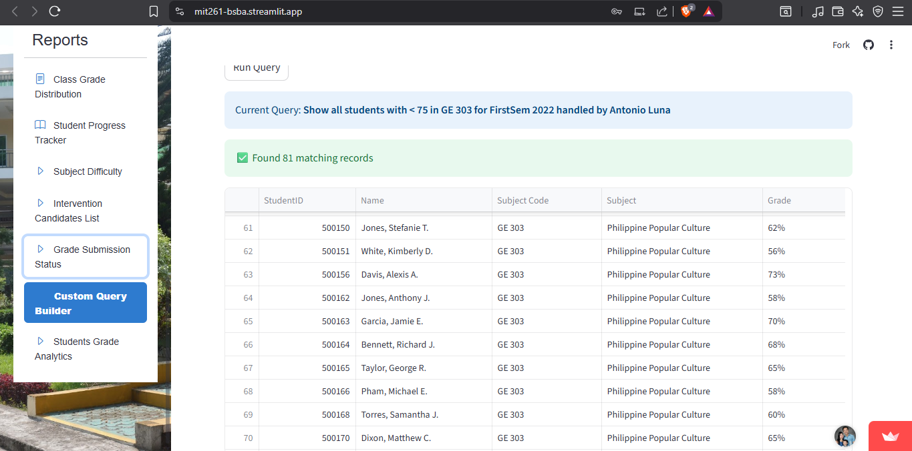

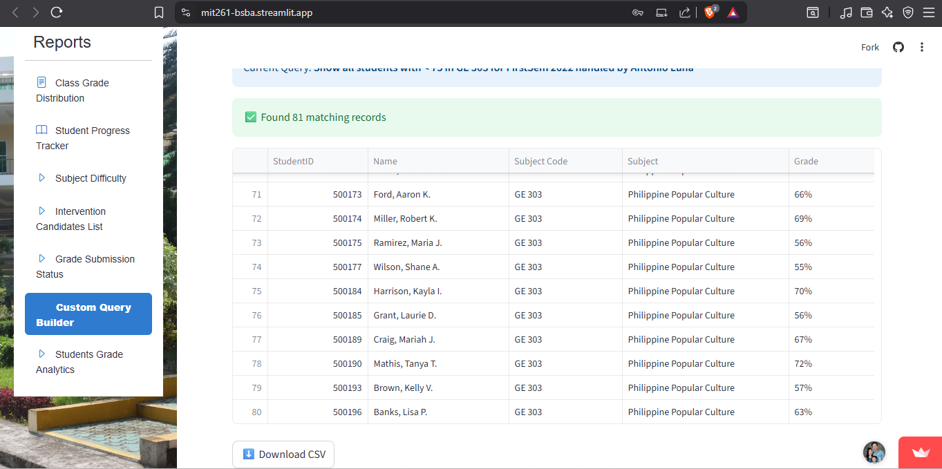

## **Students Grade Analytics (Per Teacher)**

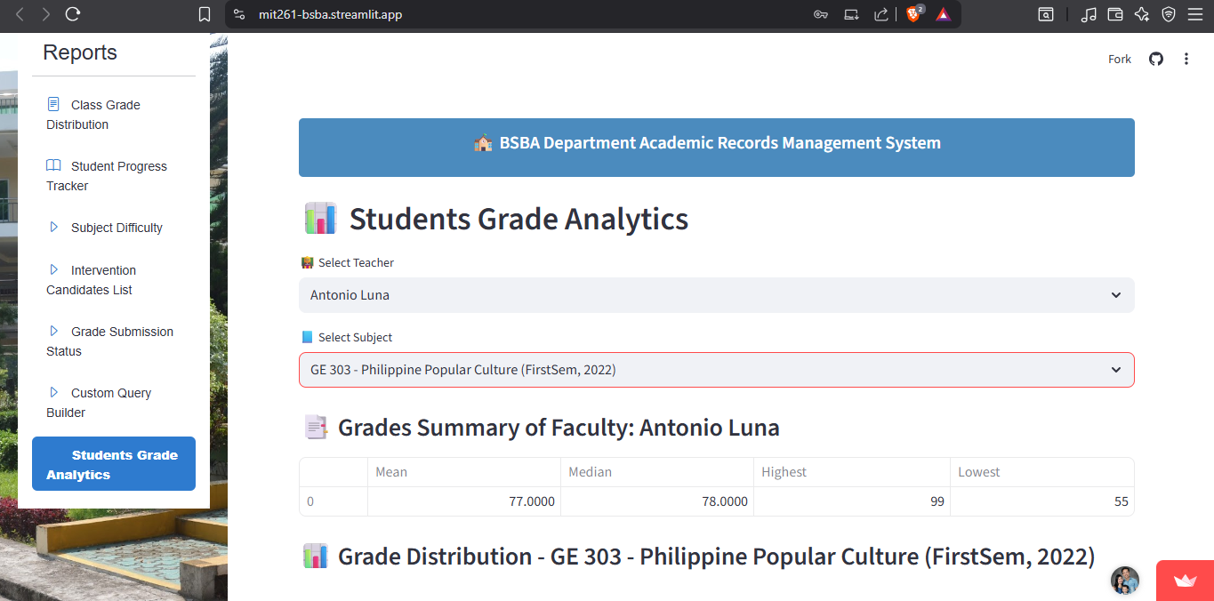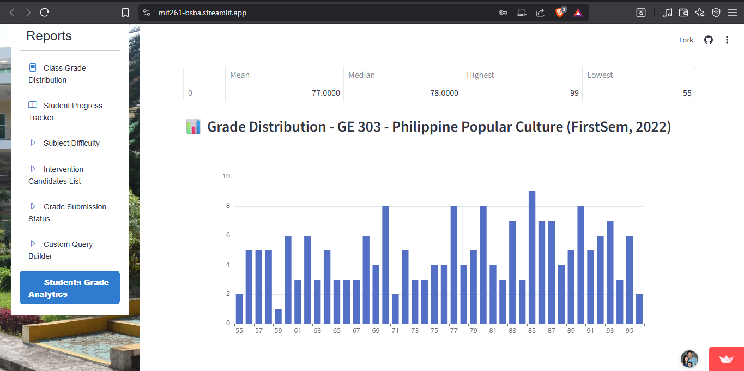

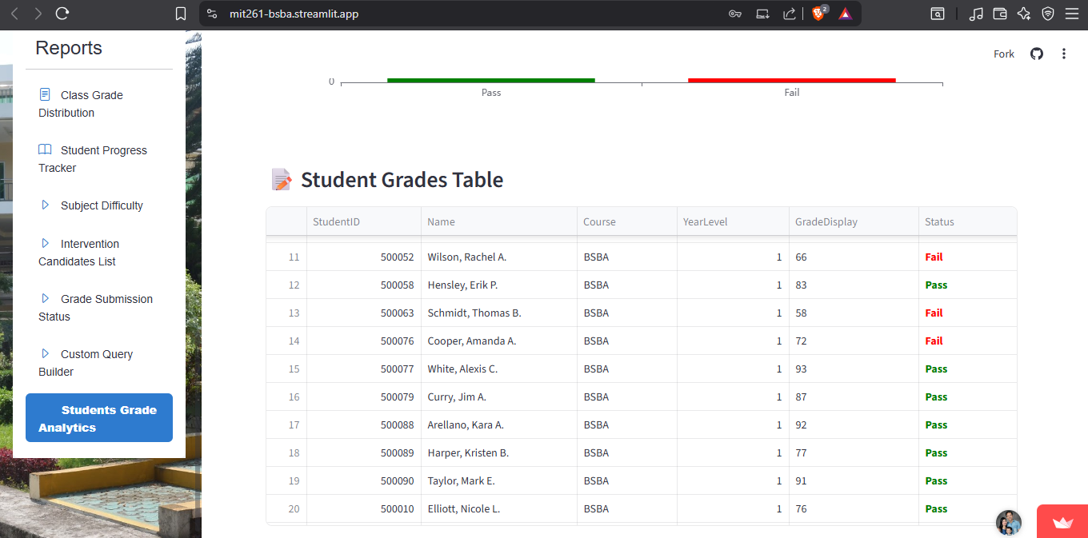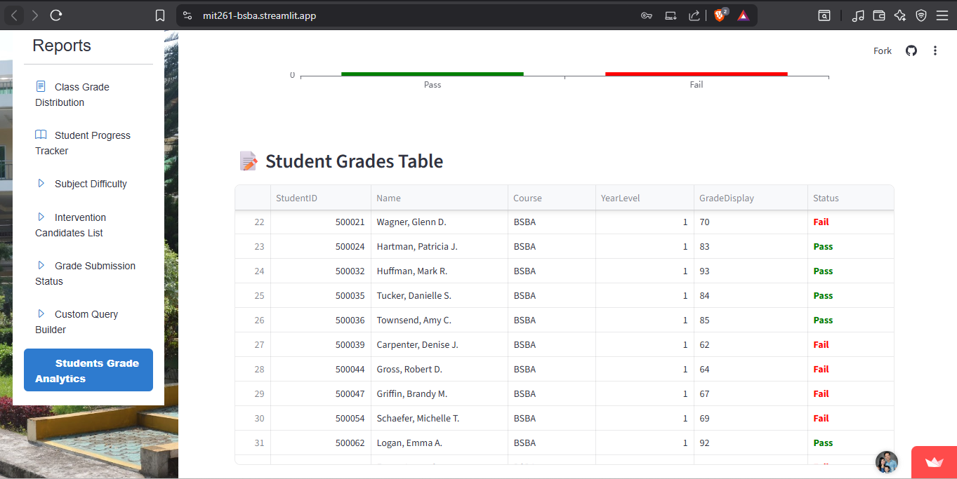

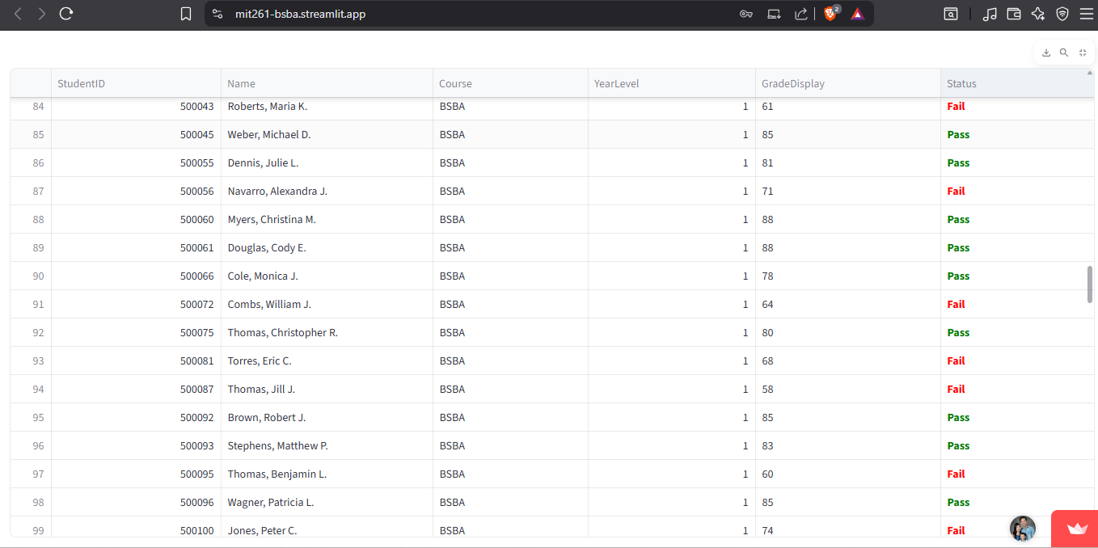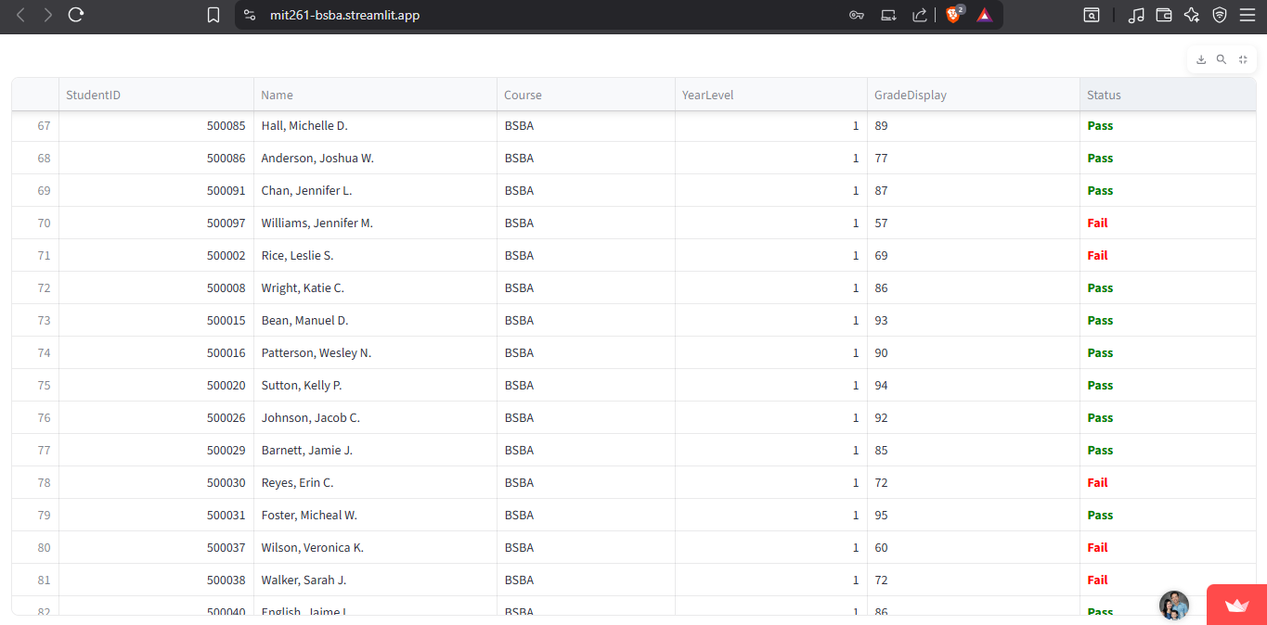

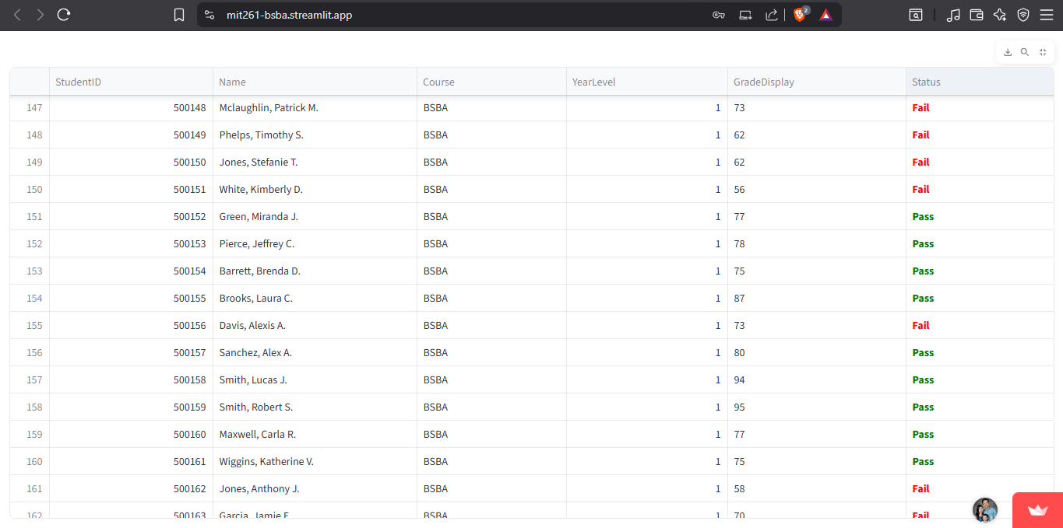

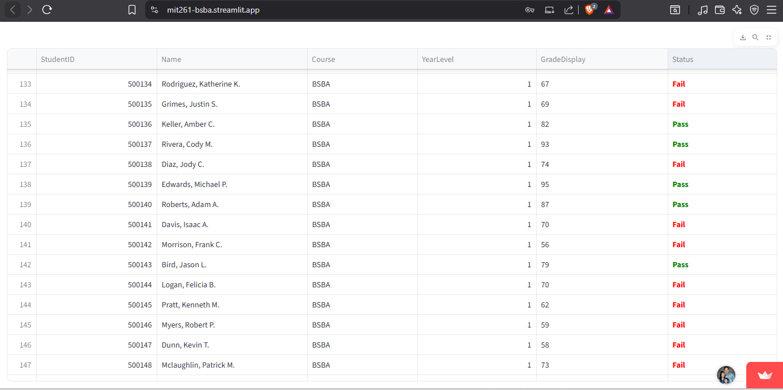

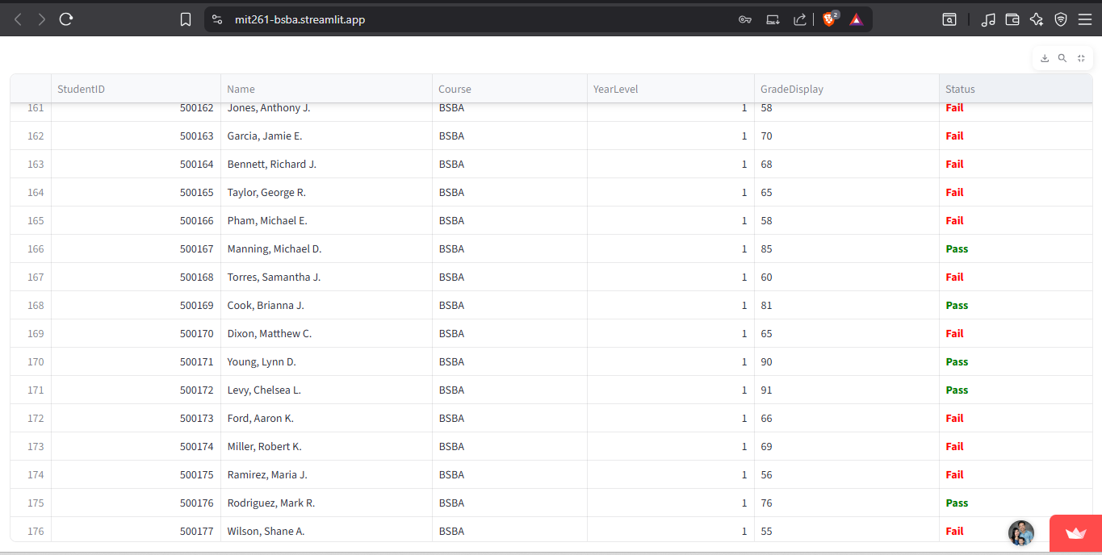

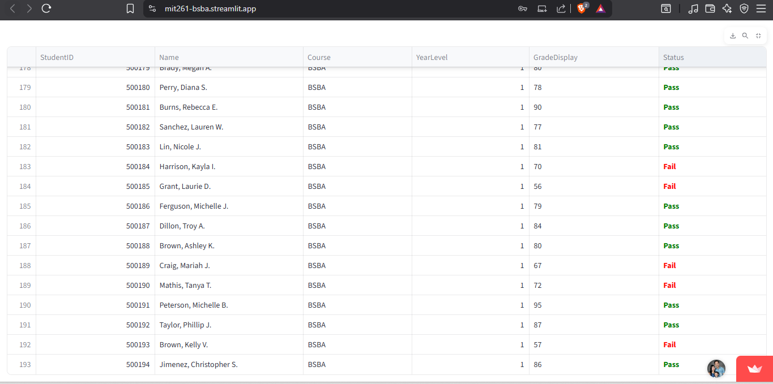

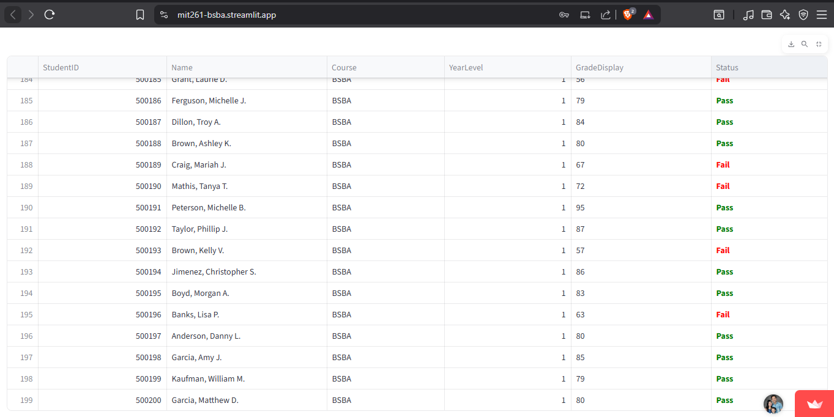

# **Students Dashboard Reports**

## **1. Academic Transcript Viewer**

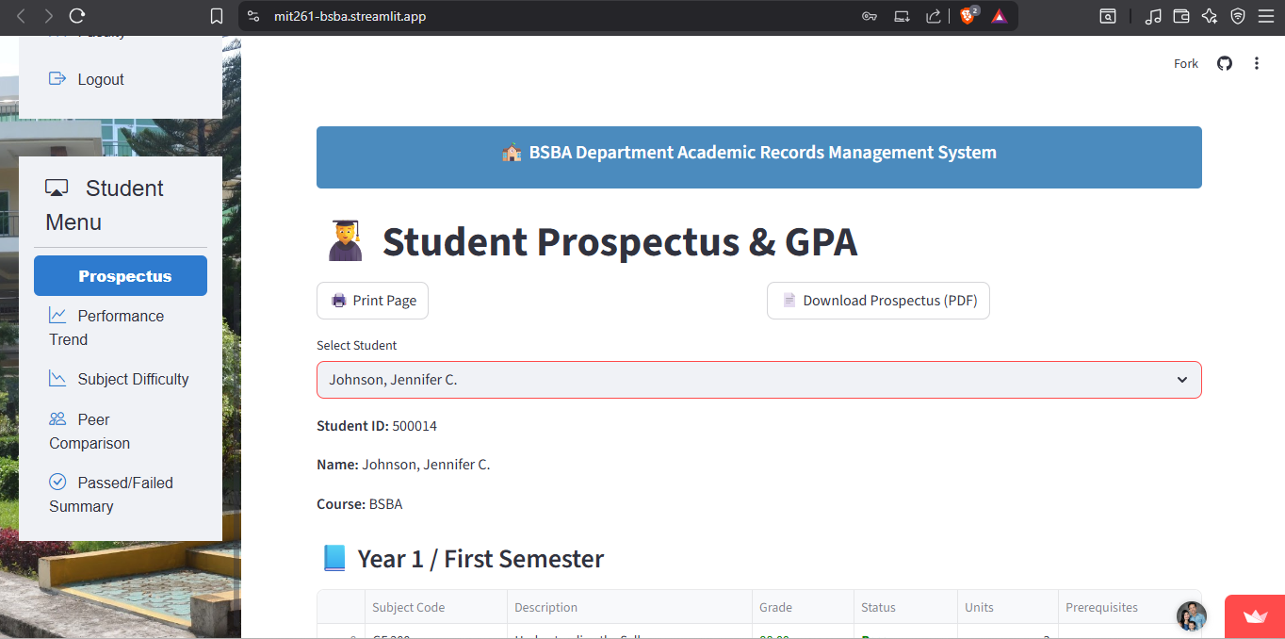

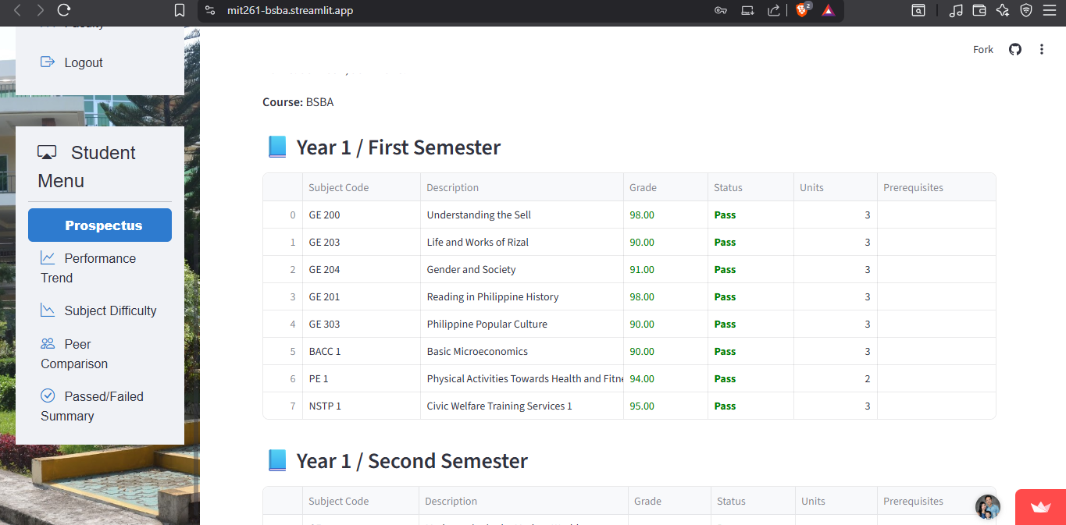

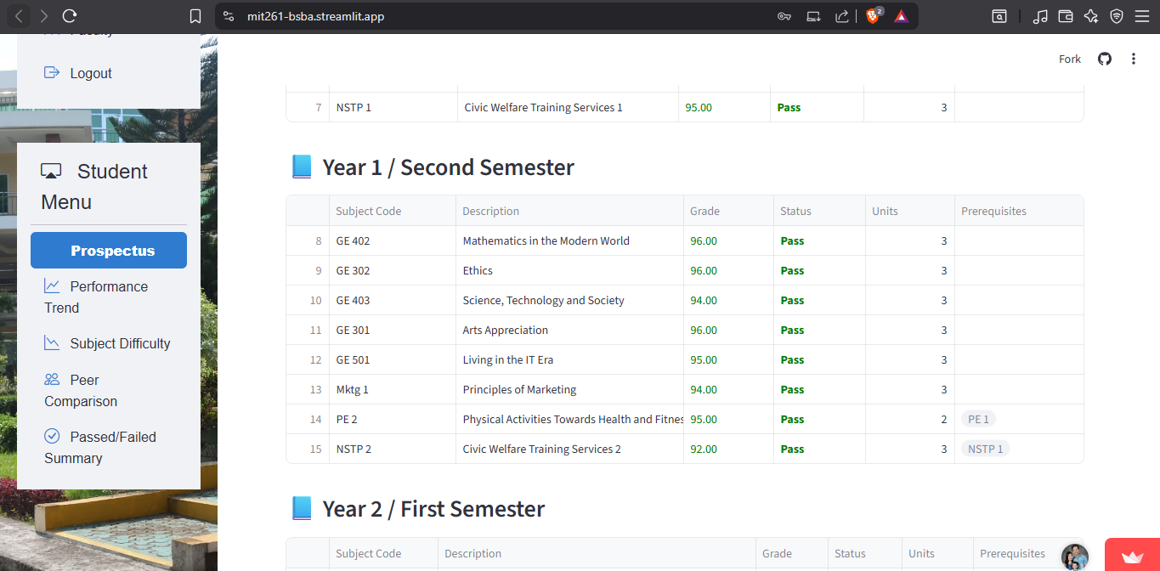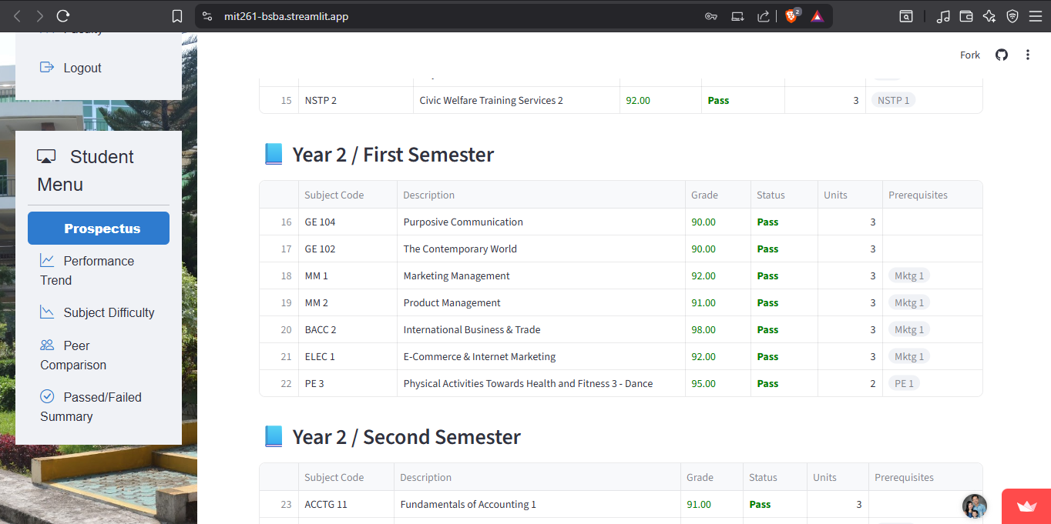

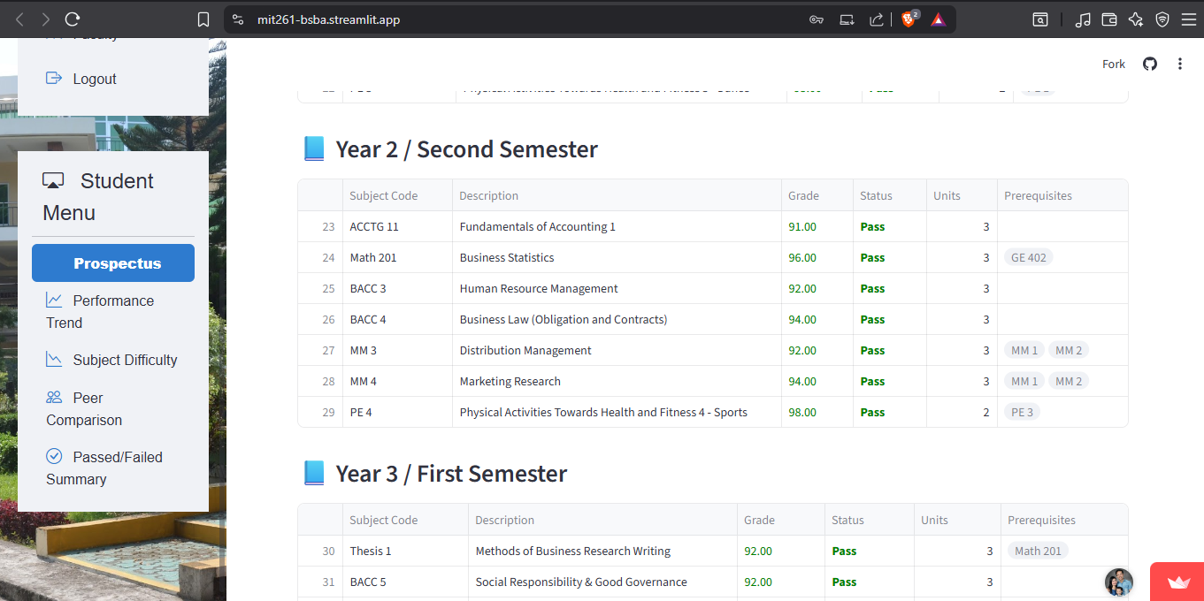

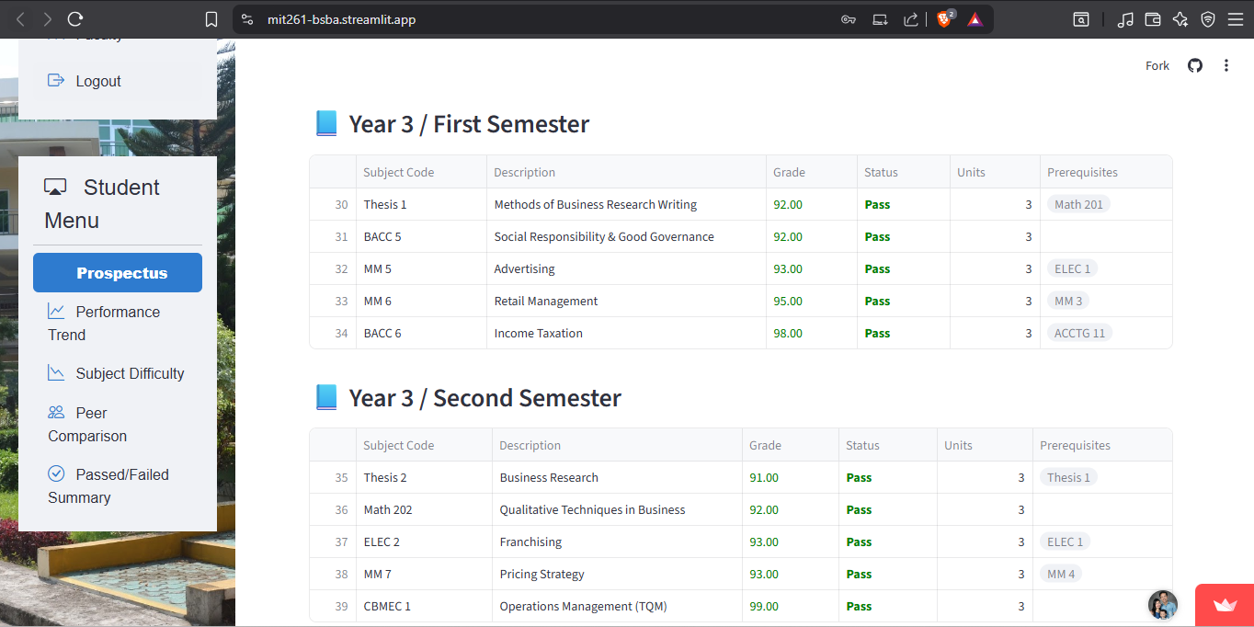

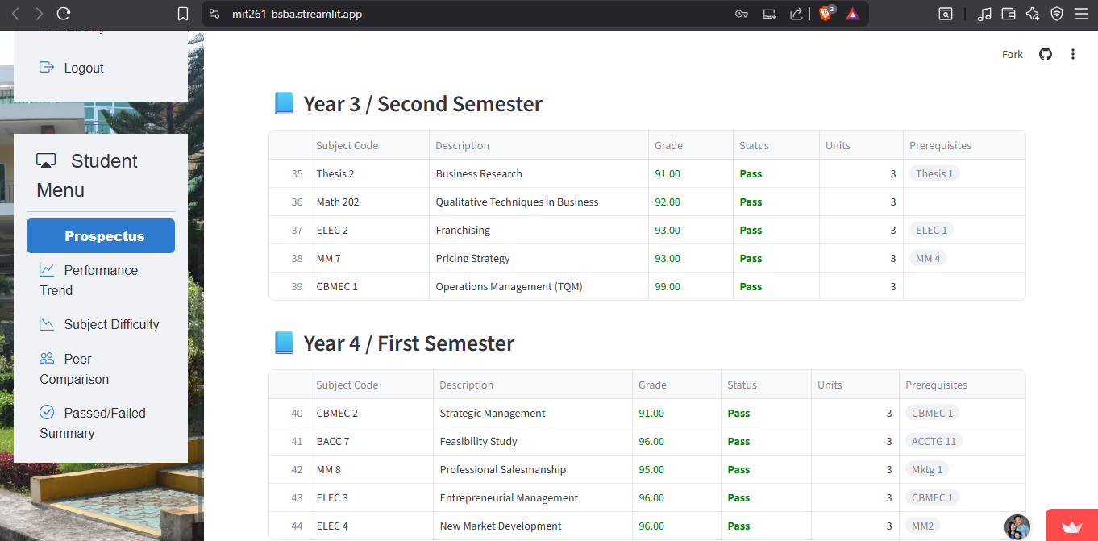

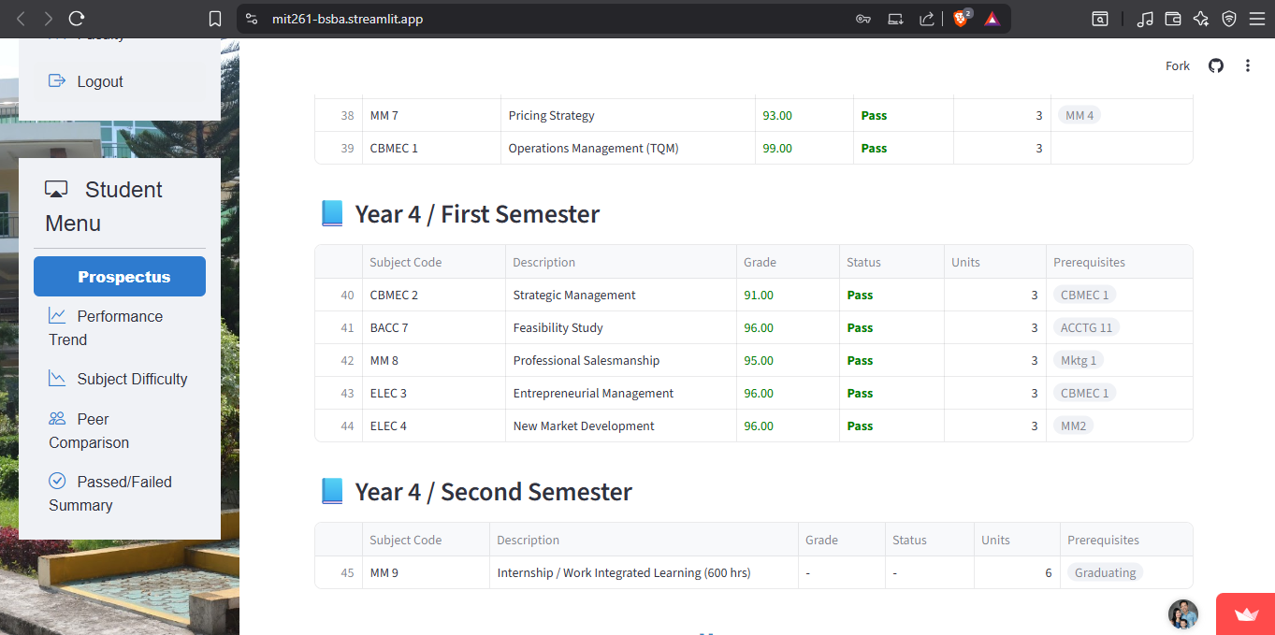

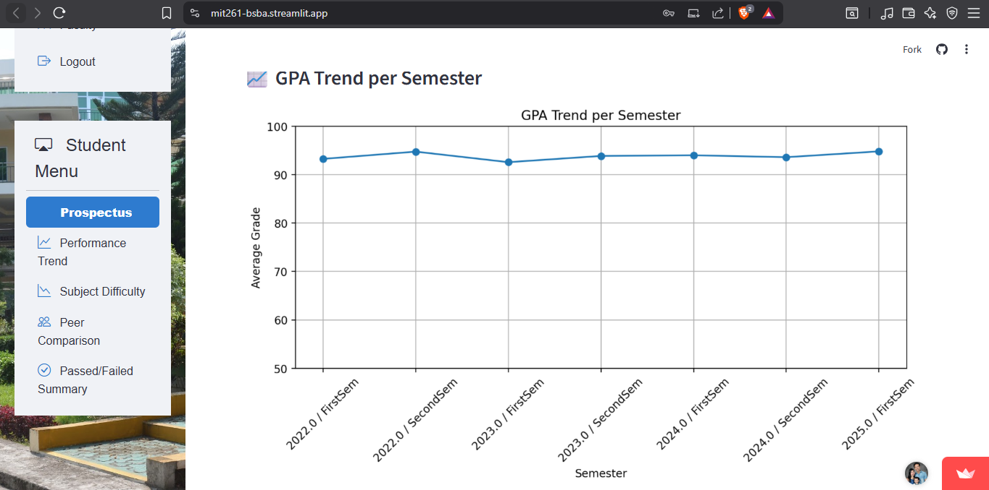

## **2. Performance Trend Over Time**

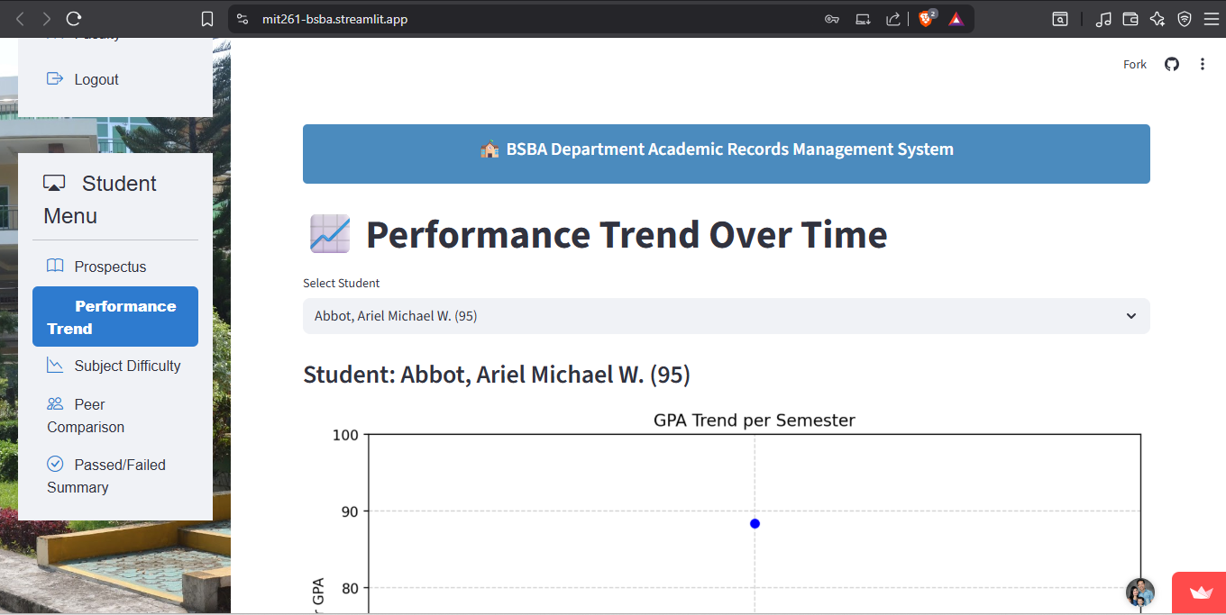

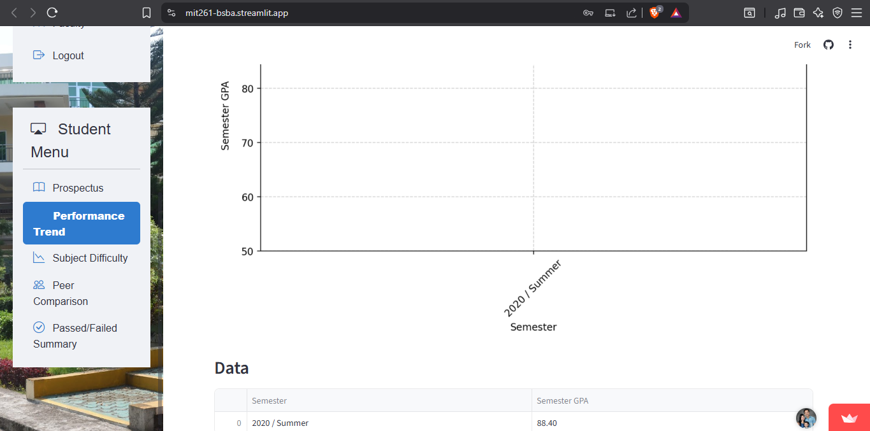

**Description:** Represents GPA progression across semesters, ideal for a line chart visual.

## **3. Subject Difficulty Ratings**

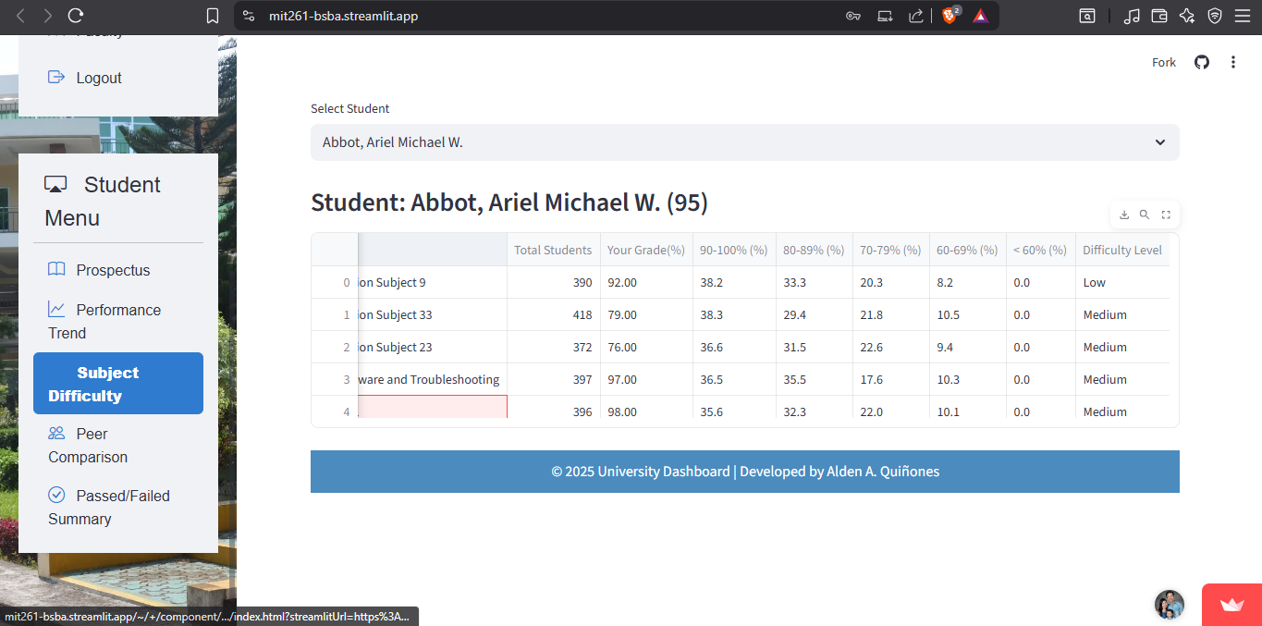

## **4. Comparison with Class Average**

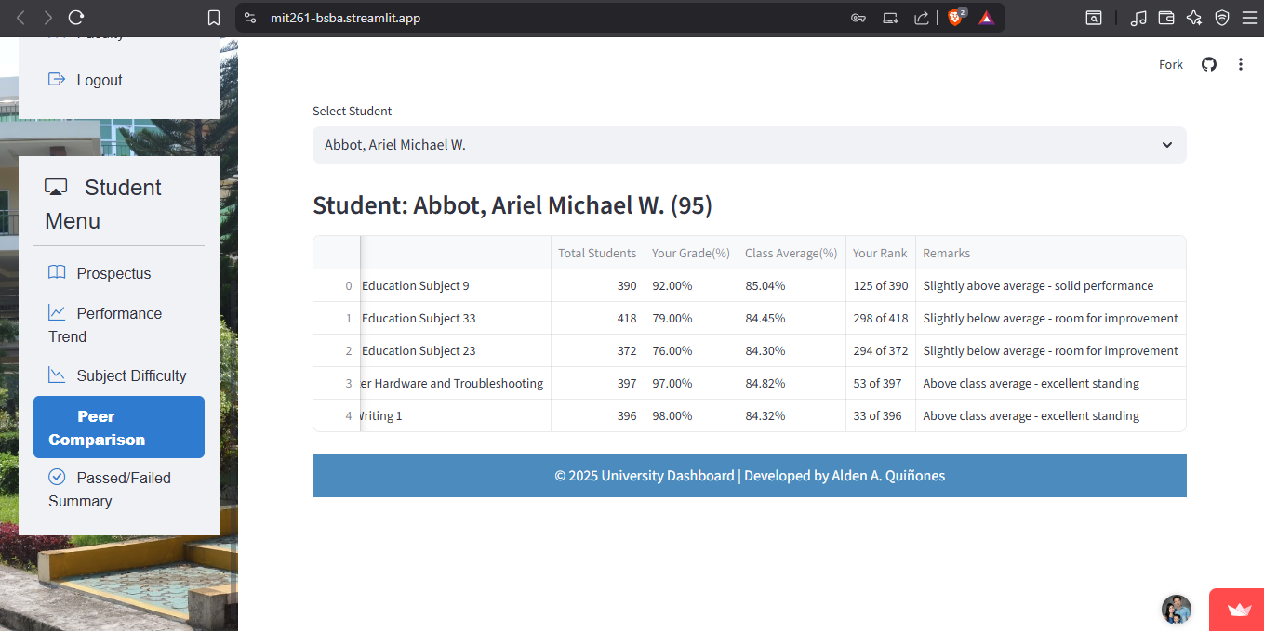

**Description:** Highlights how the student’s performance stacks up against peers.

## **5. Passed vs Failed Summary**

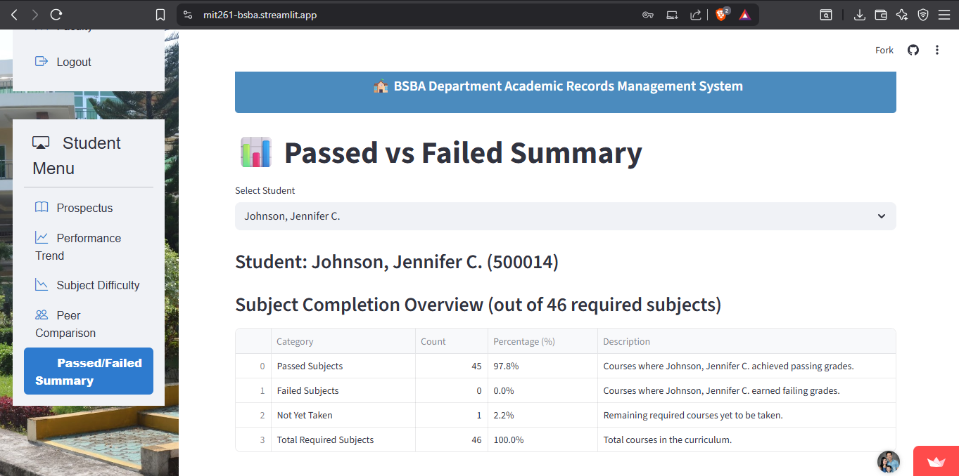

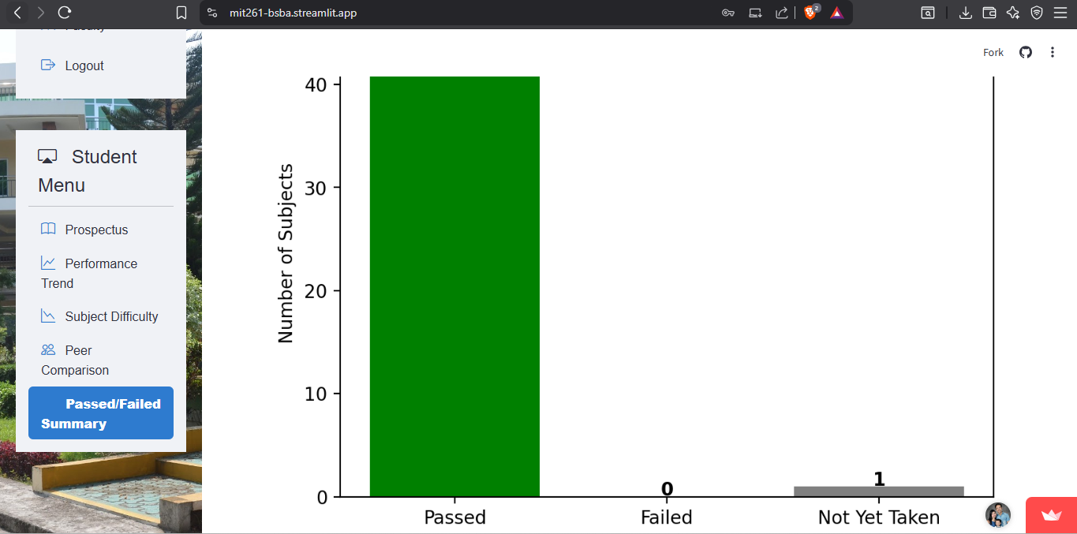

**Description:** A simple summary of academic outcomes—ideal for pie or bar chart depiction.

## **6.Curriculum and Subject Viewer**

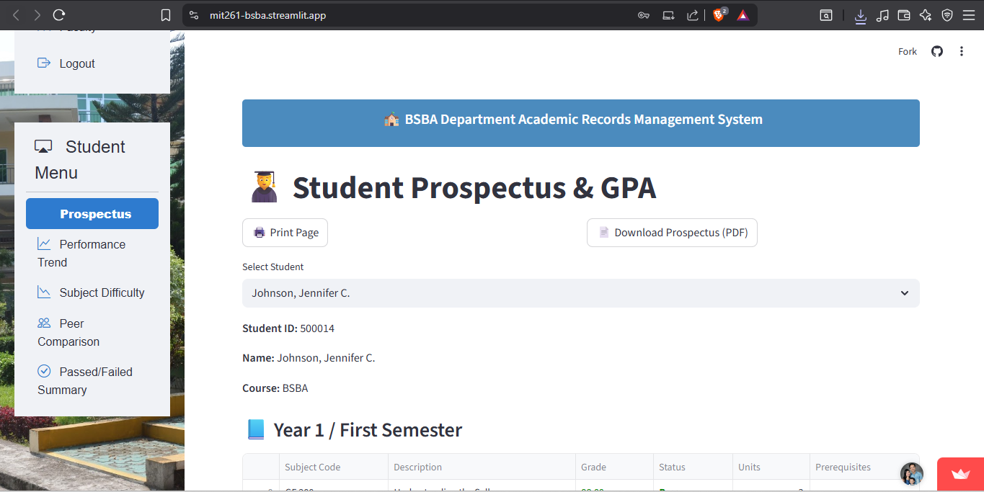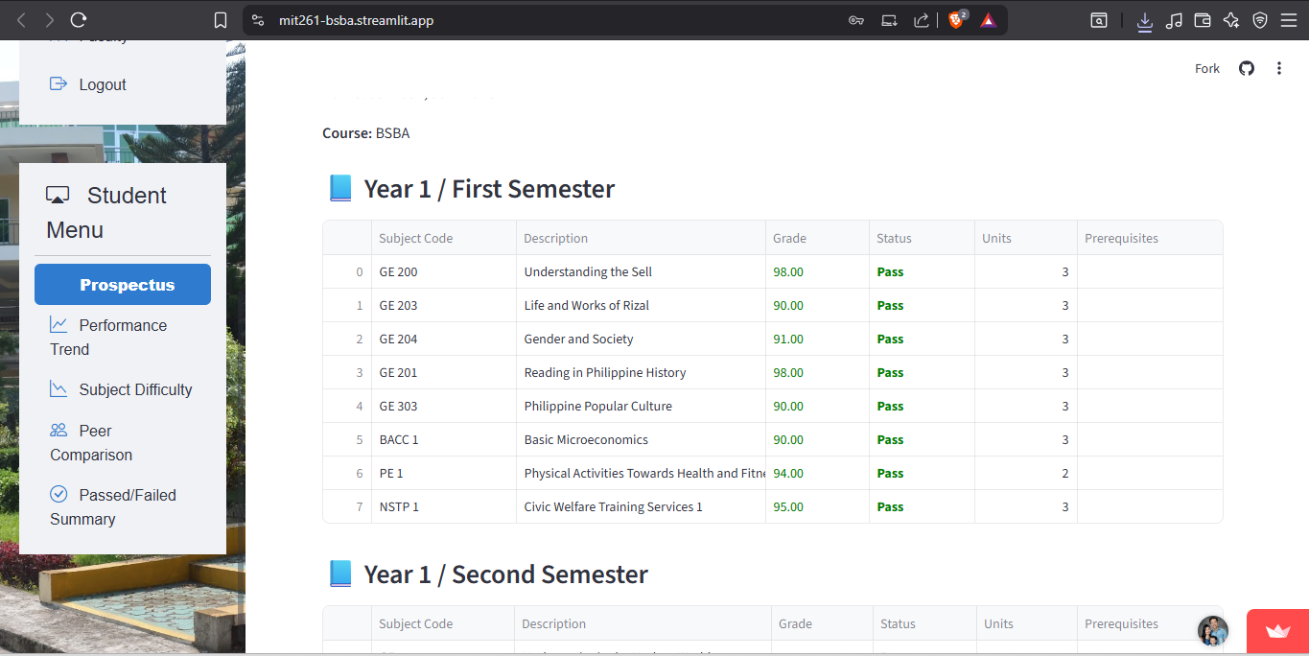

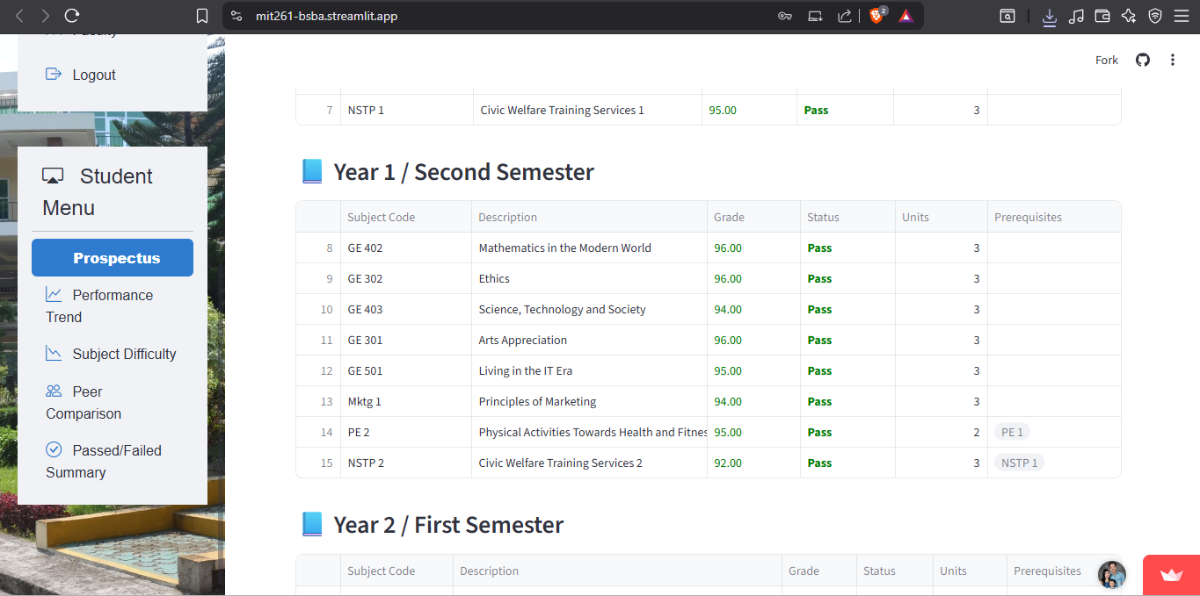

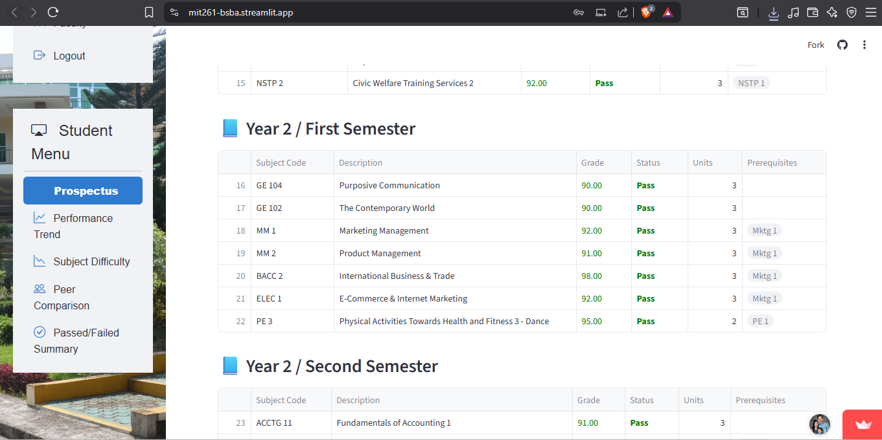

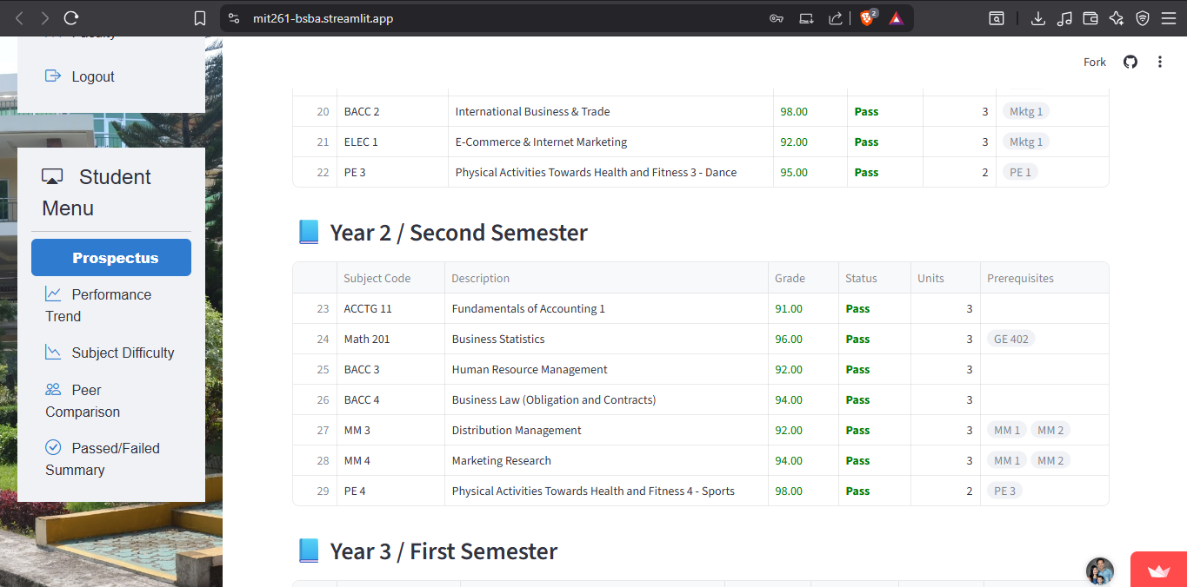

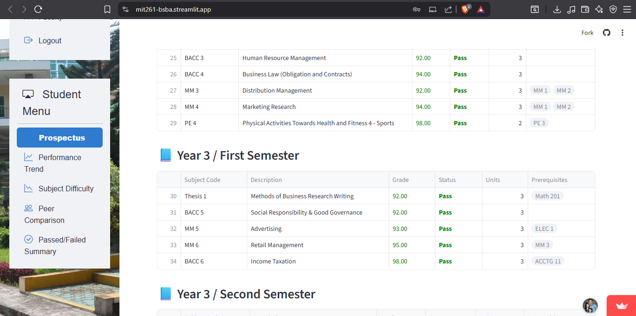

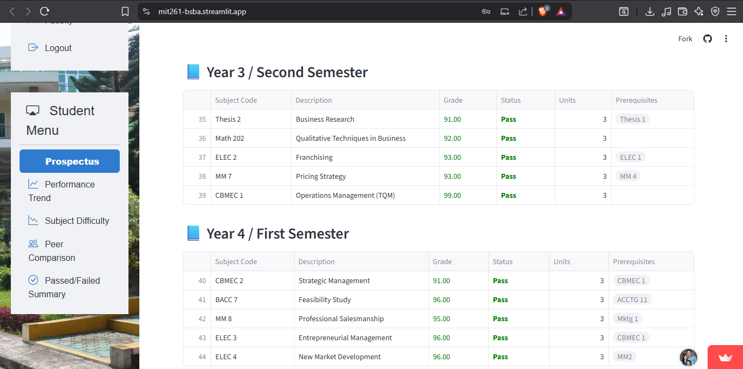

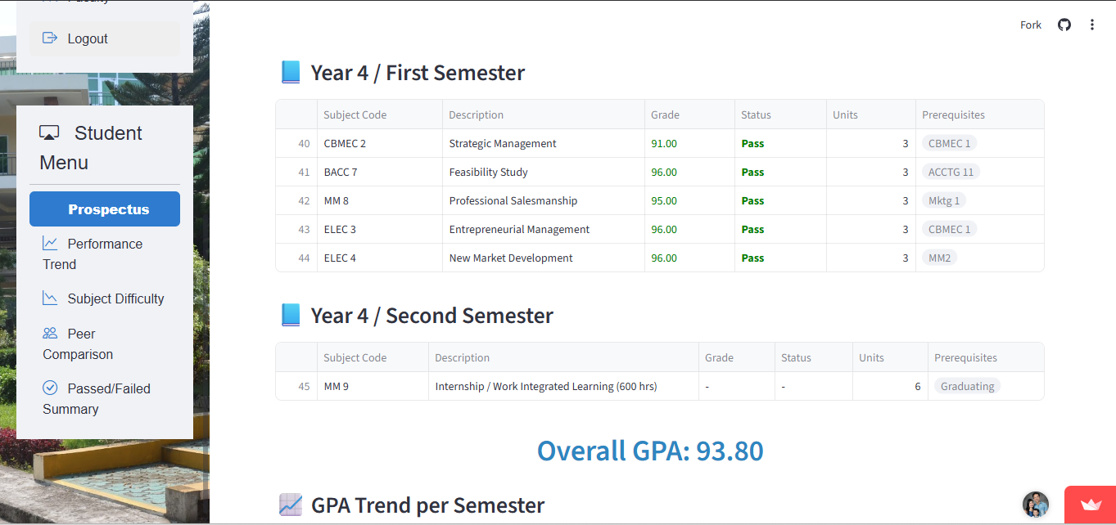

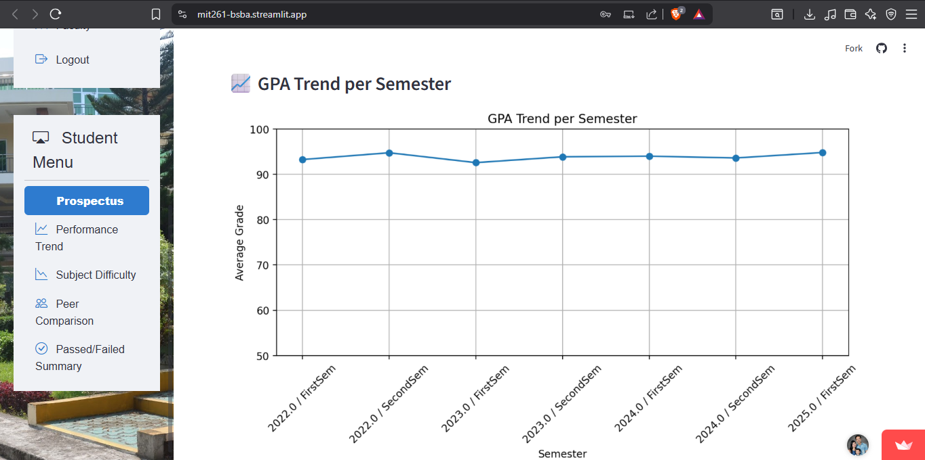

# 

# **Source code for each dashboard and reports**

# **Registrar’s Office Dashboard Reports**

## **1. Student Academic Standing Report**

1. **Dean’s List (Top 10 Students)**

| **# -------------------------------**  **# A. Dean's List**  **# -------------------------------**  **st.markdown("### A. Dean's List (:rainbow[Top 10 Students])")**  **st.markdown("**Criteria:** No grade < 85% & GPA >= 90%")**  **with st.spinner(f"Preparing data for student academic Stand Reporting - Dean's List.", show_time=True):**  **df_deans = r.get_deans_list(course=course_filter, year_level=year_level_filter) # fetch data**  **option_deans = None # ensure variable always exists**  **if df_deans.empty:**  **st.info("No Dean’s List entries found for the chosen semester/year. "**  **"This means no students met the GPA and grade requirements with the applied filters.")**  **else:**  **# Display table**  **st.dataframe(df_deans, width="stretch")**  **# Chart data**  **names_deans = df_deans["Name"].tolist()**  **gpas_deans = df_deans["GPA"].tolist()**  **option_deans = {**  **"tooltip": {"trigger": "axis", "axisPointer": {"type": "shadow"}},**  **"xAxis": {"type": "value", "name": "GPA", "min": 90},**  **"yAxis": {"type": "category", "data": names_deans[::-1]},**  **"series": [**  **{**  **"name": "GPA",**  **"type": "bar",**  **"data": gpas_deans[::-1],**  **"label": {"show": True, "position": "right", "formatter": "{c}"},**  **"itemStyle": {**  **"color": {**  **"type": "linear",**  **"x": 0, "y": 0, "x2": 1, "y2": 0,**  **"colorStops": [**  **{"offset": 0, "color": "#3b82f6"},**  **{"offset": 1, "color": "#10b981"},**  **],**  **}**  **},**  **}**  **],**  **}** |
| --- |

1. **Academic Probation**

| **# -------------------------------**  **# B. Academic Probation**  **# -------------------------------**  **st.markdown("### B. Academic Probation (10 Students)")**  **st.markdown("**Criteria:** No grade < 75 OR >= 30% FAILS")**  **with st.spinner(f"Preparing data for academic probation.", show_time=True):**  **df_probation = r.get_academic_probation_batch_checkpoint(course=course_filter, year_level=year_level_filter)**  **option_prob = None # ensure variable always exists**  **if df_probation.empty:**  **st.info("No students are under academic probation with the applied filters.")**  **else:**  **# Display table**  **st.dataframe(df_probation, width="stretch")**  **# Chart data (safe conversion)**  **required_cols = ["Name", "GPA", "Fail%"]**  **if not all(col in df_probation.columns for col in required_cols):**  **st.error(f"❌ Missing required columns: {required_cols}")**  **st.write("Available columns:", df_probation.columns.tolist())**  **else:**  **df_probation["GPA"] = pd.to_numeric(df_probation["GPA"], errors="coerce")**  **df_probation["Fail%"] = pd.to_numeric(df_probation["Fail%"], errors="coerce")**  **names_prob = df_probation["Name"].astype(str).tolist()**  **gpas_prob = df_probation["GPA"].fillna(0).tolist()**  **fails_prob = df_probation["Fail%"].fillna(0).tolist()**  **option_prob = {**  **"tooltip": {"trigger": "axis"},**  **"legend": {"data": ["GPA", "Fail%"]},**  **"xAxis": [{"type": "value", "name": "Score"}],**  **"yAxis": [{"type": "category", "data": names_prob[::-1]}],**  **"series": [**  **{**  **"name": "GPA",**  **"type": "bar",**  **"data": gpas_prob[::-1],**  **"label": {"show": True, "position": "right"},**  **"itemStyle": {"color": "#ef4444"},**  **},**  **{**  **"name": "Fail%",**  **"type": "line",**  **"data": fails_prob[::-1],**  **"label": {"show": True, "position": "top"},**  **"lineStyle": {"color": "#f59e0b", "width": 2},**  **"symbol": "circle",**  **"symbolSize": 8,**  **},**  **],**  **}** |
| --- |

## **2. Subject Pass/Fail Distribution**

## 

| **# ------------------------------**  **# 2. Subject Pass/Fail Distribution**  **# ------------------------------**  **elif report == "2. Subject Pass/Fail Distribution":**  **st.subheader("📊 Subject Pass/Fail Distribution")**    **# --- Filters ---**  **courses = r2.get_courses() + ["All"]**  **year_levels = r2.get_year_levels() + ["All"]**  **col1, col2 = st.columns(2)**  **with col1:**  **selected_course = st.selectbox("Filter by Course", courses)**  **with col2:**  **selected_year_level = st.selectbox("Filter by Year Level", year_levels)**  **# --- Apply filters ---**  **course_filter = selected_course if selected_course != "All" else None**  **year_level_filter = selected_year_level if selected_year_level != "All" else None**  **with st.spinner(f"Preparing data for {report}.", show_time = True):**  **df_subjects = r.get_subject_pass_fail(course=course_filter, year_level=year_level_filter) # columns: ['Subject Code', 'Subject Name', 'Semester', 'Pass Count', 'Fail Count', 'Pass %', 'Fail %']**  **st.dataframe(df_subjects)**  **st.markdown("""**  **\*\*Insight:\*\***  **Provides a clear picture of **subject-level performance per semester**, enabling targeted support for subjects**  **with higher failure rates. Administrators can plan remediation programs effectively.**  **""")**  **if not df_subjects.empty:**  **# Aggregate data by Subject Code and Subject Name**  **df_chart = df_subjects.groupby(['Subject Code', 'Subject Name']).agg(**  **{'Pass Count': 'sum', 'Fail Count': 'sum'}**  **).reset_index()**  **# Calculate totals and percentages (good practice)**  **df_chart['Total Count'] = df_chart['Pass Count'] + df_chart['Fail Count']**  **df_chart['Pass %'] = (df_chart['Pass Count'] / df_chart['Total Count']) * 100**  **df_chart['Fail %'] = (df_chart['Fail Count'] / df_chart['Total Count']) * 100**    **# Stacked ECharts**  **option = {**  **"tooltip": {"trigger": "axis", "axisPointer": {"type": "shadow"}},**  **"legend": {"data": ["Pass Count", "Fail Count"]}, # optional order for legend**  **"xAxis": [**  **{**  **"type": "category",**  **"data": df_chart["Subject Name"].tolist(),**  **"axisLabel": {"interval": 0, "rotate": 30},**  **}**  **],**  **"yAxis": [{"type": "value", "name": "Students"}],**  **"series": [**  **{**  **"name": "Fail Count",**  **"type": "bar",**  **"stack": "total",**  **"emphasis": {"focus": "series"},**  **"data": df_chart["Fail Count"].tolist(),**  **"itemStyle": {"color": "#ef4444"},**  **},**  **{**  **"name": "Pass Count",**  **"type": "bar",**  **"stack": "total",**  **"emphasis": {"focus": "series"},**  **"data": df_chart["Pass Count"].tolist(),**  **"itemStyle": {"color": "#3b82f6"},**  **}**  **],**  **}**  **st_echarts(options=option, height="500px")** |
| --- |

## 

## **3. Enrollment Trend Analysis**

| # ------------------------------  # 3. Enrollment Trend Analysis  # ------------------------------  elif report == "3. Enrollment Trend Analysis":  st.subheader("📈 Enrollment Trend Analysis")  # --- Filters ---  courses = r2.get_courses() + ["All"]  year_levels = r2.get_year_levels() + ["All"]  col1, col2 = st.columns(2)  with col1:  selected_course = st.selectbox("Filter by Course", courses)  with col2:  selected_year_level = st.selectbox("Filter by Year Level", year_levels)  # --- Apply filters ---  course_filter = selected_course if selected_course != "All" else None  year_level_filter = selected_year_level if selected_year_level != "All" else None  with st.spinner(f"Preparing data for {report}.", show_time = True):  df_enrollment = r.get_enrollment_trend(course=course_filter, year_level=year_level_filter) # columns: ['Semester', 'Total Enrollment', 'New Enrollees', 'Dropouts', 'Retention Rate (%)']  st.dataframe(df_enrollment)  st.markdown("""  **Insight:**  Observe semester-to-semester enrollment trends, **track retention rates**, and identify patterns of student dropouts.  Helps institutions plan resource allocation and intervention strategies.  """)  # Prepare ECharts options  option = {  "tooltip": {"trigger": "axis"},  "legend": {"data": ["Total Enrollment", "New Enrollees", "Dropouts", "Retention Rate (%)"]},  "xAxis": {"type": "category", "data": df_enrollment["Semester"].tolist()},  "yAxis": [  {"type": "value", "name": "Students"},  {"type": "value", "name": "Retention (%)", "min": 0, "max": 100}  ],  "series": [  {  "name": "Total Enrollment",  "type": "bar",  "data": df_enrollment["Total Enrollment"].tolist()  },  {  "name": "New Enrollees",  "type": "bar",  "data": df_enrollment["New Enrollees"].tolist()  },  {  "name": "Dropouts",  "type": "bar",  "data": df_enrollment["Dropouts"].tolist()  },  {  "name": "Retention Rate (%)",  "type": "line",  "yAxisIndex": 1,  "data": df_enrollment["Retention Rate (%)"].tolist()  }  ]  }  st_echarts(options=option, height="450px") |
| --- |

## 

## **4. Incomplete Grades Report**

| # ------------------------------  # 4. Incomplete Grades  # ------------------------------  elif report == "4. Incomplete Grades":  st.subheader("⚠️ Incomplete Grades Report")  # --- Filters ---  courses = r2.get_courses() + ["All"]  year_levels = r2.get_year_levels() + ["All"]  col1, col2 = st.columns(2)  with col1:  selected_course = st.selectbox("Filter by Course", courses)  with col2:  selected_year_level = st.selectbox("Filter by Year Level", year_levels)  # --- Apply filters ---  course_filter = selected_course if selected_course != "All" else None  year_level_filter = selected_year_level if selected_year_level != "All" else None  with st.spinner(f"Preparing data for {report}.", show_time = True):  df_incomplete = r.get_incomplete_grades(course=course_filter, year_level=year_level_filter) # columns: ['Student ID', 'Name', 'Course Code', 'Course Title', 'Term', 'Grade Status']  st.dataframe(df_incomplete)  st.markdown("""  **Insight:**  Enables the Registrar’s Office to follow up with **students and instructors** regarding incomplete or missing grades,  ensuring timely grade submissions.  """)  if not df_incomplete.empty:  # --- Chart ---  st.markdown("### 📊 Incomplete Grades per Course")  # Group by course and count  incomplete_counts = df_incomplete.groupby("Course Title").size().reset_index(name="Count")  incomplete_counts = incomplete_counts.sort_values("Count", ascending=False)  option = {  "tooltip": {"trigger": "axis", "axisPointer": {"type": "shadow"}},  "xAxis": {  "type": "category",  "data": incomplete_counts["Course Title"].tolist(),  "axisLabel": {"interval": 0, "rotate": 30},  },  "yAxis": {"type": "value", "name": "Number of Incomplete Grades"},  "series": [{  "name": "Incomplete Grades",  "type": "bar",  "data": incomplete_counts["Count"].tolist(),  "itemStyle": {"color": "#f59e0b"},  "label": {"show": True, "position": "top"}  }]  }  st_echarts(options=option, height="500px") |
| --- |

## **5. Retention and Dropout Rates**

| # ------------------------------  # 5. Retention and Dropout Rates  # ------------------------------  elif report == "5. Retention and Dropout Rates":  st.subheader("📊 Retention and Dropout Rates")  # --- Filters ---  courses = r2.get_courses() + ["All"]  year_levels = r2.get_year_levels() + ["All"]  col1, col2 = st.columns(2)  with col1:  selected_course = st.selectbox("Filter by Course", courses)  with col2:  selected_year_level = st.selectbox("Filter by Year Level", year_levels)  # --- Apply filters ---  course_filter = selected_course if selected_course != "All" else None  year_level_filter = selected_year_level if selected_year_level != "All" else None  with st.spinner(f"Preparing data for {report}.", show_time = True):  df_retention = r.get_retention_rates(course=course_filter, year_level=year_level_filter) # columns: ['Semester to Semester', 'Retained', 'Dropped Out', 'Retention Rate (%)']  print('df_retention2:',df_retention)  st.dataframe(df_retention)  st.markdown("""  **Insight:**  Measures **student persistence** across semesters and identifies retention issues early,  providing actionable data for academic planning and intervention programs.  """)  if not df_retention.empty:  # --- Chart ---  st.markdown("### 📊 Retention vs. Dropout")  option = {  "tooltip": {"trigger": "axis"},  "legend": {"data": ["Retained", "Dropped Out", "Retention Rate (%)"]},  "xAxis": {  "type": "category",  "data": df_retention["Semester"].tolist(),  "axisLabel": {"interval": 0, "rotate": 30},  },  "yAxis": [  {"type": "value", "name": "Number of Students"},  {"type": "value", "name": "Rate (%)", "min": 0, "max": 100}  ],  "series": [  {  "name": "Retained",  "type": "bar",  "data": df_retention["Retained"].tolist(),  "itemStyle": {"color": "#10b981"}  },  {  "name": "Dropped Out",  "type": "bar",  "data": df_retention["Dropped Out"].tolist(),  "itemStyle": {"color": "#ef4444"}  },  {  "name": "Retention Rate (%)",  "type": "line",  "yAxisIndex": 1,  "data": df_retention["Retention Rate (%)"].tolist(),  "itemStyle": {"color": "#3b82f6"}  }  ]  }  st_echarts(options=option, height="500px") |
| --- |

## 

## **6. Top Performers per Program**

| # ------------------------------  # 6. Top Performers per Program  # ------------------------------  elif report == "6. Top Performers per Program":  st.subheader("🏆 Top Performers per Program")    # --- Filters ---  courses = r2.get_courses() + ["All"]  year_levels = r2.get_year_levels() + ["All"]  col1, col2 = st.columns(2)  with col1:  selected_course = st.selectbox("Filter by Course", courses)  with col2:  selected_year_level = st.selectbox("Filter by Year Level", year_levels)  # --- Apply filters ---  course_filter = selected_course if selected_course != "All" else None  year_level_filter = selected_year_level if selected_year_level != "All" else None  with st.spinner(f"Preparing data for {report}.", show_time = True):  df_top = r.get_top_performers(course=course_filter, year_level=year_level_filter) # columns: ['Program', 'Semester', 'Student ID', 'Student Name', 'GPA', 'Rank']    st.dataframe(df_top)  st.markdown("""  **Insight:**  Highlights **high-achieving students** in each program. Useful for **recognition, awards, and program benchmarking**.  """)  if not df_top.empty:  # --- Chart ---  st.markdown("### 📊 Top 5 Performers by GPA per Program")  # Filter for top 5 in each program  df_top_5 = df_top[df_top['Rank'] <= 5]  # Create a chart for each program  programs = df_top_5['Program'].unique()  for program in programs:  st.markdown(f"#### {program}")  program_data = df_top_5[df_top_5['Program'] == program]  option = {  "tooltip": {"trigger": "axis", "axisPointer": {"type": "shadow"}},  "xAxis": {  "type": "category",  "data": program_data["Student Name"].tolist(),  "axisLabel": {"interval": 0, "rotate": 30},  },  "yAxis": {"type": "value", "name": "GPA", "min": 85},  "series": [{  "name": "GPA",  "type": "bar",  "data": program_data["GPA"].tolist(),  "label": {"show": True, "position": "top"},  "itemStyle": {  "color": {  "type": "linear", "x": 0, "y": 0, "x2": 0, "y2": 1,  "colorStops": [  {"offset": 0, "color": "#10b981"},  {"offset": 1, "color": "#3b82f6"}  ]  }  }  }]  }  st_echarts(options=option, height="400px", key=f"top_performers_{program}") |
| --- |

## 

## **7. Curriculum Progress and Advising**

| # ------------------------------  # 7. Curriculum Progress Viewer  # ------------------------------  elif report == "7. Curriculum Progress Viewer":  st.subheader("📚 Curriculum Progress Viewer")  # --- Step 1: Select Course ---  courses = sorted(db.students.distinct("Course"))  selected_course = st.selectbox("Select Course:", courses)  # --- Step 2: Search Student by Name ---  search_name = st.text_input("Search Student by Name (wildcard):")  search_trigger = st.button("Search Student")  if search_trigger:  if search_name.strip():  with st.spinner("Searching please wait...",show_time=True):  results = r2.student_find(search_name, db.students, course=selected_course)  if results:  st.session_state.search_results = results  else:  st.warning("No student found.")  st.session_state.search_results = []  else:  st.warning("Please enter a name to search.")  st.session_state.search_results = []  # --- Step 3: Show search results as inline rows with select buttons ---  if "search_results" in st.session_state and st.session_state.search_results:  st.subheader("Search Results")  for student in st.session_state.search_results:  col1, col2 = st.columns([5, 1])  col1.write(f"{student['Name']} | {student.get('Course','')} | Year Level: {student.get('YearLevel','')}")  if col2.button("Select", key=f"select_{student['_id']}"):  st.session_state.selected_student = student  st.session_state.search_results = [] # clear search results  st.rerun() # reload page to show curriculum  # --- Step 4: Display Curriculum if a student is selected ---  if (  "selected_student" in st.session_state  and st.session_state.selected_student  and search_trigger is False # only show after explicit selection, not auto-load  ):  student = st.session_state.selected_student  st.markdown(f"""  <div style="border:2px solid #1E90FF; padding:10px; border-radius:5px; background-color:#E6F0FF">  <strong>Name:</strong> {student['Name']}<br>  <strong>Student ID:</strong> {student['_id']}<br>  <strong>Course:</strong> {student['Course']}<br>  <strong>Year Level:</strong> {student.get('YearLevel', '')}<br>  </div>  """, unsafe_allow_html=True)  with st.spinner(f"Loading curriculum for {student['Course']}..."):  df_curriculum = r.get_curriculum_progress(program=student['Course'])  if not df_curriculum.empty:  df_curriculum = df_curriculum.sort_values(["Year", "Semester", "Subject Code"])  years = df_curriculum['Year'].unique()  for year in years:  with st.expander(f"🎓 Year: {year}", expanded=True):  year_data = df_curriculum[df_curriculum['Year'] == year]  semesters = year_data['Semester'].unique()  for semester in semesters:  with st.expander(f"📚 Semester: {semester}", expanded=True):  sem_data = year_data[year_data['Semester'] == semester]  sem_display = sem_data[[  "Subject Code", "Subject Description", "Lec Hours",  "Lab Hours", "Units", "Prerequisites"  ]]  st.dataframe(sem_display, width="stretch")  total_units = sem_data["Units"].sum()  st.markdown(f"**Total Units:** {total_units}")  # --- Chart for Curriculum ---  st.markdown("### 📊 Curriculum Workload Distribution")  # Group by Year and Semester to sum units  workload = df_curriculum.groupby(['Year', 'Semester'])['Units'].sum().reset_index()  workload['Term'] = workload['Year'].astype(str) + ' - ' + workload['Semester'].astype(str)  option = {  "tooltip": {"trigger": "axis", "axisPointer": {"type": "shadow"}},  "xAxis": {  "type": "category",  "data": workload["Term"].tolist(),  "name": "Term"  },  "yAxis": {"type": "value", "name": "Total Units"},  "series": [{  "name": "Total Units",  "type": "bar",  "data": workload["Units"].tolist(),  "label": {"show": True, "position": "top"},  "itemStyle": {"color": "#8369CF"}  }]  }  st_echarts(options=option, height="400px")  semester_dict = get_semesters(r2.db) # returns {_id: "Semester SchoolYear"}  semester_options = [""] + list(semester_dict.values())    selected_semester_predict = st.selectbox(  "Select Semester for Prediction:",  semester_options  )  if selected_semester_predict != "":  # Get Curriculum & Grades  curriculum_df = r2.get_curriculum(selected_course)  student_grades_df = r2.get_student_subjects_grades(student.get("_id"))  # st.dataframe(curriculum_df)  # st.dataframe(student_grades_df)  if not curriculum_df.empty:  passed_subjects = []  if not student_grades_df.empty:  passed_subjects = student_grades_df[student_grades_df["Grade"] >= 75]["Subject Code"].tolist()  curriculum_df.columns = curriculum_df.columns.str.strip()  taken_subjects = []  if not student_grades_df.empty and "Subject Code" in student_grades_df.columns:  taken_subjects = student_grades_df["Subject Code"].tolist()  print('A =====================================')  selected_semester, selected_year = selected_semester_predict.replace("Sem", "").lower().split()  potential_subjects = curriculum_df[  (curriculum_df["semester"].str.lower() == selected_semester)  & (curriculum_df["year"] == student.get("YearLevel"))  & (~curriculum_df["Subject Code"].isin(taken_subjects))  ].copy()  print('selected_semester_predict:',selected_semester_predict.replace("Sem", "").lower())  print('YearLevel:',student.get("YearLevel"))  print('taken_subjects:',taken_subjects)  available_subjects, blocked_subjects = [], []  print('B =====================================')  print('potential_subjects:',potential_subjects)  for _, row in potential_subjects.iterrows():  print('available_subjects:',available_subjects)  prerequisites = row.get("preRequisites", [])  if not prerequisites or all(prereq in passed_subjects for prereq in prerequisites):  available_subjects.append(row)  else:  blocked_subjects.append(row)  available_subjects_df = pd.DataFrame(available_subjects)  blocked_subjects_df = pd.DataFrame(blocked_subjects)  st.markdown(f"#### ✅ Recommended Subjects for {selected_semester_predict}")  if not available_subjects_df.empty:  st.dataframe(available_subjects_df[["Subject Code", "Description", "unit"]])  else:  st.info("No subjects available for enrollment.")  st.markdown(f"#### 🚫 Blocked Subjects for {selected_semester_predict}")  if not blocked_subjects_df.empty:  st.dataframe(blocked_subjects_df[["Subject Code", "Description", "unit", "preRequisites"]])  else:  st.info("No blocked subjects for this semester.")  else:  st.warning("No curriculum found for this course.") |
| --- |

# 

# **Faculty Dashboard Reports**

## **1. Class Grade Distribution**

| **def class_grade_distribution(db):**  **user_role = st.session_state.get("user_role", "")**  **if user_role == "teacher":**  **teacher_name = st.session_state.get("fullname", "")**  **teacher_names = [teacher_name]**  **else:**  **teacher_names = get_teachers(db)**  **teacher_name = None**  **# with col1:**  **if user_role != "teacher":**  **teacher_name = st.selectbox("Select Faculty", [""] + list(teacher_names))**  **else:**  **st.markdown(f"👩‍🏫 Faculty: **{teacher_name}**")**  **# with col2:**  **semester_dict = get_semesters(db, teacher=teacher_name)**  **semester_options = [""] + list(semester_dict.values())**  **selected_sem_year = st.selectbox("Select Semester & Year", semester_options)**  **# --- Generate report button ---**  **if st.button("Generate Report"):**  **if not teacher_name:**  **st.warning("Please select a faculty member to view the report.")**  **return**  **if not selected_sem_year:**  **st.warning("Please select a semester & year.")**  **return**  **# Reverse lookup semester ID**  **semester_id = next((k for k, v in semester_dict.items() if v == selected_sem_year), None)**  **if not semester_id:**  **st.warning("Selected semester and school year combination not found.")**  **return**  **st.markdown("### 📊 Class Grade Distribution")**  **st.markdown(f"**Faculty Name:** `{teacher_name}`")**  **st.markdown(f"**Semester and School Year:** `{selected_sem_year}`")**  **# Subjects taught by teacher**  **teacher_subjects_cursor = db.subjects.find({"Teacher": teacher_name})**  **teacher_subject_codes = [s["_id"] for s in teacher_subjects_cursor]**  **if not teacher_subject_codes:**  **st.warning(f"No subjects found for teacher: {teacher_name}")**  **return**  **grades_cursor = db.grades.find({**  **"Grades": {"$ne": []},**  **"SemesterID": semester_id**  **})**  **report_data = []**  **subject_details = {**  **s["_id"]: s["Description"]**  **for s in db.subjects.find({"_id": {"$in": teacher_subject_codes}})**  **}**  **for code, name in subject_details.items():**  **report_data.append({**  **"Course Code": code,**  **"Course Name": name,**  **"95-100(%)": 0,**  **"90-94 (%)": 0,**  **"85-89 (%)": 0,**  **"80-84(%)": 0,**  **"75-79%": 0,**  **"Below 75(%)": 0,**  **"student_count": 0,**  **})**  **# Process grades**  **for grade_entry in grades_cursor:**  **for i, subject_code in enumerate(grade_entry.get("SubjectCodes", [])):**  **if subject_code in teacher_subject_codes:**  **report_row = next(**  **(item for item in report_data if item["Course Code"] == subject_code), None**  **)**  **if report_row:**  **grade = grade_entry.get("Grades", [])[i]**  **report_row["student_count"] += 1**  **if grade >= 95:**  **report_row["95-100(%)"] += 1**  **elif 90 <= grade <= 94:**  **report_row["90-94 (%)"] += 1**  **elif 85 <= grade <= 89:**  **report_row["85-89 (%)"] += 1**  **elif 80 <= grade <= 84:**  **report_row["80-84(%)"] += 1**  **elif 75 <= grade <= 79:**  **report_row["75-79%"] += 1**  **else:**  **report_row["Below 75(%)"] += 1**  **if not any(row['student_count'] > 0 for row in report_data):**  **st.info("No student grade data found for the selected faculty and term.")**  **return**  **# Build DataFrame**  **df = pd.DataFrame(report_data)**  **df = df[df['student_count'] > 0].copy()**  **grade_cols = ["95-100(%)", "90-94 (%)", "85-89 (%)", "80-84(%)", "75-79%", "Below 75(%)"]**  **for col in grade_cols:**  **df[col] = (df[col] / df['student_count'] * 100).round(2).astype(str) + '%'**  **st.dataframe(df[["Course Code", "Course Name"] + grade_cols])**  **# Histogram**  **st.markdown("---")**  **st.markdown("### Grade Distribution Histograms")**  **for _, row in df.iterrows():**  **st.markdown(f"#### {row['Course Name']} ({row['Course Code']})")**  **plot_values = [float(str(row[col]).replace('%', '')) for col in grade_cols]**  **plot_labels = [col.replace('(%)', '').replace('%', '').strip() for col in grade_cols]**  **fig, ax = plt.subplots()**  **ax.bar(plot_labels, plot_values)**  **ax.set_ylabel("Percentage of Students (%)")**  **ax.set_title(f"Grade Distribution for {row['Course Code']}")**  **plt.xticks(rotation=45, ha="right")**  **st.pyplot(fig)** |
| --- |

## **2. Student Progress Tracker**

| **def student_progress_tracker_page(db):**  **"""**  **Displays the Student Progress Tracker report page.**  **"""**  **st.markdown("### 📈 Student Progress Tracker")**  **st.markdown("Shows longitudinal performance for individual students.")**  **# --- Determine teacher list based on user role ---**  **user_role = st.session_state.get("user_role", "")**  **if user_role == "registrar":**  **teacher_list = get_teachers(db)**  **elif user_role == "teacher":**  **teacher_list = [st.session_state.get("fullname", "")]**  **else:**  **teacher_list = []**  **if not teacher_list:**  **st.warning("Faculty name is required.")**  **return**  **# --- Teacher selectbox ---**  **teacher_name = st.selectbox("Select Teacher", teacher_list)**  **# --- Load data ---**  **with st.spinner("Loading teacher's handled Subjects...", show_time=True):**  **year_levels = get_year_levels(db)**  **courses = get_courses(db)**  **subjects_df = get_subjects_by_teacher(db, teacher_name)**  **if not courses or not year_levels or subjects_df.empty:**  **st.warning("⚠️ Missing data in one or more collections.")**  **return**  **# --- Prepare subject list ---**  **if "Subject Code" in subjects_df.columns:**  **subject_list = [""] + subjects_df["Subject Code"].tolist()**  **elif "Code" in subjects_df.columns: # fallback**  **subject_list = [""] + subjects_df["Code"].tolist()**  **else:**  **subject_list = []**  **st.warning("⚠️ No subject code column found in subjects_df.")**  **# --- Filters ---**  **with st.container():**  **col1, col2, col3 = st.columns(3)**  **with col1:**  **selected_course = st.selectbox("Filter by Course", courses)**  **with col2:**  **selected_year_level = st.selectbox("Filter by Year Level", year_levels)**  **with col3:**  **selected_subject = st.selectbox("Filter by Subject", subject_list)**  **# --- Generate report ---**  **if st.button("Generate Report"):**  **with st.spinner("Fetching student progress data...", show_time=True):**  **progress_data = get_student_progress_data(**  **db, selected_course, selected_year_level, selected_subject**  **)**  **if progress_data.empty:**  **st.warning("No data found for the selected filters.")**  **return**  **# --- Display DataFrame ---**  **st.markdown("### Student GPA Progress")**  **def style_trend(val):**  **color_map = {**  **"Improving": "color: green",**  **"Need Attention": "color: red",**  **"Stable High": "color: blue",**  **"Consistently Low": "color: orange",**  **"Stable": "color: black",**  **"N/A": "color: grey"**  **}**  **return color_map.get(val, "")**  **display_df = progress_data.fillna('-')**  **st.dataframe(display_df.style.applymap(style_trend, subset=['Overall Trend']))**  **# --- Visualizations ---**  **progress_data = progress_data.drop(columns=['StudentID']).fillna(0)**  **gpa_cols = progress_data.select_dtypes(include='number').columns.tolist()**  **avg_per_semester = progress_data[gpa_cols].mean().tolist()**  **st.markdown("#### Average GPA Trend per Semester")**  **line_options = {**  **"tooltip": {"trigger": "axis"},**  **"xAxis": {"type": "category", "data": gpa_cols, "name": "Semester"},**  **"yAxis": {"type": "value", "name": "Average GPA"},**  **"series": [{**  **"name": "Average GPA",**  **"type": "line",**  **"data": avg_per_semester,**  **"smooth": True,**  **}],**  **}**  **st_echarts(options=line_options, height="400px")**  **# Scatter chart**  **st.markdown("#### GPA Progress - Scatter Chart")**  **progress_data["GeneralAverage"] = progress_data[gpa_cols].mean(axis=1)**  **all_values = progress_data[gpa_cols + ["GeneralAverage"]].values.flatten()**  **min_val, max_val = 50, float(pd.Series(all_values).max())**  **scatter_options = {**  **"tooltip": {"trigger": "item", "formatter": "{b}: {c}"},**  **"legend": {"data": gpa_cols},**  **"xAxis": {"type": "value", "name": "General Average GPA", "min": min_val, "max": max_val},**  **"yAxis": {"type": "value", "name": "Semester GPA", "min": min_val, "max": max_val},**  **"series": []**  **}**  **for col in gpa_cols:**  **scatter_options["series"].append({**  **"name": col,**  **"type": "scatter",**  **"data": [**  **{"value": [row["GeneralAverage"], row[col]], "name": row["Name"]}**  **for _, row in progress_data.iterrows() if pd.notnull(row[col])**  **],**  **"symbolSize": 12,**  **})**  **st_echarts(options=scatter_options, height="500px")**  **def get_student_progress_data(db, course, year_level, subject_code):**  **"""**  **Fetches and processes data to generate the student progress report.**  **"""**  **import pandas as pd**  **students_df = pd.DataFrame(list(db.students.find()))**  **grades_df = pd.DataFrame(list(db.grades.find()))**  **subjects_df = pd.DataFrame(list(db.subjects.find()))**  **semesters_df = pd.DataFrame(list(db.semesters.find()))**  **if grades_df.empty or subjects_df.empty or students_df.empty or semesters_df.empty:**  **print("⚠️ One of the collections is empty.")**  **return pd.DataFrame()**  **students_df = students_df.rename(columns={'_id': 'StudentID'})**  **subjects_df = subjects_df.rename(columns={'_id': 'SubjectCode'})**  **semesters_df = semesters_df.rename(columns={'_id': 'SemesterID'})**  **# filter students**  **if course:**  **students_df = students_df[students_df['Course'] == course]**  **if year_level:**  **students_df = students_df[students_df['YearLevel'] == year_level]**  **# explode grades**  **if isinstance(grades_df.get("SubjectCodes").iloc[0], list):**  **grades_exploded = grades_df.explode(['SubjectCodes', 'Grades', 'Teachers'])**  **else:**  **grades_exploded = grades_df.copy()**  **grades_exploded = grades_exploded.rename(columns={'SubjectCodes': 'SubjectCode'})**  **# filter subject**  **if subject_code:**  **students_who_took_subject = grades_exploded[grades_exploded['SubjectCode'] == subject_code]['StudentID'].unique()**  **students_df = students_df[students_df['StudentID'].isin(students_who_took_subject)]**  **# merge grades with subjects**  **grades_with_units = pd.merge(grades_exploded, subjects_df[['SubjectCode', 'Units']], on='SubjectCode', how="left")**  **grades_with_units['GradePoints'] = grades_with_units['Grades'] * grades_with_units['Units']**  **gpa_df = grades_with_units.groupby(['StudentID', 'SemesterID']).apply(**  **lambda x: pd.Series({'GPA': x['GradePoints'].sum() / x['Units'].sum() if x['Units'].sum() else None})**  **).reset_index()**  **# pivot**  **gpa_pivot = gpa_df.pivot(index='StudentID', columns='SemesterID', values='GPA').reset_index()**  **semester_map = semesters_df.set_index('SemesterID')[['Semester', 'SchoolYear']].to_dict('index')**  **new_columns = {sem_id: f"{sem_info['Semester']} {sem_info['SchoolYear']}" for sem_id, sem_info in semester_map.items()}**  **gpa_pivot = gpa_pivot.rename(columns=new_columns)**  **# order columns by SchoolYear and Semester**  **semester_rank = {'Spring': 1, 'Summer': 2, 'Fall': 3} # adjust if you have other semesters**  **semester_order = semesters_df.copy()**  **semester_order['semester_num'] = semester_order['Semester'].map(semester_rank)**  **semester_order = semester_order.sort_values(['SchoolYear', 'semester_num'])**  **gpa_cols_ordered = [new_columns[sem_id] for sem_id in semester_order['SemesterID'] if new_columns[sem_id] in gpa_pivot.columns]**  **# keep only semester columns where average GPA > 0**  **non_zero_semesters = [c for c in gpa_cols_ordered if gpa_pivot[c].dropna().mean() > 0]**  **# final pivot columns**  **gpa_pivot = gpa_pivot[['StudentID'] + non_zero_semesters]**  **# merge student info**  **final_df = pd.merge(students_df[['StudentID', 'Name']], gpa_pivot, on='StudentID', how='inner')**  **# redefine gpa_cols for trend calculation**  **gpa_cols = non_zero_semesters**  **# calculate trend**  **def calculate_trend(row):**  **gpas = row[gpa_cols].dropna().values**  **if len(gpas) < 2:**  **return "N/A"**  **avg_gpa = sum(gpas) / len(gpas)**  **if all(gpa > 3.5 for gpa in gpas):**  **return "Stable High"**  **if all(gpa < 2.5 for gpa in gpas):**  **return "Consistently Low"**  **if gpas[-1] > gpas[0] and gpas[-1] > avg_gpa:**  **return "Improving"**  **if gpas[-1] < gpas[0] and gpas[-1] < avg_gpa:**  **return "Need Attention"**  **return "Stable"**  **final_df['Overall Trend'] = final_df.apply(calculate_trend, axis=1)**  **return final_df** |
| --- |

## **3. Subject Difficulty Heatmap**

| **def subject_difficulty_page(db):**  **st.markdown("### 📊 Subject Difficulty Report")**  **st.markdown("Visualizes subjects with high failure or dropout rates handled by the faculty.")**  **# teacher from session (or allow manual input for testing)**  **teacher_name = st.session_state.get("fullname", "")**  **if not teacher_name:**  **teacher_name = st.text_input("Teacher full name (for testing)", value="")**  **if not teacher_name:**  **st.warning("Please set `st.session_state['fullname']` or enter a name for testing.")**  **return**  **# load collections**  **with st.spinner("Loading data...", show_time=True):**  **semesters_list = list(db.semesters.find())**  **subjects_df = get_subjects_by_teacher(db, teacher_name)**  **grades_list = list(db.grades.find())**  **# student info map (for possible future drilldowns)**  **students_list = list(db.students.find())**  **# semesters -> DataFrame + map**  **if not semesters_list:**  **st.warning("No semester data found.")**  **return**  **semesters_df = pd.DataFrame(semesters_list)**  **if "_id" in semesters_df.columns:**  **semesters_df = semesters_df.rename(columns={"_id": "SemesterID"})**  **for c in ["SemesterID", "Semester", "SchoolYear"]:**  **if c not in semesters_df.columns:**  **semesters_df[c] = ""**  **# normalize strings**  **semesters_df["SemesterID"] = semesters_df["SemesterID"].astype(str)**  **semesters_df["Semester"] = semesters_df["Semester"].astype(str)**  **semesters_df["SchoolYear"] = semesters_df["SchoolYear"].astype(str)**  **semester_labels = (semesters_df["Semester"] + " " + semesters_df["SchoolYear"]).tolist()**  **# map label -> list of semester ids (some systems may have duplicates)**  **semester_map = {}**  **for sid, label in zip(semesters_df["SemesterID"].tolist(), semester_labels):**  **semester_map.setdefault(label, []).append(str(sid))**  **semester_options = ["All Semesters"] + list(semester_map.keys())**  **selected_semester_label = st.selectbox("📅 Select Semester", semester_options)**  **# build set of semester ids to include**  **if selected_semester_label == "All Semesters":**  **selected_semester_ids = set(semesters_df["SemesterID"].astype(str).tolist())**  **else:**  **selected_semester_ids = set(semester_map.get(selected_semester_label, []))**  **if not selected_semester_ids:**  **st.info("No semester IDs resolved for selection.")**  **return**  **# ensure we have the teacher's subject codes list**  **if subjects_df.empty:**  **st.info("You have no subjects assigned.")**  **return**  **subj_codes_handled = set(subjects_df["Subject Code"].astype(str).tolist())**  **subj_desc_map = dict(zip(subjects_df["Subject Code"].astype(str), subjects_df["Description"].astype(str)))**  **# build students map for possible lookup**  **students_map = {str(s.get("_id")): s for s in students_list}**  **# Flatten grades list by zipping parallel arrays — robust and lossless**  **flat_rows = []**  **for gdoc in grades_list:**  **sid = gdoc.get("StudentID")**  **sid_s = str(sid) if sid is not None else ""**  **sem_raw = gdoc.get("SemesterID", "")**  **sem_s = str(sem_raw)**  **# if this grade doc's semester is not in the selected set -> skip early**  **if sem_s not in selected_semester_ids:**  **continue**  **subject_codes = gdoc.get("SubjectCodes", []) or []**  **grades = gdoc.get("Grades", []) or []**  **teachers = gdoc.get("Teachers", []) or []**  **status = gdoc.get("Status", []) or []**  **# iterate indices, use zip_longest so we won't lose mis-sized arrays (use None for missing)**  **for subj, grd, tchr, stat in zip_longest(subject_codes, grades, teachers, status, fillvalue=None):**  **subj_s = str(subj).strip() if subj is not None else ""**  **tchr_s = str(tchr).strip() if tchr is not None else ""**  **# only include entries for this teacher (ensures teacher filter works)**  **if tchr_s != teacher_name:**  **continue**  **# only consider subjects that the teacher handles (extra guard)**  **if subj_s not in subj_codes_handled:**  **continue**  **# coerce grade to numeric if possible, else None**  **try:**  **grd_num = float(grd) if grd is not None and str(grd).strip() != "" else None**  **except Exception:**  **grd_num = None**  **flat_rows.append({**  **"StudentID": sid_s,**  **"SemesterID": sem_s,**  **"SubjectCode": subj_s,**  **"Grade": grd_num,**  **"Status": str(stat) if stat is not None else "",**  **"Teacher": tchr_s**  **})**  **# if no rows found after applying teacher+semester filters**  **if not flat_rows:**  **st.info("No grade rows found for this teacher in the selected semester(s).")**  **return**  **flat_df = pd.DataFrame(flat_rows)**  **# helper counters**  **def count_fails(df_slice, passing_threshold=75):**  **if df_slice.empty:**  **return 0**  **# prefer explicit Status column if it uses e.g. 'Failed'**  **if df_slice["Status"].astype(str).str.contains("fail", case=False, na=False).any():**  **return df_slice[df_slice["Status"].astype(str).str.contains("fail", case=False, na=False)]["StudentID"].nunique()**  **# else use numeric Grades (< passing threshold)**  **if "Grade" in df_slice.columns:**  **mask = pd.to_numeric(df_slice["Grade"], errors="coerce") < passing_threshold**  **return df_slice[mask]["StudentID"].nunique()**  **return 0**  **def count_dropouts(df_slice):**  **if df_slice.empty:**  **return 0**  **if df_slice["Status"].astype(str).str.contains("drop", case=False, na=False).any():**  **return df_slice[df_slice["Status"].astype(str).str.contains("drop", case=False, na=False)]["StudentID"].nunique()**  **# fallback: missing grade might indicate dropout (best-effort)**  **if "Grade" in df_slice.columns:**  **return df_slice[df_slice["Grade"].isna()]["StudentID"].nunique()**  **return 0**  **# Build summary per subject the teacher handles (even if no rows for some subjects)**  **rows = []**  **for subj_code in sorted(subj_codes_handled):**  **subj_rows = flat_df[flat_df["SubjectCode"].astype(str) == subj_code]**  **total_students = subj_rows["StudentID"].nunique() if not subj_rows.empty else 0**  **fails = count_fails(subj_rows)**  **dropouts = count_dropouts(subj_rows)**  **fail_rate = round((fails / total_students) * 100, 2) if total_students else 0.0**  **dropout_rate = round((dropouts / total_students) * 100, 2) if total_students else 0.0**  **if fail_rate >= 20 or dropout_rate >= 10:**  **difficulty = "High"**  **elif fail_rate >= 10 or dropout_rate >= 5:**  **difficulty = "Medium"**  **else:**  **difficulty = "Low"**  **rows.append({**  **"Course Code": subj_code,**  **"Course Name": subj_desc_map.get(subj_code, ""),**  **"Fail Rate (%)": fail_rate,**  **"Dropout Rate (%)": dropout_rate,**  **"Difficulty Level": difficulty,**  **"Total": total_students**  **})**  **summary_df = pd.DataFrame(rows)**  **# show table**  **display_cols = ["Course Code", "Course Name", "Fail Rate (%)", "Dropout Rate (%)", "Difficulty Level", "Total"]**  **st.markdown("### 📋 Subject Difficulty Table")**  **st.dataframe(summary_df[display_cols].sort_values(by=["Fail Rate (%)", "Dropout Rate (%)"], ascending=False).reset_index(drop=True))**  **# build heatmap data in the shape [xName, yName, value] (ECharts accepts category names)**  **subject_codes = summary_df["Course Code"].tolist()**  **y_categories = ["Fail Rate (%)", "Dropout Rate (%)"]**  **heatmap_data = []**  **for _, r in summary_df.iterrows():**  **heatmap_data.append([r["Course Code"], "Fail Rate (%)", float(r["Fail Rate (%)"])])**  **heatmap_data.append([r["Course Code"], "Dropout Rate (%)", float(r["Dropout Rate (%)"])])**  **heatmap_options = {**  **"tooltip": {**  **# no python % formatting here, plain JS string**  **"formatter": """function (params) {**  **// params.value = [xName, yName, value] when using category names**  **var subj = params.value[0] || params.name || '';**  **var metric = params.value[1] || '';**  **var value = params.value[2] || 0;**  **return params.marker + subj + '<br/>' + metric + ': ' + value + '%';**  **}"""**  **},**  **"grid": {"height": "60%", "top": "10%"},**  **"xAxis": {"type": "category", "data": subject_codes, "axisLabel": {"rotate": 45, "interval": 0}},**  **"yAxis": {"type": "category", "data": y_categories},**  **"visualMap": {"min": 0, "max": 100, "calculable": True, "orient": "horizontal", "left": "center", "bottom": "0"},**  **"series": [{**  **"name": "Subject Difficulty",**  **"type": "heatmap",**  **"data": heatmap_data,**  **"label": {"show": True},**  **"emphasis": {"itemStyle": {"shadowBlur": 10, "shadowColor": "rgba(0,0,0,0.5)"}}**  **}]**  **}**  **st.markdown("### 🔥 Subject Difficulty Heatmap")**  **st_echarts(options=heatmap_options, height="480px")**  **# CSV download**  **csv = summary_df[display_cols].to_csv(index=False).encode("utf-8")**  **safe_label = selected_semester_label.replace(" ", "_")**  **st.download_button("Download CSV", data=csv, file_name=f"subject_difficulty_{teacher_name}_{safe_label}.csv", mime="text/csv")** |
| --- |

## **4. Intervention Candidates List**

## 

| **def intervention_candidates_page(db):**  **"""📋 Lists students at academic risk (low or missing grades)."""**  **st.markdown("### 🚨 Intervention Candidates List")**  **st.markdown("Students flagged due to **low grades (<60)** or **missing grades (INC)**.")**  **# --- Determine teacher list based on user role ---**  **user_role = st.session_state.get("user_role", "")**  **if user_role == "registrar":**  **# Registrar sees all teachers**  **teacher_list = get_teachers(db)**  **elif user_role == "teacher":**  **# Teacher sees only themselves**  **teacher_list = [st.session_state.get("fullname", "")]**  **else:**  **teacher_list = []**  **if not teacher_list:**  **st.warning("Faculty name is required.")**  **return**  **# --- Teacher selectbox ---**  **teacher_name = st.selectbox("Select Teacher", teacher_list)**  **# --- Load collections ---**  **with st.spinner("Loading data..."):**  **students_df = pd.DataFrame(list(db.students.find()))**  **grades_list = list(db.grades.find())**  **semesters_df = pd.DataFrame(list(db.semesters.find()))**  **subjects_df = get_subjects_by_teacher(db, teacher_name)**  **if students_df.empty or not grades_list or semesters_df.empty or subjects_df.empty:**  **st.warning("⚠️ Missing data in one or more collections.")**  **return**  **# --- Semester Filter ---**  **semesters_df = semesters_df.rename(columns={"_id": "SemesterID"})**  **semesters_df["SemesterID"] = semesters_df["SemesterID"].astype(str)**  **semesters_df["Label"] = semesters_df["Semester"].astype(str) + " " + semesters_df["SchoolYear"].astype(str)**  **semester_map = dict(zip(semesters_df["SemesterID"], semesters_df["Label"]))**  **semester_options = ["All Semesters"] + list(semester_map.values())**  **selected_sem = st.selectbox("📅 Select Semester", semester_options)**  **if selected_sem == "All Semesters":**  **selected_ids = set(semesters_df["SemesterID"])**  **else:**  **selected_ids = {k for k, v in semester_map.items() if v == selected_sem}**  **# --- Normalize ---**  **students_df = students_df.rename(columns={"_id": "StudentID"})**  **students_df["StudentID"] = students_df["StudentID"].astype(str)**  **subj_map = dict(zip(subjects_df["SubjectCode"], subjects_df["Description"]))**  **# --- Flatten grades ---**  **flat_rows = []**  **for gdoc in grades_list:**  **sem = str(gdoc.get("SemesterID", ""))**  **if sem not in selected_ids:**  **continue**  **sid = str(gdoc.get("StudentID", ""))**  **for subj, grd, tchr in zip_longest(**  **gdoc.get("SubjectCodes", []),**  **gdoc.get("Grades", []),**  **gdoc.get("Teachers", []),**  **fillvalue=None**  **):**  **if tchr != teacher_name:**  **continue**  **subj_s = str(subj) if subj else ""**  **grade_val = None**  **risk_flag = ""**  **# Treat 0 or empty as INC**  **if grd is None or str(grd).strip() == "" or float(grd) == 0:**  **grade_val, risk_flag = "INC", "Missing Grades"**  **else:**  **try:**  **grade_val = float(grd)**  **if grade_val < 60:**  **risk_flag = "At Risk (<60)"**  **except:**  **grade_val, risk_flag = "INC", "Missing Grades"**  **if risk_flag:**  **flat_rows.append({**  **"StudentID": sid,**  **"SubjectCode": subj_s,**  **"Grade": grade_val,**  **"RiskFlag": risk_flag**  **})**  **if not flat_rows:**  **st.info("✅ No at-risk students found for the selected semester(s).")**  **return**  **flat_df = pd.DataFrame(flat_rows)**  **# --- Merge with student + subject info ---**  **final_df = pd.merge(flat_df, students_df[["StudentID", "Name"]], on="StudentID", how="left")**  **final_df["SubjectName"] = final_df["SubjectCode"].map(subj_map)**  **display_df = final_df[["StudentID", "Name", "SubjectCode", "SubjectName", "Grade", "RiskFlag"]]**  **# --- Show table ---**  **st.dataframe(display_df)**  **# --- Export CSV ---**  **csv = display_df.to_csv(index=False).encode("utf-8")**  **sem_label = selected_sem.replace(" ", "_")**  **st.download_button(**  **label="⬇️ Download CSV",**  **data=csv,**  **file_name=f"intervention_candidates_{teacher_name}_{sem_label}.csv",**  **mime="text/csv"**  **)** |
| --- |

## 

## **5. Grade Submission Status**

## 

| **def grade_submission_status_page(db):**  **st.markdown("### 📊 Grade Submission Status")**  **st.markdown("Tracks whether faculty have completely submitted grades for their classes.")**  **# --- Determine teacher list based on user role ---**  **user_role = st.session_state.get("user_role", "")**  **if user_role == "registrar":**  **# Registrar sees all teachers**  **teacher_list = get_teachers(db)**  **elif user_role == "teacher":**  **# Teacher sees only themselves**  **teacher_list = [st.session_state.get("fullname", "")]**  **else:**  **teacher_list = []**  **if not teacher_list:**  **st.warning("Faculty name is required.")**  **return**  **# --- Teacher selectbox ---**  **teacher_name = st.selectbox("Select Teacher", teacher_list)**  **if st.button("Search", key="search_btn"):**  **# --- Load collections ---**  **with st.spinner("Loading data..."):**  **students_df = pd.DataFrame(list(db.students.find()))**  **grades_list = list(db.grades.find())**  **semesters_df = pd.DataFrame(list(db.semesters.find()))**  **subjects_df = pd.DataFrame(list(db.subjects.find({"Teacher": teacher_name})))**  **if students_df.empty or not grades_list or semesters_df.empty or subjects_df.empty:**  **st.warning("⚠️ Missing data in one or more collections.")**  **return**  **# --- Semester Filter ---**  **semesters_df = semesters_df.rename(columns={"_id": "SemesterID"})**  **semesters_df["SemesterID"] = semesters_df["SemesterID"].astype(str)**  **semesters_df["Label"] = semesters_df["Semester"].astype(str) + " " + semesters_df["SchoolYear"].astype(str)**  **semester_map = dict(zip(semesters_df["SemesterID"], semesters_df["Label"]))**  **semester_options = ["All Semesters"] + list(semester_map.values())**  **selected_sem = st.selectbox("📅 Select Semester", semester_options)**  **if selected_sem == "All Semesters":**  **selected_ids = set(semesters_df["SemesterID"])**  **else:**  **selected_ids = {k for k, v in semester_map.items() if v == selected_sem}**  **# --- Normalize subjects ---**  **subjects_df = subjects_df.rename(columns={"_id": "SubjectCode"})**  **subjects_df["SubjectCode"] = subjects_df["SubjectCode"].astype(str)**  **# --- Build submission rows ---**  **submission_rows = []**  **for gdoc in grades_list:**  **sem = str(gdoc.get("SemesterID", ""))**  **if sem not in selected_ids:**  **continue**  **sid = str(gdoc.get("StudentID", ""))**  **for subj, grd, tchr in zip_longest(**  **gdoc.get("SubjectCodes", []),**  **gdoc.get("Grades", []),**  **gdoc.get("Teachers", []),**  **fillvalue=None**  **):**  **if tchr != teacher_name:**  **continue**  **submission_rows.append({**  **"SemesterID": sem,**  **"StudentID": sid,**  **"SubjectCode": str(subj) if subj else "",**  **"Grade": grd**  **})**  **if not submission_rows:**  **st.info("✅ No grade records found for the selected semester(s).")**  **return**  **grades_df = pd.DataFrame(submission_rows)**  **# --- Count submissions ---**  **def grade_is_submitted(val):**  **return val not in [None, "", "0"]**  **grouped = grades_df.groupby("SubjectCode").agg(**  **SubmittedGrades=("Grade", lambda x: sum(grade_is_submitted(g) for g in x)),**  **TotalStudents=("StudentID", "nunique")**  **).reset_index()**  **grouped["SubmissionRate"] = (grouped["SubmittedGrades"] / grouped["TotalStudents"] * 100).round(1).astype(str) + "%"**  **# --- Merge with subject info ---**  **subj_map = dict(zip(subjects_df["SubjectCode"], subjects_df["Description"]))**  **grouped["Subject"] = grouped["SubjectCode"].map(subj_map)**  **display_df = grouped[["SubjectCode", "Subject", "SubmittedGrades", "TotalStudents", "SubmissionRate"]]**  **# --- Show table ---**  **st.dataframe(display_df)**  **# --- Export CSV ---**  **csv = display_df.to_csv(index=False).encode("utf-8")**  **sem_label = selected_sem.replace(" ", "_")**  **st.download_button(**  **label="⬇️ Download CSV",**  **data=csv,**  **file_name=f"grade_submission_status_{teacher_name}_{sem_label}.csv",**  **mime="text/csv"**  **)** |
| --- |

## 

## 

## **6. Custom Query Builder**

| **def custom_query_builder_page(db):**  **"""**  **📋 Custom Query Builder**  **Allows users to build filtered queries on student grades.**  **Example: Show all students with <75 in CS101.**  **"""**  **st.markdown("### 🔎 Custom Query Builder")**  **st.markdown("Build a custom query to filter student performance.")**  **# --- Determine teacher list based on user role ---**  **user_role = st.session_state.get("user_role", "")**  **if user_role == "registrar":**  **teacher_list = get_teachers(db)**  **elif user_role == "teacher":**  **teacher_list = [st.session_state.get("fullname", "")]**  **else:**  **teacher_list = []**  **if not teacher_list:**  **st.warning("Faculty name is required.")**  **return**  **# --- Teacher selectbox ---**  **teacher_name = st.selectbox("Select Teacher", teacher_list)**  **# --- Load collections ---**  **with st.spinner("Loading data..."):**  **students_df = pd.DataFrame(list(db.students.find()))**  **grades_list = list(db.grades.find())**  **subjects_df = pd.DataFrame(list(db.subjects.find({"Teacher": teacher_name})))**  **semesters_df = pd.DataFrame(list(db.semesters.find()))**  **if students_df.empty or not grades_list or subjects_df.empty or semesters_df.empty:**  **st.warning("⚠️ Missing data in one or more collections.")**  **return**  **# --- Normalize ---**  **students_df = students_df.rename(columns={"_id": "StudentID"})**  **subjects_df = subjects_df.rename(columns={"_id": "SubjectCode"})**  **semesters_df = semesters_df.rename(columns={"_id": "SemesterID"})**  **# Build semester labels**  **semesters_df["Label"] = semesters_df["Semester"].astype(str) + " " + semesters_df["SchoolYear"].astype(str)**  **semester_map = dict(zip(semesters_df["SemesterID"].astype(str), semesters_df["Label"]))**  **# --- Filters ---**  **col1, col2, col3, col4 = st.columns(4)**  **selected_teacher = teacher_name # already selected**    **with col1:**  **selected_sem = st.selectbox("📅 Semester", ["All"] + list(semester_map.values()))**  **with col2:**  **selected_subject = st.selectbox("📘 Subject", ["All"] + subjects_df["SubjectCode"].astype(str).tolist())**  **with col3:**  **operator = st.selectbox("Operator", ["<", ">", "<=", ">=", "<>"])**  **with col4:**  **grade_value = st.number_input("Grade", min_value=0, max_value=100, value=75)**  **# --- Query Execution ---**  **if st.button("Run Query"):**  **st.info(f"Current Query: **Show all students with {operator} {grade_value}"**  **f"{' in ' + selected_subject if selected_subject != 'All' else ''}"**  **f"{' for ' + selected_sem if selected_sem != 'All' else ''}"**  **f"{' handled by ' + selected_teacher if selected_teacher else ''}**")**  **records = []**  **with st.spinner("Fetching information based on query.", show_time=True):**  **for gdoc in grades_list:**  **sem_id = str(gdoc.get("SemesterID", ""))**  **sem_label = semester_map.get(sem_id, "Unknown")**  **# filter semester**  **if selected_sem != "All" and sem_label != selected_sem:**  **continue**  **sid = gdoc.get("StudentID")**  **for subj, grd, tchr in zip_longest(**  **gdoc.get("SubjectCodes", []),**  **gdoc.get("Grades", []),**  **gdoc.get("Teachers", []),**  **fillvalue=None**  **):**  **subj = str(subj) if subj else ""**  **grd_val = float(grd) if grd is not None and str(grd).strip() != "" else None**  **tchr_s = str(tchr) if tchr else ""**  **# filter teacher**  **if selected_teacher and tchr_s != selected_teacher:**  **continue**  **# filter subject**  **if selected_subject != "All" and subj != selected_subject:**  **continue**  **# apply operator**  **if grd_val is None:**  **continue**  **match = False**  **if operator == "<": match = grd_val < grade_value**  **elif operator == ">": match = grd_val > grade_value**  **elif operator == "<=": match = grd_val <= grade_value**  **elif operator == ">=": match = grd_val >= grade_value**  **elif operator == "<>": match = grd_val != grade_value**  **if match:**  **student_row = students_df[students_df["StudentID"] == sid]**  **student_name = student_row["Name"].values[0] if not student_row.empty else "Unknown"**  **subj_desc = subjects_df.loc[subjects_df["SubjectCode"] == subj, "Description"]**  **subj_name = subj_desc.values[0] if not subj_desc.empty else "Unknown"**  **records.append({**  **"StudentID": sid,**  **"Name": student_name,**  **"Subject Code": subj,**  **"Subject": subj_name,**  **"Grade": f"{grd_val:.0f}%"**  **})**  **if not records:**  **st.warning("⚠️ No matching records found.")**  **return**  **result_df = pd.DataFrame(records)**  **st.success(f"✅ Found {len(result_df)} matching records")**  **st.dataframe(result_df)**  **# --- Export ---**  **csv = result_df.to_csv(index=False).encode("utf-8")**  **st.download_button(**  **label="⬇️ Download CSV",**  **data=csv,**  **file_name=f"custom_query_results.csv",**  **mime="text/csv"**  **)** |
| --- |

## 

## **7. Students Grade Analytics (Per Teacher)**

## 

| **def get_subjects_by_teacher(db, teacher_name: str) -> pd.DataFrame:**  **try:**  **grades: List[Dict] = list(db.grades.find({"Teachers": teacher_name}))**  **except Exception as e:**  **print(f"Error querying grades collection: {e}")**  **return pd.DataFrame()**  **if not grades:**  **return pd.DataFrame()**  **# Extract unique subject codes and semester IDs**  **all_subject_codes = set()**  **all_semester_ids = set()**  **for entry in grades:**  **if "SubjectCodes" in entry:**  **all_subject_codes.update(entry["SubjectCodes"])**  **if "SemesterID" in entry:**  **all_semester_ids.add(entry["SemesterID"])**  **# Fetch related subjects and semesters**  **subjects = list(db.subjects.find({"_id": {"$in": list(all_subject_codes)}}))**  **semesters = list(db.semesters.find({"_id": {"$in": list(all_semester_ids)}}))**  **# Convert to DataFrames**  **grades_df = pd.DataFrame(grades)**  **subjects_df = pd.DataFrame(subjects).rename(columns={"_id": "SubjectCodes"})**  **semesters_df = pd.DataFrame(semesters).rename(columns={"_id": "SemesterID"})**  **# Explode grades for multi-subject entries**  **if not grades_df.empty:**  **grades_df = grades_df.explode(["SubjectCodes", "Grades", "Teachers", "Status"])**  **# Merge all**  **merged = pd.merge(grades_df, subjects_df, how="left", on="SubjectCodes")**  **merged = pd.merge(merged, semesters_df, how="left", on="SemesterID")**  **# Build DisplayName**  **merged["DisplayName"] = merged.apply(**  **lambda row: f"{row.get('SubjectCodes', '')} - {row.get('Description', '')} "**  **f"({row.get('Semester', '')}, {row.get('SchoolYear', '')})",**  **axis=1**  **)**  **return merged**  **def get_student_grades(db, teacher_name, subject_code):**  **students_df = pd.DataFrame(list(db.students.find()))**  **grades_df = pd.DataFrame(list(db.grades.find()))**  **if students_df.empty or grades_df.empty:**  **return pd.DataFrame()**  **students_df = students_df.rename(columns={'_id': 'StudentID'})**  **# explode**  **if isinstance(grades_df.get("SubjectCodes").iloc[0], list):**  **grades_exploded = grades_df.explode(['SubjectCodes', 'Grades', 'Teachers'])**  **else:**  **grades_exploded = grades_df.copy()**  **grades_exploded = grades_exploded.rename(columns={'SubjectCodes': 'SubjectCode'})**  **# filter by teacher + subject**  **filtered = grades_exploded[**  **(grades_exploded["SubjectCode"] == subject_code) &**  **(grades_exploded["Teachers"] == teacher_name)**  **]**  **if filtered.empty:**  **return pd.DataFrame()**  **merged = pd.merge(filtered, students_df, on="StudentID", how="left")**  **return merged[["StudentID", "Name", "Course", "YearLevel", "Grades"]]**  **def get_teachers(db, teacher=None):**  **"""**  **Returns a list of teacher names from the subjects collection.**    **:param teacher: Optional string to filter by a specific teacher**  **:return: List of teacher names**  **"""**  **query = {}**  **if teacher:**  **query['Teacher'] = teacher**    **# Use distinct to get unique teacher names**  **teacher_names = db.subjects.distinct("Teacher", filter=query)**  **return teacher_names**  **# ---------- Main Page ----------**  **def student_grade_analytics_page(db):**  **st.markdown("## 📊 Students Grade Analytics")**  **user_role = st.session_state.get("user_role", "")**  **teacher_list = []**  **if user_role == "registrar":**  **teacher_list = get_teachers(db)**  **elif user_role == "teacher":**  **teacher_list = get_teachers(db, st.session_state.get("fullname", ""))**  **else:**  **st.warning("⚠️ Unknown user role.")**  **return**  **if not teacher_list:**  **st.warning("⚠️ No teachers available for selection.")**  **return**  **teacher_name = st.selectbox("👩‍🏫 Select Teacher", [""] + teacher_list)**  **if not teacher_name:**  **st.info("Please select a teacher to continue.")**  **return**  **# ---------- Load teacher's subjects ----------**  **with st.spinner("Loading teacher's subjects..."):**  **subjects_df = get_subjects_by_teacher(db, teacher_name)**  **if subjects_df.empty:**  **st.warning("⚠️ No subjects found for this teacher.")**  **return**  **subject_options = [""] + subjects_df["DisplayName"].unique().tolist()**  **subject_map = dict(zip(subjects_df["DisplayName"], subjects_df["SubjectCodes"]))**  **selected_subject_label = st.selectbox("📘 Select Subject", subject_options)**  **selected_subject_code = subject_map.get(selected_subject_label, None)**  **if not selected_subject_code:**  **return**  **# ---------- Fetch student grades ----------**  **with st.spinner("Fetching grades..."):**  **df = get_student_grades(db, teacher_name, selected_subject_code)**  **if df.empty:**  **st.warning("⚠️ No grades found for this subject.")**  **return**  **# ---------- Summary Stats ----------**  **st.subheader(f"📑 Grades Summary of Faculty: {teacher_name}")**  **summary_data = {**  **"Mean": round(df["Grades"].mean(), 2),**  **"Median": round(df["Grades"].median(), 2),**  **"Highest": round(df["Grades"].max(), 2),**  **"Lowest": round(df["Grades"].min(), 2),**  **}**  **st.table(pd.DataFrame([summary_data]))**  **# ---------- Histogram (Grade Distribution) ----------**  **st.subheader(f"📊 Grade Distribution - {selected_subject_label}")**  **hist_data = df["Grades"].value_counts().sort_index()**  **hist_options = {**  **"tooltip": {"trigger": "axis"},**  **"xAxis": {"type": "category", "data": [str(i) for i in hist_data.index.tolist()]},**  **"yAxis": {"type": "value"},**  **"series": [{"data": [int(v) for v in hist_data.values.tolist()], "type": "bar"}],**  **}**  **st_echarts(options=hist_options, height="400px")**  **# ---------- Pass vs Fail ----------**  **st.subheader("✅ Pass vs ❌ Fail")**  **pass_fail_counts = {**  **"Pass": int((df["Grades"] >= 75).sum()),**  **"Fail": int((df["Grades"] < 75).sum()),**  **}**  **pass_fail_options = {**  **"tooltip": {"trigger": "axis"},**  **"xAxis": {"type": "category", "data": list(pass_fail_counts.keys())},**  **"yAxis": {"type": "value"},**  **"series": [{**  **"data": [**  **{"value": int(pass_fail_counts["Pass"]), "itemStyle": {"color": "green"}},**  **{"value": int(pass_fail_counts["Fail"]), "itemStyle": {"color": "red"}},**  **],**  **"type": "bar",**  **}],**  **}**  **st_echarts(options=pass_fail_options, height="400px")**  **# ---------- Student Grades Table ----------**  **st.subheader("📝 Student Grades Table")**  **df["GradeDisplay"] = df["Grades"].apply(lambda g: "INC" if g == 0 else str(g))**  **df["Status"] = df["Grades"].apply(lambda x: "Pass" if x >= 75 else "Fail")**  **def style_pass_fail(val):**  **return "color: green; font-weight: bold" if val == "Pass" else "color: red; font-weight: bold"**  **st.dataframe(**  **df[["StudentID", "Name", "Course", "YearLevel", "GradeDisplay", "Status"]]**  **.style.applymap(style_pass_fail, subset=["Status"])**  **)** |
| --- |

## 

# **Students Dashboard Reports**

## **1. Academic Transcript Viewer**

| **def transcript_page(db):**  **r = dh.data_helper({"db": db})**  **user_role = st.session_state.get("user_role", "")**  **StudentID = st.session_state.get("uid")**  **st.title("🧑‍🎓 Student Transcript & GPA")**  **# ---------------- ACTION BAR (TOP) ----------------**  **action_col1, action_col2 = st.columns([1, 1])**  **with action_col1:**  **if st.button("🖨️ Print Page"):**  **st.markdown("<script>window.print()</script>", unsafe_allow_html=True)**  **with action_col2:**  **pdf_download_placeholder = st.empty()**  **# ---------------- Student Selection ----------------**  **if user_role == "registrar":**  **# registrar can select any student**  **students = get_students_info(db) # all students**  **if students.empty:**  **st.warning("No students found.")**  **return**  **selected_student = st.selectbox("Select Student", students["Name"].tolist())**  **student_row = students[students["Name"] == selected_student].iloc[0]**  **else:**  **# student role: only their own record**  **students = get_students_info(db, StudentID=StudentID)**  **if students.empty:**  **st.warning("No student record found.")**  **return**  **student_row = students.iloc[0]**  **# ---------------- Display student info ----------------**  **st.write(f"**Student ID:** {student_row['_id']}")**  **st.write(f"**Name:** {student_row['Name']}")**  **st.write(f"**Course:** {student_row['Course']}")**  **# st.write(f"**Year Level:** {student_row['YearLevel']}")**  **# --- Get Curriculum and Grades ---**  **student_id = student_row["_id"]**  **program_code = student_row['Course']**  **curriculum_df = r.get_curriculum(program_code)**  **stud_grades = get_student_subjects_grades(db, StudentID=student_id)**  **if curriculum_df.empty:**  **st.warning(f"No curriculum found for the program: {program_code}")**  **if not stud_grades.empty:**  **st.subheader("Grades")**  **st.dataframe(stud_grades)**  **return**  **# --- Merge curriculum with grades ---**  **if not stud_grades.empty:**  **grades_to_merge = stud_grades[['Subject Code', 'Grade', 'SchoolYear', 'Semester']].copy()**  **prospectus_df = pd.merge(curriculum_df, grades_to_merge, on="Subject Code", how="left")**  **else:**  **prospectus_df = curriculum_df.copy()**  **prospectus_df['Grade'] = np.nan**  **prospectus_df['SchoolYear'] = ''**  **prospectus_df['Semester'] = ''**  **# --- Status Column ---**  **def grade_status(grade):**  **if pd.isna(grade) or grade == '' or grade == 0:**  **return "-"**  **elif float(grade) >= 75:**  **return "Pass"**  **else:**  **return "Fail"**  **prospectus_df["Status"] = prospectus_df["Grade"].apply(grade_status)**  **# --- Styling Functions ---**  **def color_status(val):**  **if val == "Pass":**  **return "color: green; font-weight: bold;"**  **elif val == "Fail":**  **return "color: red; font-weight: bold;"**  **else:**  **return ""**  **def color_grade(val):**  **if val == "-" or pd.isna(val):**  **return ""**  **elif float(val) >= 75:**  **return "color: green;"**  **else:**  **return "color: red;"**  **# --- Display Prospectus per Year/Semester ---**  **prospectus_df.sort_values(by=['year', 'semester'], inplace=True)**  **for (year, sem), group in prospectus_df.groupby(["year", "semester"]):**  **st.subheader(f"📘 Year {year} / {sem} Semester")**  **display_df = group[["Subject Code", "Description", "Grade", "Status", "unit", "preRequisites"]].copy()**  **# Format Grade column**  **display_df['Grade'] = display_df['Grade'].apply(lambda x: f"{x:.2f}" if pd.notna(x) else "-")**  **display_df.rename(columns={"unit": "Units", "preRequisites": "Prerequisites"}, inplace=True)**  **# --- Apply styling ---**  **styled_df = display_df.style.applymap(color_status, subset=["Status"]) \**  **.applymap(color_grade, subset=["Grade"])**  **# Display in Streamlit — remove .reset_index()**  **st.dataframe(styled_df)**  **# --- Calculations for subjects with grades ---**  **graded_subjects = prospectus_df.dropna(subset=['Grade'])**  **if not graded_subjects.empty:**  **# Overall GPA**  **gpa = graded_subjects["Grade"].astype(float).mean()**  **st.markdown(**  **f"<h2 style='text-align: center; color: #2E86C1;'>Overall GPA: {gpa:.2f}</h2>",**  **unsafe_allow_html=True**  **)**  **# GPA Trend**  **st.subheader("📈 GPA Trend per Semester")**  **gpa_trend = (**  **graded_subjects.groupby(["SchoolYear", "Semester"])["Grade"]**  **.mean()**  **.reset_index()**  **)**  **gpa_trend["Period"] = gpa_trend["SchoolYear"].astype(str) + " / " + gpa_trend["Semester"].astype(str)**  **gpa_trend.sort_values("Period", inplace=True)**  **fig, ax = plt.subplots(figsize=(10, 4))**  **ax.plot(gpa_trend["Period"], gpa_trend["Grade"], marker='o', linestyle='-')**  **ax.set_ylim(50, 100)**  **ax.set_xlabel("Semester")**  **ax.set_ylabel("Average Grade")**  **ax.set_title("GPA Trend per Semester")**  **ax.grid(True)**  **plt.xticks(rotation=45)**  **st.pyplot(fig)**  **chart_buf = BytesIO()**  **fig.savefig(chart_buf, format="png", bbox_inches="tight")**  **chart_buf.seek(0)**  **else:**  **st.info("No grades available to calculate GPA or show trend.")**  **gpa = None**  **gpa_trend = pd.DataFrame()**  **chart_buf = None**  **# ---------------- PDF GENERATION ----------------**  **def create_prospectus_pdf(student_row, prospectus_df, gpa, gpa_trend, chart_buf):**  **buf = BytesIO()**  **doc = SimpleDocTemplate(buf, pagesize=A4, rightMargin=30, leftMargin=30, topMargin=36, bottomMargin=30)**  **styles = getSampleStyleSheet()**  **story = []**  **# Header**  **story.append(Paragraph(f"Student Prospectus — {student_row['Name']}", styles["Title"]))**  **story.append(Paragraph(f"Course: {student_row['Course']} &nbsp;&nbsp; Year Level: {student_row['YearLevel']}", styles["Normal"]))**  **story.append(Paragraph(f"Student ID: {student_row['_id']}", styles["Normal"]))**  **story.append(Spacer(1, 12))**  **# Summary**  **story.append(Paragraph("Prospectus Summary", styles["Heading2"]))**  **total_subjects = len(prospectus_df)**  **passed_subjects = (prospectus_df['Status'] == 'Pass').sum()**  **failed_subjects = (prospectus_df['Status'] == 'Failed').sum()**  **not_taken = total_subjects - passed_subjects - failed_subjects**  **sum_data = [**  **["Overall GPA", f"{gpa:.2f}" if gpa else "—"],**  **["Total Subjects in Curriculum", total_subjects],**  **["Passed", passed_subjects],**  **["Failed", failed_subjects],**  **["Not Yet Taken", not_taken],**  **]**  **t_sum = Table(sum_data, hAlign="LEFT", colWidths=[180, 200])**  **t_sum.setStyle(TableStyle([**  **("GRID", (0, 0), (-1, -1), 0.3, colors.grey),**  **("BACKGROUND", (0, 0), (-1, 0), colors.HexColor("#eef2ff")),**  **("FONTNAME", (0, 0), (-1, 0), "Helvetica-Bold"),**  **]))**  **story.append(t_sum)**  **story.append(Spacer(1, 14))**  **# Per-Semester Tables**  **for (year, sem), group in prospectus_df.groupby(["year", "semester"]):**  **story.append(Paragraph(f"Year {year} / {sem} Semester", styles["Heading2"]))**  **data = [["Code", "Description", "Units", "Grade", "Status"]]**  **for _, r in group.iterrows():**  **grade_str = f"{r['Grade']:.2f}" if pd.notna(r['Grade']) else "—"**  **data.append([r["Subject Code"], r["Description"], r["unit"], grade_str, r["Status"]])**  **tbl = Table(data, hAlign="LEFT", colWidths=[70, 220, 40, 50, 70])**  **tbl.setStyle(TableStyle([**  **("BACKGROUND", (0, 0), (-1, 0), colors.HexColor("#26364a")),**  **("TEXTCOLOR", (0, 0), (-1, 0), colors.whitesmoke),**  **("FONTNAME", (0, 0), (-1, 0), "Helvetica-Bold"),**  **("GRID", (0, 0), (-1, -1), 0.3, colors.grey),**  **("ALIGN", (2, 1), (-1, -1), "CENTER"),**  **]))**  **story.append(tbl)**  **story.append(Spacer(1, 16))**  **# GPA Trend**  **if chart_buf:**  **story.append(Paragraph("GPA Trend Chart", styles["Heading2"]))**  **story.append(Image(chart_buf, width=400, height=180))**  **doc.build(story)**  **buf.seek(0)**  **return buf.read()**  **# --- Download Button ---**  **pdf_buffer = create_prospectus_pdf(student_row, prospectus_df, gpa, gpa_trend, chart_buf)**  **if pdf_buffer:**  **pdf_download_placeholder.download_button(**  **"📄 Download Prospectus (PDF)",**  **data=pdf_buffer,**  **file_name=f"prospectus_{student_row['_id']}.pdf",**  **mime="application/pdf"**  **)** |
| --- |

## **2. Performance Trend Over Time**

| **def performance_trend_page(db):**  **r = dh.data_helper({"db": db})**  **st.title("📈 Performance Trend Over Time")**  **user_role = st.session_state.get("user_role", "")**  **StudentID = st.session_state.get("uid", None)**  **# --- Student Selection ---**  **if user_role == "registrar":**  **students = r.get_students() # all students**  **if students.empty:**  **st.warning("No students found.")**  **return**  **student_display = students["Name"] + " (" + students["_id"].astype(str) + ")"**  **selected_student = st.selectbox("Select Student", student_display.tolist())**  **selected_id = students.iloc[student_display[student_display == selected_student].index[0]]["_id"]**  **student_info = students[students["_id"] == selected_id]**  **else:**  **# Student user**  **if not StudentID:**  **st.warning("Student not logged in.")**  **return**  **student_info = r.get_students(StudentID=StudentID)**  **if student_info.empty:**  **st.warning("Student not found.")**  **return**  **student_name = student_info.iloc[0]["Name"]**  **sid = student_info.iloc[0]["_id"]**  **st.subheader(f"Student: {student_name} ({sid})")**  **# --- Get Grades ---**  **stud_grades = r.get_student_subjects_grades(StudentID=sid)**  **if stud_grades.empty or 'Grade' not in stud_grades.columns or stud_grades['Grade'].isnull().all():**  **st.info("No grades available to show performance trend.")**  **return**  **# --- Calculate GPA Trend ---**  **stud_grades['Grade'] = pd.to_numeric(stud_grades['Grade'], errors='coerce')**  **gpa_trend = (**  **stud_grades.dropna(subset=['Grade'])**  **.groupby(["SchoolYear", "Semester"])["Grade"]**  **.mean()**  **.reset_index()**  **)**  **if gpa_trend.empty:**  **st.info("No semester data available to show trend.")**  **return**  **gpa_trend["Period"] = gpa_trend["SchoolYear"].astype(str) + " / " + gpa_trend["Semester"].astype(str)**  **gpa_trend.sort_values(["SchoolYear", "Semester"], inplace=True)**  **gpa_trend.rename(columns={"Grade": "Semester GPA"}, inplace=True)**  **# --- Display Chart ---**  **fig, ax = plt.subplots(figsize=(10, 5))**  **ax.plot(gpa_trend["Period"], gpa_trend["Semester GPA"], marker='o', linestyle='-', color='b')**  **ax.set_ylim(50, 100)**  **ax.set_xlabel("Semester")**  **ax.set_ylabel("Semester GPA")**  **ax.set_title("GPA Trend per Semester")**  **ax.grid(True, linestyle='--', alpha=0.6)**  **plt.xticks(rotation=45)**  **st.pyplot(fig)**  **# --- Display Table ---**  **st.subheader("Data")**  **display_df = gpa_trend[["Period", "Semester GPA"]].copy()**  **display_df["Semester GPA"] = display_df["Semester GPA"].map("{:.2f}".format)**  **st.dataframe(display_df.rename(columns={"Period": "Semester"}).reset_index(drop=True))** |
| --- |

## **3. Subject Difficulty Ratings**

## 

| **def calculate_difficulty(grades_series):**  **"""Calculates difficulty level based on grade distribution."""**  **average_grade = grades_series.mean()**  **if average_grade >= 85:**  **return "Low"**  **elif average_grade >= 75:**  **return "Medium"**  **else:**  **return "High"**  **def subject_difficulty_page(db):**  **r = dh.data_helper({"db": db})**  **st.title("📊 Subject Difficulty Ratings")**  **# --- Role & UID ---**  **role = st.session_state.get("user_role", "student") # e.g. "student" or "registrar"**  **StudentID = st.session_state.get("uid", None)**  **if role == "registrar":**  **students = r.get_students()**  **if students.empty:**  **st.warning("No students found.")**  **return**  **selected_student = st.selectbox(**  **"Select Student",**  **students["Name"].tolist()**  **)**  **student_row = students[students["Name"] == selected_student].iloc[0]**  **StudentID = student_row["_id"]**  **student_name = student_row["Name"]**  **elif role == "student":**  **if not StudentID:**  **st.warning("Student not logged in.")**  **return**  **student_info = r.get_students(StudentID=StudentID)**  **if student_info.empty:**  **st.warning("Student not found.")**  **return**  **student_name = student_info.iloc[0]["Name"]**  **else:**  **st.error("Unauthorized role.")**  **return**  **# --- Show selected student ---**  **st.subheader(f"Student: {student_name} ({StudentID})")**  **# --- Get student's taken subjects and grades ---**  **student_grades = r.get_student_subjects_grades(StudentID=StudentID)**  **if student_grades.empty:**  **st.info("No grades recorded for this student.")**  **return**  **# Get all subjects for description mapping**  **all_subjects_df = r.get_subjects()**  **subject_map = {}**  **if not all_subjects_df.empty:**  **subject_map = all_subjects_df.set_index('Subject Code')['Description'].to_dict()**  **# --- Process each subject ---**  **report_data = []**  **subjects_taken = student_grades[['Subject Code', 'Grade']].drop_duplicates(subset=['Subject Code'])**  **for _, row in subjects_taken.iterrows():**  **subject_code = row['Subject Code']**  **your_grade = row['Grade']**  **all_grades_subject = r.get_all_grades_for_subject(subject_code)**  **if all_grades_subject.empty:**  **continue**  **total_students = len(all_grades_subject)**  **grades = all_grades_subject['Grade'].astype(float)**  **dist_90_100 = (grades >= 90).sum() / total_students * 100**  **dist_80_89 = ((grades >= 80) & (grades < 90)).sum() / total_students * 100**  **dist_70_79 = ((grades >= 70) & (grades < 80)).sum() / total_students * 100**  **dist_60_69 = ((grades >= 60) & (grades < 70)).sum() / total_students * 100**  **dist_lt_60 = (grades < 60).sum() / total_students * 100**  **difficulty = calculate_difficulty(grades)**  **report_data.append({**  **"Subject Code": subject_code,**  **"Subject": subject_map.get(subject_code, "N/A"),**  **"Total Students": total_students,**  **"Your Grade(%)": f"{your_grade:.2f}",**  **"90-100% (%)": f"{dist_90_100:.1f}",**  **"80-89% (%)": f"{dist_80_89:.1f}",**  **"70-79% (%)": f"{dist_70_79:.1f}",**  **"60-69% (%)": f"{dist_60_69:.1f}",**  **"< 60% (%)": f"{dist_lt_60:.1f}",**  **"Difficulty Level": difficulty,**  **})**  **# --- Display Table ---**  **if not report_data:**  **st.info("Could not generate difficulty ratings for this student's subjects.")**  **return**  **report_df = pd.DataFrame(report_data)**  **st.dataframe(report_df)** |
| --- |

## 

## **4. Comparison with Class Average**

## 

| **def get_remarks(your_grade, class_average):**  **"""Generates remarks based on grade vs. class average."""**  **diff = your_grade - class_average**  **if diff > 10:**  **return "Above class average - excellent standing"**  **elif diff > 0:**  **return "Slightly above average - solid performance"**  **elif diff == 0:**  **return "At class average"**  **elif diff > -10:**  **return "Slightly below average - room for improvement"**  **else:**  **return "Below class average - needs additional support"**  **def peer_comparison_page(db):**  **r = dh.data_helper({"db": db})**  **st.title("🧑‍🤝‍🧑 Subject Peer Comparison")**  **# --- Role & UID ---**  **role = st.session_state.get("user_role", "student") # "student" or "registrar"**  **StudentID = st.session_state.get("uid", None)**  **if role == "registrar":**  **students = r.get_students()**  **if students.empty:**  **st.warning("No students found.")**  **return**  **selected_student = st.selectbox(**  **"Select Student",**  **students["Name"].tolist()**  **)**  **student_row = students[students["Name"] == selected_student].iloc[0]**  **StudentID = student_row["_id"]**  **student_name = student_row["Name"]**  **elif role == "student":**  **if not StudentID:**  **st.warning("Student not logged in.")**  **return**  **student_info = r.get_students(StudentID=StudentID)**  **if student_info.empty:**  **st.warning("Student not found.")**  **return**  **student_name = student_info.iloc[0]["Name"]**  **else:**  **st.error("Unauthorized role.")**  **return**  **st.subheader(f"Student: {student_name} ({StudentID})")**  **# --- Get student's taken subjects and grades ---**  **student_grades = r.get_student_subjects_grades(StudentID=StudentID)**  **if student_grades.empty:**  **st.info("No grades recorded for this student.")**  **return**  **# Get all subjects for description mapping**  **all_subjects_df = r.get_subjects()**  **subject_map = all_subjects_df.set_index('Subject Code')['Description'].to_dict() if not all_subjects_df.empty else {}**  **# --- Process each subject ---**  **report_data = []**  **subjects_taken = student_grades[['Subject Code', 'Grade']].drop_duplicates(subset=['Subject Code'])**  **for _, row in subjects_taken.iterrows():**  **subject_code = row['Subject Code']**  **your_grade = float(row['Grade'])**  **all_grades_subject = r.get_all_grades_for_subject(subject_code)**  **if all_grades_subject.empty or len(all_grades_subject) < 2:**  **continue # Not enough data for comparison**  **grades = all_grades_subject['Grade'].astype(float)**  **total_students = len(grades)**  **class_average = grades.mean()**  **# --- Rank calculation ---**  **sorted_grades = grades.sort_values(ascending=False)**  **# Rank is position (1 = top rank)**  **your_rank = (sorted_grades >= your_grade).sum()**  **remarks = get_remarks(your_grade, class_average)**  **report_data.append({**  **"Subject Code": subject_code,**  **"Subject": subject_map.get(subject_code, "N/A"),**  **"Total Students": total_students,**  **"Your Grade(%)": f"{your_grade:.2f}%",**  **"Class Average(%)": f"{class_average:.2f}%",**  **"Your Rank": f"{your_rank} of {total_students}",**  **"Remarks": remarks,**  **})**  **# --- Display Table ---**  **if not report_data:**  **st.info("Could not generate peer comparison for this student's subjects.")**  **return**  **report_df = pd.DataFrame(report_data)**  **st.dataframe(report_df)** |
| --- |

## 

## **5. Passed vs Failed Summary**

## 

| **def get_student_subjects_grades(db, StudentID=None, limit=1000):**  **"""**  **Returns all subjects and grades for a specific student with:**  **["Subject Code", "Description", "Grade", "Semester", "SchoolYear"]**  **"""**  **def query():**  **if StudentID is None:**  **return pd.DataFrame()**  **student_id = int(StudentID)**  **grade_docs = db.grades.find({"StudentID": student_id}) # ✅ Multiple documents**  **rows = []**  **for grade_doc in grade_docs:**  **subject_codes = grade_doc.get("SubjectCodes", [])**  **grades = grade_doc.get("Grades", [])**  **semester_id = grade_doc.get("SemesterID")**  **# Fetch semester info**  **sem = db.semesters.find_one({"_id": semester_id})**  **semester = sem["Semester"] if sem else None**  **school_year = sem["SchoolYear"] if sem else None**  **# Process each subject**  **for code, grade in zip(subject_codes, grades):**  **subj = db.subjects.find_one({"_id": code})**  **desc = subj["Description"] if subj else None**  **rows.append({**  **"Subject Code": code,**  **"Description": desc,**  **"Grade": grade,**  **"Semester": semester,**  **"SchoolYear": school_year**  **})**  **# Apply limit**  **if limit:**  **rows = rows[:limit]**  **return pd.DataFrame(rows)**  **return query() # no caching**  **def passed_failed_summary_page(db):**  **r = dh.data_helper({"db": db})**  **st.title("📊 Passed vs Failed Summary")**  **# --- Role & UID ---**  **role = st.session_state.get("user_role", "student")**  **StudentID = st.session_state.get("uid", None)**  **if role == "registrar":**  **students = r.get_students()**  **if students.empty:**  **st.warning("No students found.")**  **return**  **selected_student = st.selectbox(**  **"Select Student",**  **students["Name"].tolist()**  **)**  **student_row = students[students["Name"] == selected_student].iloc[0]**  **StudentID = student_row["_id"]**  **student_name = student_row["Name"]**  **program_code = student_row["Course"]**  **elif role == "student":**  **if not StudentID:**  **st.warning("Student not logged in.")**  **return**  **student_info = r.get_students(StudentID=StudentID)**  **if student_info.empty:**  **st.warning("Student not found.")**  **return**  **student_name = student_info.iloc[0]["Name"]**  **program_code = student_info.iloc[0]["Course"]**  **else:**  **st.error("Unauthorized role.")**  **return**  **st.subheader(f"Student: {student_name} ({StudentID})")**  **# --- Get Curriculum and Grades ---**  **curriculum_df = r.get_curriculum(program_code)**  **if curriculum_df.empty:**  **st.warning(f"No curriculum found for course: {program_code}")**  **return**  **total_required_subjects = len(curriculum_df)**  **stud_grades = get_student_subjects_grades(db,StudentID=StudentID)**  **# --- Calculations ---**  **if not stud_grades.empty:**  **merged_df = pd.merge(**  **curriculum_df,**  **stud_grades[['Subject Code', 'Grade']],**  **on="Subject Code",**  **how="left"**  **)**  **# print('curriculum_df:',curriculum_df)**  **print('stud_grades:',stud_grades)**  **# print('merged_df:',merged_df)**  **merged_df['Grade'] = pd.to_numeric(merged_df['Grade'], errors='coerce')**  **passed_subjects = merged_df[merged_df['Grade'] >= 75].shape[0]**  **failed_subjects = merged_df[(merged_df['Grade'] < 75) & (merged_df['Grade'].notna())].shape[0]**  **taken_subjects = passed_subjects + failed_subjects**  **not_yet_taken = total_required_subjects - taken_subjects**  **else:**  **passed_subjects = 0**  **failed_subjects = 0**  **not_yet_taken = total_required_subjects**  **# --- Prepare Data for Display ---**  **summary_data = {**  **"Category": ["Passed Subjects", "Failed Subjects", "Not Yet Taken", "Total Required Subjects"],**  **"Count": [passed_subjects, failed_subjects, not_yet_taken, total_required_subjects],**  **"Percentage (%)": [**  **(passed_subjects / total_required_subjects) * 100 if total_required_subjects > 0 else 0,**  **(failed_subjects / total_required_subjects) * 100 if total_required_subjects > 0 else 0,**  **(not_yet_taken / total_required_subjects) * 100 if total_required_subjects > 0 else 0,**  **100**  **],**  **"Description": [**  **f"Courses where {student_name} achieved passing grades.",**  **f"Courses where {student_name} earned failing grades.",**  **"Remaining required courses yet to be taken.",**  **"Total courses in the curriculum."**  **]**  **}**  **summary_df = pd.DataFrame(summary_data)**  **summary_df["Percentage (%)"] = summary_df["Percentage (%)"].map("{:.1f}%".format)**  **st.subheader(f"Subject Completion Overview (out of {total_required_subjects} required subjects)")**  **st.dataframe(summary_df)**  **# --- Display Bar Chart ---**  **st.subheader("Visual Summary")**  **chart_data = {**  **"Passed": passed_subjects,**  **"Failed": failed_subjects,**  **"Not Yet Taken": not_yet_taken,**  **}**  **fig, ax = plt.subplots()**  **ax.bar(chart_data.keys(), chart_data.values(), color=['green', 'red', 'grey'])**  **ax.set_ylabel("Number of Subjects")**  **ax.set_title("Subject Completion Status")**  **for i, v in enumerate(chart_data.values()):**  **ax.text(i, v + 0.1, str(v), ha='center', fontweight='bold')**  **st.pyplot(fig)** |
| --- |

## 

## **Recommendations for Dashboard Enhancements**

To evolve the Distributed Academic Performance Analytics System beyond descriptive analytics and into predictive and prescriptive intelligence, the following enhancements are recommended:

## **A. Registrar Dashboard**

**Predictive Features**

1. **Enrollment Demand Forecasting** – Predict enrollment trends by program and semester, identifying courses at risk of over- or under-enrollment.
2. **Graduation Pipeline Projection** – Estimate number of students on track to graduate each term.
3. **Attrition & Retention Risk Modeling** – Forecast which cohorts are likely to have high dropout rates.
4. **Faculty Load Forecast** – Predict teaching load requirements for upcoming semesters.

**Prescriptive Features**

1. **Course Offering Optimization** – Recommend opening new sections or consolidating low-demand subjects.
2. **Resource Allocation Guidance** – Suggest optimal distribution of faculty, classrooms, and labs based on demand forecasts.
3. **Targeted Retention Programs** – Recommend scholarships, advising, or support interventions for high-risk groups.
4. **Policy Simulation Tools** – Allow “what-if” scenarios (e.g., impact of increasing admission slots or scholarship funds)

## **B. Faculty Dashboard**

**Predictive Features**

1. **Student Grade Forecasting** – Predict likely final grades for each student early in the semester.
2. **Risk-of-Failure Alerts** – Identify students at medium/high risk of failing or dropping the course.
3. **Class Performance Forecast** – Predict pass rates and grade distributions for the subject.
4. **Bottleneck Topic Prediction** – Forecast which upcoming lessons are likely to lower performance.

**Prescriptive Features**

1. **Intervention Recommendations** – Suggest targeted actions (e.g., tutoring, review sessions, flexible assessments) for at-risk students.
2. **Adaptive Teaching Suggestions** – Recommend pacing changes or supplementary resources for difficult topics.
3. **Feedback Prioritization** – Highlight which students need one-on-one attention.
4. **Course Design Scenarios** – Allow simulation of grading weight changes or new assessment methods to see their impact on predicted outcomes.

## **C. Student Dashboard**

**Predictive Features**

1. **Personal Grade Forecasting** – Show predicted final grade ranges for each current subject.
2. **GPA & Graduation Timeline Projection** – Estimate if the student is on track to graduate on time.
3. **Risk Alerts** – Warn students if they are likely to fail a subject or drop below required GPA/scholarship thresholds.
4. **Performance Simulation** – “What-if” tool to see GPA impact of improving or failing certain subjects.

**Prescriptive Features**

1. **Personalized Study Plan** – Recommend remedial activities, tutoring, or additional practice for weak areas.
2. **Course Planning Assistance** – Suggest optimal subject loads and electives for the next semester.
3. **Success Nudges & Alerts** – Automated reminders about deadlines, attendance, and missing work.
4. **Career/Program Alignment Guidance** – Suggest courses or focus areas aligned with predicted strengths and career goals.

# **MongoDB Database Model for Dashboard Enhancements**

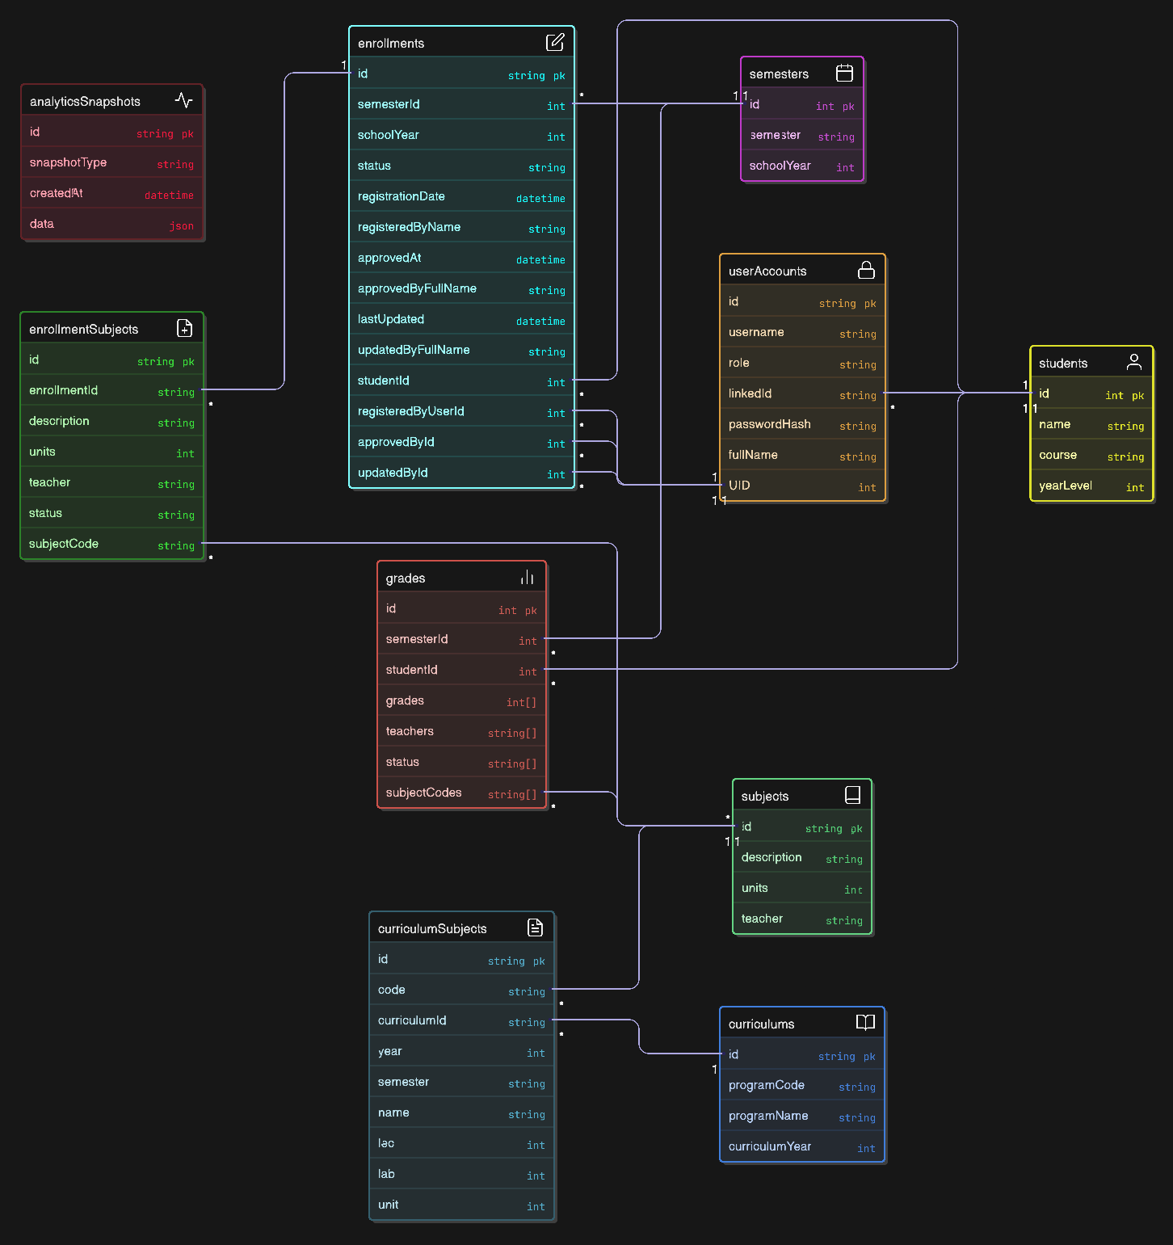

## **A. Registrar Dashboard – Data Flow**

### 1. enrollments

* Tracks which students are enrolled in what semester, who approved them, etc.
* Used to count enrollments per subject/program.

### 2. semesters

* Defines academic terms (e.g., Semester 1, 2025–2026).
* Used to group data (enrollment, grades) by time period.

### 3. curriculums and curriculumSubjects

* Stores program information (e.g., BSCS 2022).
* Ensures students are following correct academic paths.

### 4. analyticsSnapshots

* Contains precomputed data like trends, bottlenecks, etc. (data field is JSON).
* Helps in forecasting and planning (e.g., which subjects are in high demand).

**Registrar used this to:**

* Monitor enrollment trends.
* Check compliance with curriculum.
* Predict future subject demand or bottlenecks.

## **B. Faculty Dashboard – Data Flow**

### 1. grades

* Records students' grades per subject and semester.
* Helps visualize class performance, like pass rates or averages.

### 2. subjects

* Contains subject info and assigned teacher.
* Used to display what subjects a teacher is handling.

### 3. enrollmentsSubjects (via enrollments)

* Shows which students are in each subject under a teacher.

### 4. analyticsSnapshots

* Provides **early warnings** (e.g., failing trends, drop-out risk).

**Faculty used this to:**

* See their current teaching load.
* Monitor student performance.
* Intervene early for struggling students.

## **C. Student Dashboard – Data Flow**

### 1. grades

* Displays a student's personal grades and GPA.

### 2. enrollments

* Lists current and past enrolled subjects and status.

### 3. curriculums and curriculumSubjects

* Shows required subjects, and highlights what’s completed or pending.

### 4. analyticsSnapshots

* Provides personalized predictions (GPA trends, risk alerts).

**Students used this to:**

* Track academic progress.
* Get advice on how to stay on track.
* See what’s left for graduation.